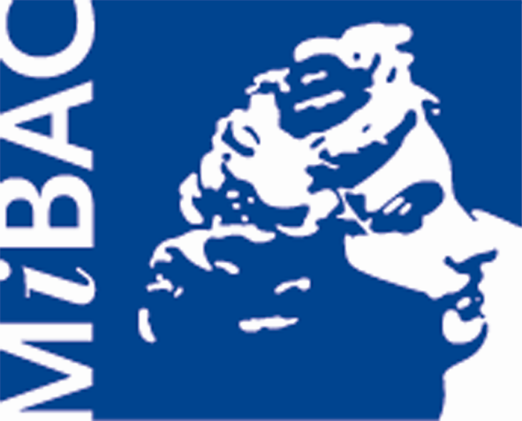
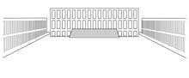
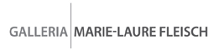
Archivio Centrale dello Stato



Chiara Dynys. Labyrinths of Memory

List of works

All unpublished, specifically created for this space

EXTERNAL STAIRCASE - outdoors, always visible
Memoria e Oblio (Memory and Oblivion), 2010, installation of twelve three-dimensional letters in steel, which reproduce the words "MEMORY" mt 1.90x13.00x0.45, and "Oblivion" mt 1.90x10.00x0.45.
THE COLLECTION GALLERY - visits Monday to Friday h 9am-2pm and by appointment (*)
Doppio sogno (Double dream), 2010, living sculpture: Spiral steel cage painted in blue, blue neon displaying the message "Più luce su tutto” (More light on everything), cm 220x335x282.
Sfoglia la carne in petali (Browse the meat in petals) 1, 2010, installation: projector, desktop, mouse. An interactive book of diaries. The artist has selected pages of unpublished diaries, united in a single book that recounts one of the history paths of Italy. The visitor sits at his desk, opens it with the mouse, browse the book and read the pages as if they were real: bending them, folding, hearing its noise.
Among the documents stands out the diary of the British nurse of Garibaldi.
Sfoglia la carne in petali (Browse the meat in petals) 2, 2010, installation: projector, desktop, mouse. An interactive book of letters. The artist has selected pages of unpublished correspondence, joined in a single book that recounts one of the history paths of Italy. The visitor sits at his desk, opens it with the mouse, browse the book and read the pages as if they were real: bending them, folding, hearing its noise.
An example of correspondence not so known and part of this work is given by a postcard sent in 1916 from the front, by Benito Mussolini to Pietro Nenni.
CONFERENCE ROOM - visits Monday to Friday h 9am-2pm and by appointment (*)
Sfoglia la carne in petali (Browse the meat in petals) 3, 2010, installation: projector, desktop, mouse. An interactive book of documents. The artist has selected unpublished images of original historical documents, combining them into a single book that recounts one of the history paths of Italy. The visitor sits at his desk, opens it with the mouse, browse the book and read the pages as if they were real: bending them, folding, hearing its noise.
An absolutely unknown document is the sketch of the United States of Europe flag, envisioned in 1950 by the Pan-European Movement.
DEPOSITS, OPEN TO THE PUBLIC FOR THE FIRST TIME - visits by appointment only (*)
Passages 1, 2010, video-projection in perspective of the Central State Archive high corridors, covered with paper documents for over one hundred kilometers of shelves, mt 4.40x1.80.

Passages 2, 2010, video-projection in perspective of the Central State Archive high corridors, covered with paper documents, mt 3.40x1.00.
Passages 3, 2010, video-projection in perspective of the Central State Archive high corridors, covered with paper documents, mt 6.50x1.80.
Il futuro dell’umanità è una libreria (The future of humanity is a library), 2010, carved polychrome written on the plaster of an indoor staircase.
Cage One, 2010, installation: iron, gold, mirror, cm 84x104x24. The visitor is mirrored and seen imprisoned along with the documents in a gilded cage.
Cage Two, 2010, installation: iron, gold, mirror, cm 84x104x24. The visitor is mirrored and seen imprisoned along with the books in a gilded cage.
Anomalie (Anomalies), 2010, installation of 20 light box: plexiglas, bronze, LEDs and photographs by the artist, each cm 30x20x7. The light boxes are distributed along two corridors created by the shelves.
La Biblioteca di Baabel (The Baabel Library), 2010, installation: lights, coloured papers. A sentence based on a quote from Borges lives in the chromatig dialogue between two components: paper and light.

Ad Astra, 2010, sculpture: gigantic steel staircase with four wheels placed on the corners and carved colourful written in enamel, mt 6.20x2.80x1.30. The phrases evoke events of Italian history.
Tutto Niente (Whole Nothing), 2010, installation with the words "whole" and "nothing" traced with neon lights, red and green respectively, on opposite white walls. The work is created on a stairway and the colours evoke the Italian flag.
Tutto scorre (Everything flows), 2010, installation: slab mirror, coloured glass stones, cm 20x400x100.
(*) Appointments for overall visits, even for deposits of the archive, can be done on Friday h 4-6pm and Saturday h 10-12am. Also these guided tours are free.

