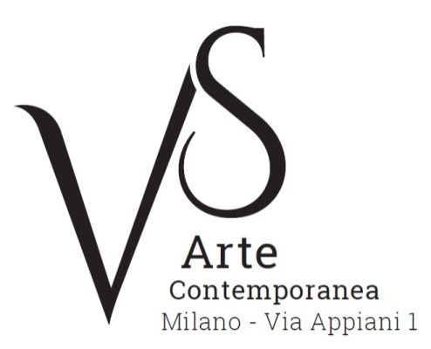

ABOUT US

VS Arte was born in 2017 from the strong passion for Contemporary Art of Vincenzo Panza and Samantha Ceccardi, who combine their entrepreneurial spirit with an artistic sensitivity.

Vincenzo Panza, who graduated from Bocconi University, has 30 years’ experience in the management of international companies, is Management Consultant and Member of the Board and Executive Committee of Confindustria (Confederation of industries) – Teramo. He fulfilled his need to transform his interest in art into a reality that he could share and enjoy with the public.

Samantha Ceccardi, who has 20 years’ experience in Event Management, in 2002 founded ‘Visionplus’, an agency for the organization of events and great shows. Her expertise together with an attention to the world of art are directed to an exhibition space focused on contemporaneity and combination of different techniques and ways of expression.

Their entrepreneurial spirit and skills in creating art events combine with their enthusiasm, in order to offer unprecedented works of art, bold experimentations, and connections among the artists, art lovers and experts.

OUR VENUE

VS Arte is off to an excellent start and is located in a very unique exhibition venue.
It is the rooms of Appiani Arte, the name of which is tied to the well-known art dealer and patron Alfredo Paglione.

Paglione’s gallery had been the point of reference for all the greatest artists in the 1900s, nationally and internationally. It hosted prominent masters among which there are Guttuso, Sassu, Manzù, Fontana, De Chirico and great international artists such as Picasso, Rauschenberg, Grosz, Gropper and Levin, just to mention a few. Its rooms had been a dynamic and fruitful meeting place for scholars, musicians and intellectuals of great calibre. In this venue of cultural gathering – dedicated to art in all its expressions – we can find such names as Raffaele Carrieri, Carlo Levi, Dino Buzzati, Salvatore Quasimodo, Leonardo Sciascia, Mario Luzi and Giuseppe Ungaretti. An osmosis between art and poetry was born in this place, creating a rare productive and creative environment.

It is indeed from here, among these walls full of prestige and history, that VS Arte begins its journey into the world of Contemporary Art, organizing acclaimed exhibitions that are dedicated to the great masters, but also devoted to the promotion of new artists.

OUR MISSION

The engines that run and guide VS Arte are our management and celebration of the works of art; the promotion and circulation of contemporary art in Italy and abroad; the development of a contemporary artistic sensitivity. These are the fundamental commitments at the heart of all the activities of the gallery. In addition, we aim for another important goal: to discover and launch talents in the world of art, giving them the possibility of being successful in the artistic scene, nationally and internationally.

