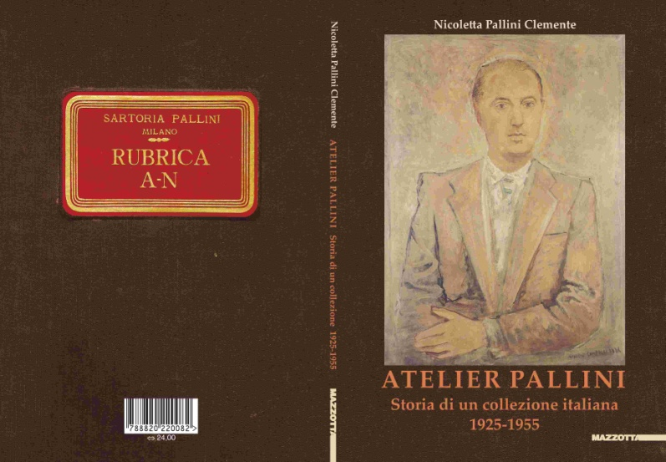

TITLE: ATELIER PALLINI

Storia di una collezione italiana 1925-1955/

ATELIER PALLINI

History of an Italian collection 1925-1955

Volume curated by Nicoletta Pallini Clemente

ESSAYS by: Nicoletta Pallini Clemente,
Paolo Baldacci and Gerd Roos, Elena Pontiggia,
Francesco Tedeschi, Silvia Bignami,
Nicoletta Boschiero, Nicoletta Colombo,
Irene Cafarelli
:

The volume entitled “Atelier Pallini. Storia di una collezione italiana 1925-1955/Atelier Pallini. History of an Italian collection 1925-1955” curated by Nicoletta Pallini Clemente and published by Edizioni Mazzotta, is the historical reconstruction of one of the most important art collections of the Twentieth Century in Italy and internationally.

For years the collection of Adriano Pallini has been a reference for art lovers and in regards to the history of the Milanese collectors from the Thirties to the Fifties as well as for the dress and fashion of the period between the two world wars.

His daughter, Nicoletta, who long before rebuilt and organized the archive of the paternal collection, focuses on the various steps in the life and collection of Adriano Pallini, Atri (Teramo) 1897 - Milan 1955.
A tailor from Abruzzo following the family tradition, he moved to Milan during the 1920s; he was friend and philanthropist of the main artists of the 1900s in Italy up to the “youth” of the Fifties, he started his collection “dressing” artists and poets still unknown at that time such as Giorgio de Chirico, Mario Sironi, Massimo Campigli, Vincenzo Cardarelli, Piero Marussig, Arturo Martini, Achille Funi, Pompeo Borra, Lucio Fontana, Antonio Corpora and many more. In his famous collection there were also artists the likes of Amedeo Modigliani, Pablo Picasso, Henri Matisse, Alexander Archipenko and Marie Laurencin, whose works are today preserved in the main international public institutes.

Nicoletta Pallini Clemente has been dealing with art for a while now, at the beginning as the person responsible of a column at “Gioia” for seventeen years, then as an independent curator of exhibitions in Italy and abroad that were dedicated to the masters of the Twentieth Century, such as Massimo Campigli, and to the protagonists of our time such as David Tremlett, Mark Lewis and Marco Bagnoli.

FORMAT: 15.5x22cm
136 pages, 130 illustrations
Text in Italian

TECHNICAL FEATURES:
Art Paper 170 g
matt laminated cover
thread-sewn paperback

ISBN: 978-88-202-2008-2
Price: € 24,00
Series: Biblioteca Varia

Presentation on 4 June 2014 at 6pm
Museo Diocesano (Diocesan Museum), Milan
featuring
the author: Nicoletta Pallini Clemente
the authors of the essays: Paolo Baldacci, Gerd Roos, Elena Pontiggia, Francesco Tedeschi, Silvia Bignami, Nicoletta Boschiero, Nicoletta Colombo, Irene Cafarelli.
moderator: Paolo Biscottini

For Edizioni Mazzotta, Media Relations and Communications
Stefano Sbarbaro: Foro Buonaparte 50 - 20121 Milan
Tel. +3902878380 - Fax +39028693046 - Cell. +393929821475
stefano.sbarbaro@mazzotta.it
www.mazzotta.it

