
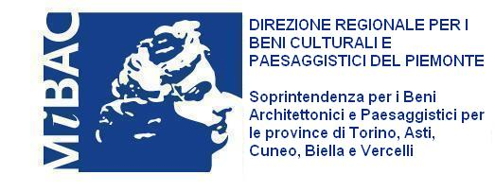
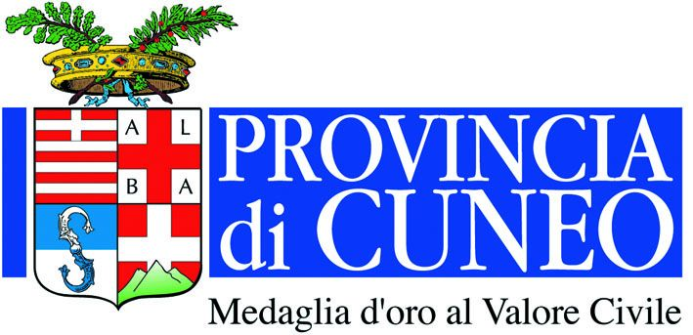
Con il Patrocino della:

Con il contributo della:

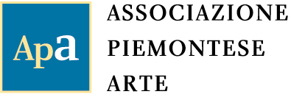
Organizzazione

International Sculpture in Racconigi, 2010
The present and experience of the past
curated by Luciano Caramel

Works exhibited

- Franco Batacchi, Venere e l’ombra, 2010, iron and stainless steel, cm 210x100x50
- Zadok Ben-David, Sunny Moon, stainless steel, cm 210x320x240
- Paolo Borghi, Le Alpi, bronze, cm 161x325x76
- Maria Cristina Carlini, Labirinto, 2010, iron, cm 400x900x43
- Mirta Carroli, Sentinella avamposto, 2009, corten steel, cm 350x200x49
- Jessica Carroll, I love you too, 2009, bronze, cm 200x50x40
- Giorgio Celiberti, Porta del Senato, 2004, aluminium, cm 197x45x9
- Ann Christopher, The Edge of Light, bronze, cm 222x45x14
- Girolamo Ciulla, Stele nera, 1997, granite from Zimbawe, cm 420x130x40
- Mariapia Fanna Roncoroni, Libreria muta, 1998-2001, iron and wood installation,
cm 160x70x40, 1°book cm 90x50, 2° book cm 50x30, 3° book cm 50x30
- Marienzo Ferrero, Portale – frammento di stella, 2001, copper plate, neon, methacrylate, cm 265x500x36
- Laura Ford, Bird, 2007, bronze, cm 150x100x55
- Elio Garis, Macchina per, 1998, iron and stainless steel, cm 300x550x450
- Marco Gastini, La pagina del volto, 2005, mixed media, copper and plaster on slate,
cm 37x40x12
- Annamaria Gelmi, Oltre la soglia, painted iron, cm 610x300x120
- Ale Guzzetti, Symbiotic micro-robot, several parts, installation
- Nigel Hall, The Now, 2000, bronze, cm 277x350x120
- Yung-Hsu Hsu, 2009-59, 2009, clay, cm 297x108x96
- Yi Hung, Lucky Tiger, 2010, two lacquered iron sculptures, cm 123x150x100 each
- Kenny Hunter, Blonde Boy, 2008, coated bronze, cm 181x48x48
- Allen Jones, Femme assise, 2005, coloured iron, cm 271x183x244
- Phillip King, Academy Piece, 1971, coloured iron, cm 116x640x640
- Masayuki Koorida, Embryo, 2010,black granite, cm 100x220x200
- Christopher Le Brun, Statue with Shield and Shadow, 1999-2008, bronze and steel,
cm 500x100x100
- Riccardo Licata, Ombra mai fu, 2001, painted wood, cm 200x70x70
- Pao-Chun Liu, Cow, 2008, silver FRP (Fiber Reinforced Polymers), cm 130x230x60
- Luigi Mainolfi, Sole alluminio, 2006, aluminium, cm 280 Ø
- Giuseppe Maraniello, Chiaroscuro, 2008, bronze, cm 300x600x120
- Gino Marotta, Universo vegetale, 1973, coloured acrylic glass, cm 120 Ø
- Igor Mitoraj, Torso di Ikaro, 2002, bronze, cm 220x298x162
- David Nash, Two Falling Spoons, 2006, black coated bronze, cm 226x194x117
- Nunzio, Senza titolo, 2010, lead on wood, two parts, cm 121x101x4 e cm 125x91x4
- Giovanni Padovese, Totem concetto di tempo, 2009, wood and papier maché, cm 225x64x70
- Mimmo Paladino, Elmo, 1993, bronze, cm 130x190x190
- Arnaldo Pomodoro, Stele I-II-III-IV, 1997-2000, bronze, cm 700x70x40 each
- Peter Randall-Page, Fructus, 2009, Kilkenny stone, cm 250x160x160
- Claudio Rotta Loria, Africa di Wulbari, 2003, mixed media, installation
- Marina Sasso, Struttura, 2009, iron, cm 230x160x120
- Valdi Spagnulo, Architettura: con-torsione, 2007, polished stainless steel, acrylic glass, cm 400x250x200
- Mauro Staccioli, Piazza Duomo ‘08, 2008, iron, cm 1020x1020x90
- Luigi Stoisa, Gea, bronze on iron base, cm 200x300x140
- Marialuisa Tadei, Il sogno, aluminium and glass, cm 160x100 Ø each
- Valter Valentini, Dialogo spaziale, 2007, coated bronze, cm 290x150x120
- Rob Ward, Ladder and Seat, bronze, ladder cm 300x100x100, chair cm 150x40x40
- Po-Lin Yang, Beautiful Homeland, 2009, stainless steel, cm 210x146x146

