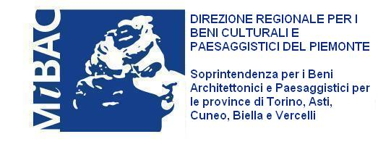

The Park at the Castle of Racconigi is a breathtakingly peaceful, harmonious place, drenched in history and positive interaction between man and nature, a space that has known the kind of innovation that respects the environment to the full, ever since Carlo Alberto, in the first half of the nineteenth century, gave instructions for the Royal Household’s farm to be installed here and the neo-Gothic complex of the Margaria and the glasshouses was built.
Nowadays, the spirit of place that is so typical of the Park and Castle of Racconigi hosts an event in perfect harmony with that place, the International Sculpture Biennale: International Sculpture in Racconigi, 2010. Present and Experience of the Past, curated by Luciano Caramel and organised by the Piedmontese Art Association under the presidency of the sculptor Riccardo Cordero.
Sculptures by successful artists and emerging new talents interact and dialogue with the Park’s visitors in what blossoms into a stimulating cultural experience.
Like many other beautiful and important initiatives that have been organised over the years in the Savoy family’s residence of Racconigi, this one also enjoys the important support of the neighbourhood, well aware that when the cultural heritage thrives, it can only act as a positive driver in the development of its host area.
This event is promoted by the Region of Piedmont with a contribution from the CRT Foundation and the patronage of the Province of Cuneo, in partnership with the Artistic Heritage and Cultural Activities Ministry and the Regional Directorate for Piedmont that I represent, aware – in this the Castle of Racconigi has always been a benchmark – that all will treasure the synergies and partnerships with organisms and associations, to coin an expression “to build a system”.
I am certain that the International Sculpture Biennale will furnish a further new impetus to the cultural policies practised at the Castle and will contribute to valorising one of the leading examples of cultural heritage in our region.

Mario Turetta
Regional Director for Piedmont National and Natural Heritage

