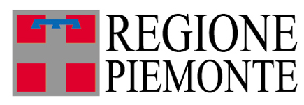
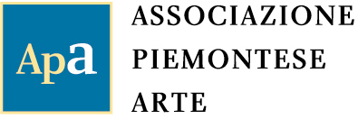
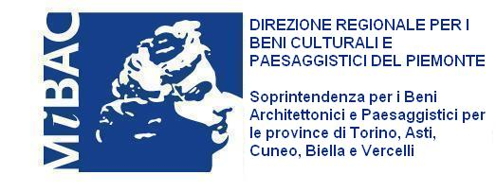
Organisation

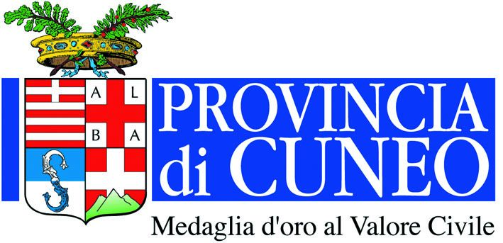

With the Patronage of:
With the contribution of:

Press release 04.16.2010

International Sculpture in Racconigi, 2010
The present and experience of the past
curated by Luciano Caramel

Exhibition venue Castle of Racconigi
Exhibition dates 6 June – 10 October 2010
Inauguration Saturday 5 June, 5.00 p.m.

The breathtaking Castle of Racconigi is to host the important International Sculpture Biennale, this year entitled International Sculpture in Racconigi, 2010. The present and experience of the past, curated by Luciano Caramel and organised by the Piedmontese Art Association chaired by the sculptor Riccardo Cordero. From 6 June to 10 October, the Park, the Garden and the glasshouses of the Margaria and the Savoy family’s royal residence will house forty-five sculptures in all sorts of different materials and on different scales, in an intense dialogue between contemporary sculpture, nature, architecture and history.

The event is being promoted by the Region of Piedmont in partnership with the Ministry of Artistic Heritage and Cultural Activities and with the Patronage of the Province of Cuneo.

The forty-five artists invited, each one showing one piece in the exhibition, are different in nationality, generation and so culture and creative backgrounds. They come from Italy, the UK and Taiwan: in addition to the initiative’s constituent international vocation, this choice is based on an intention to offer testimonials of living experiences, combined in a manifold, multicoloured and multi-dimensional relationship.
The artists showing this year are Franco Batacchi, Zadok Ben-David, Paolo Borghi, Maria Cristina Carlini, Mirta Carroli, Jessica Carroll, Giorgio Celiberti, Ann Christopher, Girolamo Ciulla, Mariapia Fanna Roncoroni, Marienzo Ferrero, Laura Ford, Elio Garis, Marco Gastini, Annamaria Gelmi, Ale Guzzetti, Nigel Hall, YungHsu Hsu, Yi Hung, Kenny Hunter, Allen Jones, Phillip King, Masayuki Koorida, Christopher Le Brun, Riccardo Licata, Po-Chun Liu, Luigi Mainolfi, Giuseppe Maraniello, Gino Marotta, Igor Mitoraj, David Nash, Nunzio, Giovanni Padovese, Mimmo Paladino, Arnaldo Pomodoro, Peter Randall-Page, Claudio Rotta Loria, Marina Sasso, Valdi Spagnulo, Mauro Staccioli, Luigi Stoisa, Marialuisa Tadei, Walter Valentini, Rob Ward and Po-Lin Yang.
All of these are successful artists at the peak of their creative maturity, sculptors who have made names for themselves for their personal poetic and idiomatic choices, others are emerging young artists.

The event’s leitmotiv is interaction with the environment and with the public, practising sculpture’s aperture and relationships. Curator Luciano Caramel puts it this way: “albeit within the three dimensions of the product’s status as an object, the artist intends the sculpture to be not just an object, but a veritable extension. In such a context, the environment is not an external factor of negligible influence any more, but a process in a state of constant flux that transforms the work, just as it is transformed by it, within rather extensive, flexible topological co-ordinates involving the overall nature of a space, perceived and frequented as a field that – as in the case of Racconigi – may also be experiencing direct friction with a past that has weighed it down with historical and artistic memorials, involving the public visiting the venerable stately home in a stimulating cultural experience, rich in creativity and imagination.”

The Royal Residence of Racconigi offers the sculptures a context of rare quality, beauty and historical and artistic significance: the historical stately home, one of the largest built by Italy’s royal house of Savoy, has a complex architectural and functional articulation of special importance that enables the sculptures to benefit from unprecedented environmental settings.
In addition to the castle residence, along the margins of the property stands the Margaria, the farm that was once by appointment to the Italian royal family, designed by Pelagio Pelagi in the neo-Gothic style and erected between 1835 and 1843, at once time celebrated, among other things, for the collection of exotic plants housed in the Royal Glasshouses, also neo-Gothic in style, with their bright white structures, slim of line and elegant.

The exhibition is accompanied by a complete catalogue published by Silvana Editoriale, featuring a critical description by Luciano Caramel, essays by Barbara Tuzzolino and Giovanni Cordero and institutional pieces.

Co-ordinates

Title International Sculpture in Racconigi, 2010. The present and experience of the past
Curated by Luciano Caramel
Venue Castle of Racconigi Piazza Carlo Alberto, 1 – Racconigi (Cuneo)
Tel. +39-0172.84005 Fax +39-0172.811.531
www.ilcastellodiracconigi.it
Dates 6 June – 10 October 2010
Inauguration Saturday 5 June 2010, 5.00 p.m.
How to get there By train: Turin – Racconigi. A train leaves Turin for Racconigi and vice-versa once every half hour. The journey takes 35 minutes.
By car: Motorway A6, exit a Carmagnola, follow signs for Racconigi
Opening hours Tuesday – Sunday, 9.00 a.m. – 7.00 p.m., closed on Mondays.
Price The ticket for the Castel Park costs € 2.00 and includes a visit to the exhibition.
Catalogue published by Silvana Editoriale with a critical description by Luciano Caramel, essays by Barbara Tuzzolino and Giovanni Cordero and institutional pieces

Organisation – public information Associazione Piemontese Arte
Via Mantova, 19 – 10153 Torino
Tel./Fax +39.011.248.1790 - piemontearte@libero.it
www.piemontearte.com

Press Office Irma Bianchi Comunicazione
Tel. +39.02.89404694 - +39.02.89400732
Fax +39.02.8356467 info@irmabianchi.it
Texts and photos are available from the website www.irmabianchi.it

