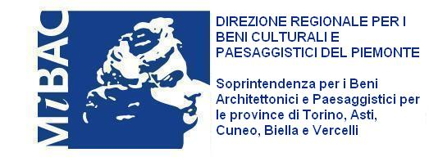
Ministero per i Beni e
le Attività Culturali

In recent years, the Royal Castle of Racconigi has demonstrated the ability to stimulate the renewed interest of numerous visitors, offering its services as a fundamental component of the sequence of residences on which the Savoy family lavished care and resources and that now constitute a much appreciated tourist destination.
The constant increase in the numbers of visitors, together with the monument’s growing importance for the cultural identity of its surroundings, is the result of a ceaseless, tenacious labour of love that started with the restoration, requalification and conservation of a priceless heritage and has since also launched it on a great variety of occasions and initiatives, as the Castle and its Park have hosted activities that have attracted increasingly numerous audiences.
The key to this success story is the ability to keep the spirit of this place intact and to maintain the high quality of the events it hosts, which range from antiquity to the very latest contemporary: this is a model of cultural management and policy that deserves to be monitored with interest.
The exhibition of the International Sculpture Biennale, hosted this year for the first time at Racconigi, is an initiative of unquestioned prestige. Curated by Luciano Caramel and organised by the Piedmontese Art Association, under the presidency of the sculptor Riccardo Cordero, the exhibition will benefit from a location of unparalleled value in this Castle and Park, so much so that one might wish that contemporary art may take even firmer root in Racconigi, as it has such a splendid opportunity here to develop an intense dialogue with the forms of architecture that have written our history. Presenting the work of some of the leading sculptors on the international scene, this event offers us all a chance to ponder on the potential of such a dialogue, generating yet another reason for inviting everyone to enjoy the venue’s extraordinary beauty.

Sandro Bondi
Minister for National Heritage and Cultural Activities

