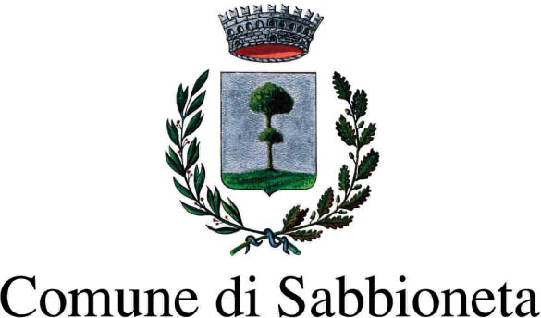

Con il Patrocinio di:


Press Release 04.09.2010

II International Biennale of Contemporary Art of Sabbioneta. Parallels
Curated by Stefania Provinciali

Location Sabbioneta, Palazzo Ducale
Date September 5 – November 14, 2010

The 2nd International Biennale of Contemporary Art of Sabbioneta entitled “Parallels” opens to public from September 5 to November 14 and is hosted in the wonderful Palazzo Ducale of Sabbioneta, former location of the first edition that was a great success in terms of visitors and critics.

The exhibition is curated by the art critic, Stefania Provinciali and involves artists from four continents of the world, Europe, Asia, Americas and Africa. Every artistic expression known has been used, starting from the more traditional – painting and sculpture - to the most contemporary ones – videos and installations – including photography and live performances.

The core of the new edition of the exhibition is to compare and encounter different Countries, cultures and artistic forms which are a sort of representation of the present contemporary art world. The artists involved come from social, cultural and historical realities, deeply different one from each other but so effectively expressed through multiform art styles.
“My choice always involves art in progress, the art that one does or is currently doing.” – comments the curator.
With reference to this, the Chinese artists invited are strongly representative of an art “in progress”. Chinese culture has had the peculiarity of questioning itself and then of assimilating the western artistic “lesson”, giving birth to a unique artistic synthesis.

South African art is currently experimenting a different ferment. Usually mentioned only for its great social problems, South Africa has in these days hit the headlines worldwide thanks to one of the most important ever sport events. The Biennale of Sabbioneta is going to focus above all on its contemporary art which includes great actual problems such as the social gap between black and white people, the poverty, the difficult relationship of South Africans with such a wonderful environment surrounding them.

The exhibition project follows an idea of internationality and involves a few European countries and the United States together with India and Egypt, which are well-known both for their natural, artistic beauties and for their past and present history.
The ‘Parallels’ evocated by the exhibition title are originated by this wide look on international art. ‘Parallels’ open to new creative aims through the art of men and women who are already drawing the attention of the art world.

The Biennale includes 28 artists : Huang Kehua, Liu Zhong, Long Bu Jiang, Xu De Qi, Zhang Xian Ming e Zhang Hongmei (China); Medhat Shafik (Egypt); Marcel Alocco (France); Heidi Bedenknecht and Sarit Lichtenstein (Germany); Gabriella Bozzi, Felice Cappa, Ferruccio D'Angelo, Dario Ghibaudo, Antonella Mazzoni, Marco Nereo Rotelli, Enrico Robusti, Agostino Rocco, Rino Valido and William Xerra (Italy); Nuria Rami Jurado and Francis Naranjo (Spain); Alexander Bocchialini Shundi (USA); Ruchika Wason Singh (India); Jake Aikmann, Johann Louw e Anton Karstel (South Africa).
Among the artists invited, a particular mention is for the Italian sculptor Novello Finotti, whose works open the exhibition accompanied by a selection of photographs to show his artistic development.

Sabbioneta is still an ‘ideal location’ for contemporary art, such a perfect union between the the artistic evolving of the Biennale and the history of this XVI century ‘ideal city’ created by the noble Gonzaga family and declared “Patrimony of Humanity” by UNESCO in 2008.
“It’s a match between past and present - says the curator Stefania Provinciali – today’s best way to support great culture and art.”

The event is promoted by the Municipality of Sabbioneta with the Patronage of the Region of Lombardy and the Province of Mantua.
The exhibition is accompanied by a complete catalogue curated by Stefani Provinciali with texts by Stefania Provinciali and Dario Fo, actor and winner of 1997 Nobel Prize for Literature.

Organization and coordination are by Sala Advertising.
Main sponsor is Padania Alimenti.

Exhibition Details
Title 2nd International Biennale of Contemporary Art of Sabbioneta. Parallels
Curator Stefania Provinciali
Location Palazzo Ducale, Piazza Ducale - Sabbioneta
Dates 5 September – 14 November 2010
Opening hours Tuesday - Sunday h. 9.30am –12.30pm / 3pm–6pm. Closed on Mondays.
Admission ticket € 4,00

Organization Municipality of Sabbioneta
and general information Anna Ghizzardi a.ghizzardi@comune.sabbioneta.mn.it
Tel. +39 0375 52599

Press Office Irma Bianchi Comunicazione
Tel. +39 02 89404694 - Fax +39 02 8356467 info@irmabianchi.it
Texts and photos are available from the website www.irmabianchi.it

