Exhibition organized by In conjunction with In collaboration with

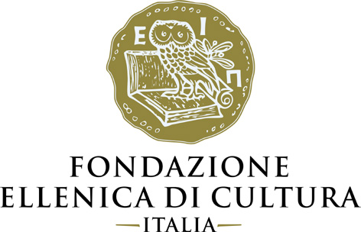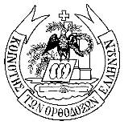

SARTORIO CIVIC MUSEUM AND SAN GIUSTO CASTLE
Trieste

VENIA DIMITRAKOPOULOU
PRIMORDIAL FUTURE
Sound

curated by Afrodite Oikonomidou and Matteo Pacini
with critic text by Franco Fanelli

13 April - 16 June 2019

Grand opening Sartorio Civic Museum Friday 12 April, 5pm
Meeting with the artist San Giusto Castle Saturday 13 April, 12pm

press release, 12.04.2019

From 13 April to 16 June 2019, the historic halls of the Sartorio Civic Museum and the San Giusto Castle in Trieste will host the last of the trilogy of Italian exhibitions by Greek sculptress Venia Dimitrakopoulou, entitled Primordial Future - Sound, curated by Afrodite Oikonomidou and Matteo Pacini.

For this third major Italian solo show, which follows her exhibitions centred on the theme of ‘Matter’ in Palermo and ‘Logos’ in Turin, the artist is presenting a new selection of works dedicated to the theme of ‘Sound’, which, in keeping with her stylistic approach, range from small to large dimensions and span traditional sculpture, installation, video, performance, writing and graphics. Intended as a single project in evolution, the Italian trilogy Primordial Future has proposed different works in each city and exhibition space, with the aim of integrating the sculptress’s work into each specific museum environment to create a visual interaction with the objects on exhibit.

In Trieste, the exhibition focuses on the artist’s sound evocations, winding through the stately rooms of the eighteenth-century villa, home of the Sartorio Civic Museum, in dialogue with the original period furnishings. Visitors enter the exhibition on the first floor in the ‘Salone delle Feste’ - characterized by the presence of two magnificent 18th century tapestries - and interact with an installation composed by key works of the entire exhibition triptych of Venia Dimitrakopoulou in Italy, such as warrior heads in plaster and bronze, Linethoughts, Shirt of Nessus I and a new work on paper entitled The Score of Memory. The work, especially created for the occasion, represents the emblematic expression of the exhibition’s theme, marking the end of a path, that is both linear and circular. In the words of the artist: “The trilogy ends in Trieste, an important city for its geographical position and its history, a crossroads that connects North and South, in a way like Greece. Duality is one of the pivotal themes in my work. Starting in Palermo, where the focus was ‘Matter’, going through Turin, where the focus was ‘Logos’, I am now in Trieste, with ‘Sound’, the ‘non-material’, in an attempt to map the human condition and the cycle of life as I understand it. The historical moment in which my journey through Italy is taking place is a time of great change, both in Europe and the world. In this rather foggy landscape, art today can play an important role and artists face their responsibility. Memory and history form the common thread that emerges from the depths of time, and I feel that, if we can hold it in our hands, it can lead us towards a less uncertain future. In Trieste I’m trying to activate memory especially through sounds. Individual, personal memory at the Sartorio Museum and collective memory at San Giusto Castle”.
The Ducal Apartment is occupied by the striking work Insomnia Bed, a large sheet of paper laid on the bed that dominates the room. Words in various languages appear on it, following a technique reminiscent of automatic writing and Joycean flow of consciousness. The words include visions, epiphanies, second thoughts, dreams, sensations and even most intimate personal thoughts, all of it intensified by the sound: a narrative spoken by Dimitrakopoulou herself.
The exhibition continues into the Music Room. There we encounter a site-specific sound installation entitled Ricercar, conceived in collaboration with composer Pablo Ortiz. “Sound has enormous evocative power, stemming from its abstract nature”, remarks Ortiz. “Sound suggests narratives that we develop and complete in the intimacy of our own minds. Like the proverbial Proustian madeleine, sounds are able to bring back sensations from the past, and at the same time, to open doors into a new understanding and perception of the world. The sounds in this installation are not meant to be listened to, they simply contribute to the immersive nature of the experience. The sounds complete, almost subliminally, the feelings provoked by the artworks on display”.
The Rose drawing room contains another installation, Ecdysis, composed by emblematic and majestic Shirts.

The exhibition itinerary ends within the walls of the San Giusto Castle, an ideal space in which to contemplate the monumental creation Promahones, the artist’s major work. The imposing steel discs, fringed at the top, are currently installed in the main courtyard of the National Archaeological Museum of Athens and are evoked here through a new video installation, Sounds and Shadows, which reconstructs the sounds and the shadows of the work itself, elaborated by Ortiz and the sculptress. Their distinctiveness is already suggested by the sculpture’s title, which means ‘bastions’, meaning ​​fortress or walls, but also the front line in the battle, and suggesting even “percussion instruments, capable of producing arcane melodies”, as Franco Fanelli writes in the catalogue’s critical text: “Walls that can be crossed, navigable bastions made of metal, shadows and sounds, the Promahones can suggest other rhythms, for example those of dance or performance, yet without moulding themselves into pure scenography because of this”, instead they weave a ‘sound play’ made of references and past echoes for looking at the present and building the future. As Pablo Ortiz also points out: “I’ve worked with Venia Dimitrakopoulou for many years on various projects and on the monumental installation Promahones at the Benaki Museum in Athens. During our fruitful collaboration, our point of departure and main goal was to connect sound with physical substance. In the case of Promahones in particular, this meant literally drumming on the steel of the sculpture, recording the results, and elaborating them to create a synthesis: a breath-like sound emanating organically from the sculpture itself”.

The Trieste exhibition crowns the trilogy of Italian exhibitions organised by the Hellenic Foundation for Culture - Italy in conjunction for this final event with the Municipality of Trieste, and in collaboration with Artespressione, Milan, the gallery representing the artist in Italy, and the Eastern Greek Community of Trieste.
The event is under the patronage of the Hellenic Ministry of Culture and Sports, the Greek Embassy in Rome, the Consulates of Greece and Cyprus in Trieste, the National Museum of Contemporary Art in Athens (EMST), the G. Costantinides Trieste-Greece Association and the Scuola Di Musica 55 - Casa Della Musica.

Venia Dimitrakopoulou’s three exhibitions in Italy - in Palermo, Turin and Trieste - are part of the Tempo Forte Italia - Grecia programme, an initiative promoted by the Italian Embassy in Athens and ratified during the First Intergovernmental Summit between Italy and Greece, held on 14 September 2017 on Corfu, whose purpose is to encourage and support the strengthening of cultural ties between the two countries, maintaining a balance between the various cultural spheres, from the traditional to the contemporary, and from the past to the future.

The exhibition series is accompanied by a complete bilingual catalogue in Italian and English, published by Umberto Allemandi.

Short biography: Venia Dimitrakopoulou was born in Athens, Greece, in 1965. She attended sculpture at the 1st Workshop of Sculpture in the Athens School of Fine Arts while studying theatre at the Athens Conservatoire Drama School. She has also attended drawing classes at the Atelier Vivant of the École Nationale Supérieure des Beaux-Arts (ENSBA). She lives and works in Athens and on the island of Aegina. She is a member of the Chamber of Fine Arts of Greece (EETE) and of the working group of ‘Tempo Forte Italia – Grecia’ of the Italian Embassy in Athens.
She has presented her work in solo exhibitions and participated in group shows in Greece and abroad. Her work is located in public spaces as well as private collections in Greece and abroad.
In 2014, Venia Dimitrakopoulou. Promahones was published by Hatje Cantz, a publication that focuses on her large-scale sculpture Promahones, presented at the Benaki Museum in Athens during the winter of 2014-2015. Since 2016, this public sculpture has been installed in the garden of the National Archaeological Museum of Athens.
In November 2015 she presented her artistic activity and work in Italy, to the students of the University Ca’ Foscari, in the context of Biennale Sessions of the Venice Biennale; the meetings were realized by the University Ca’ Foscari, Venice in collaboration with Fondo Ambiente Italiano (FAI) - Sezione giovani and the Hellenic Foundation of Culture in Italy. The events were curated by Caterina Carpinato and the gallery Artespressione of Paula Nora Seegy in Milan, where in 2016 Venia Dimitrakopoulou held her first personal exhibition in Italy, curated by Charis Kanellopoulou and Matteo Pacini.
Ιn January 2017, the President of the Italian Republic, Sergio Mattarella awarded her as Cavaliere dell’Ordine della Stella d’Italia, in recognition of her contribution, through her artistic work, to creating bonds with Italy, a country with which she feels deeply connected.
www.dimitrakopoulou.com

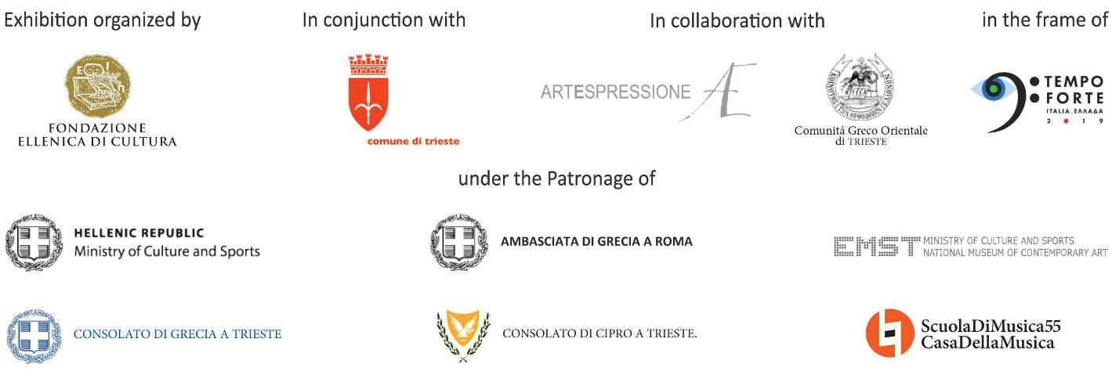

Exhibition details - Trieste
Title Venia Dimitrakopoulou. Primordial Future - Sound
Exhibition organized by Hellenic Foundation for Culture, Italy
In conjunction with Municipality of Trieste
In collaboration with Artespressione, Milan and Eastern Greek Community of Trieste
Curated by Afrodite Oikonomidou and Matteo Pacini
Venues Sartorio Civic Museum, Largo Papa Giovanni XXIII 1, Trieste | San Giusto Castle, Piazza della Cattedrale 3, Trieste
Dates 13 April - 16 June 2019
Grand opening Sartorio Civic Museum Friday 12 April, 5pm
Meeting with the artist San Giusto Castle Saturday 13 April, 12pm
Opening hours Sartorio Civic Museum Thu-Sun 10am-5pm | San Giusto Castle every day 10am-7pm
Special openings: 21 April, 22 April and 1 May
Entrance Sartorio Civic Museum: free | San Giusto Castle: included in the museum ticket (full-price ticket € 3,00 - reduced ticket € 2,00)
Catalogue published by Umberto Allemandi with critic text by Franco Fanelli

Info to the public veniad.italia@gmail.com

Press office
IBC Irma Bianchi Communication
Ph. +39 02 8940 4694 - mob. +39 328 5910857 - info@irmabianchi.it
Text and image downloads from www.irmabianchi.it

