An exhibition |  | In collaboration with
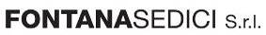 |  |  |  | 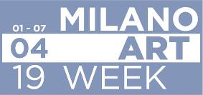
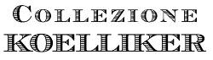 | 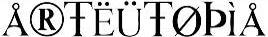 |  | 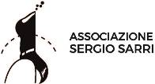 |  | 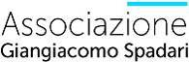

PALAZZO LOMBARDIA EXHIBITION SPACE
Milan, via Galvani 27
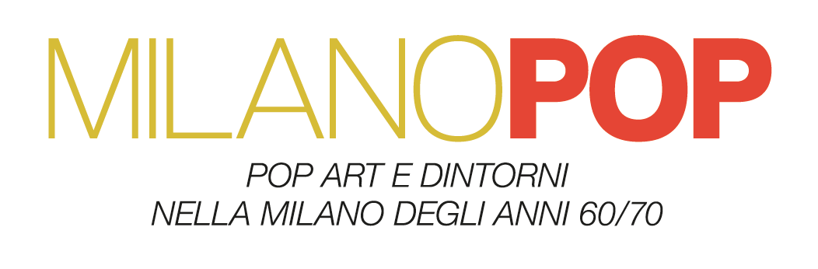
curated by Elena Pontiggia

4 April - 29 May 2019

press release, 12.04.2019

Palazzo Lombardia Exhibition Space in Milan, headquarters of the Region, welcomes the exhibition “MILANO POP. Pop Art e dintorni nella Milano degli anni ’60/’70" from 4 April to 29 May 2019, curated by Elena Pontiggia.

The exhibition is promoted by Arteutopia and by the Associations Sergio Sarri and Giangiacomo Spadari in collaboration with Regione Lombardia, Collezione Koelliker and Fontanasedici S.r.l. The exhibition is one of the initiatives of the Milan Art Week organized by the Municipality of Milan in collaboration with miart.

The exhibition route traverses a series of rooms as it explores Italian history during the Sixties and Seventies through fifty artworks - many of which never previously shown - by the major Milanese exponents of Pop Art, an artistic movement that more than any other was able to express the icons and contradictions of contemporary society. Originating in the United States, the movement also galvanised Italy, especially after the famous 1964 Venice Biennale.

The group exhibition moves from a panorama of Italian Pop Art with the great protagonists of the movement, from Mario Schifano to Tano Festa, from Mimmo Rotella to Giosetta Fioroni, to concentrate then on the Milanese environment with Valerio Adami, Enrico Baj, Paolo Baratella, Gianni Bertini, Fernando De Filippi, Lucio Del Pezzo, Umberto Mariani, Silvio Pasotti, Sergio Sarri, Giangiacomo Spadari, Tino Stefanoni, Emilio Tadini.

The exhibition highlights the various points of contact, but also the profound differences between Italian and American Pop Art by investigating how Italian, and particularly Milanese artists first interpreted this new direction in art, against the background of a restless Italy experiencing an economic boom while also moving towards the so-called anni di piombo (“the years of lead”).

The exhibition is complemented by a video documentary which includes testimonies and exclusive interviews with the artists and curator, collated by Stefano Sbarbaro.

A detailed catalogue accompanies the exhibition with a critical text by Elena Pontiggia and other unpublished interviews with the artists.

The thematic exhibition CINEMA POP, an important side event accompanying MILAN POP throughout its run, opens on Wednesday, 10 April at the Robilant+Voena Gallery, in collaboration with the Sergio Sarri Association and the Giangiacomo Spadari Association.
For supporting MILANO POP exhibition thanks to the Sponsors
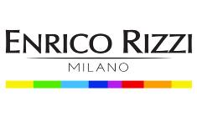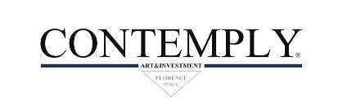

MILANO POP Exhibition details
Title MILANO POP. Pop Art e dintorni nella Milano degli anni ’60/’70
Curated by Elena Pontiggia
Venue Palazzo Lombardia Exhibition Space, via Galvani 27, Milan
Dates 4 April - 29 May 2019
Opening hours Monday-Friday 11am-7pm; Saturday-Sunday 3pm-7pm; closed on Easter, Easter Monday, 25 April and 1 May
Entrance free
Info milanopop@f16arte.it

Facebook Page www.facebook.com/MostraMilanoPop

Official Hashtag #MostraMilanoPop

CINEMA POP Exhibition details
Title CINEMA POP
Curated by Elena Pontiggia
Venue Galleria Robilant+Voena, via Fontana 16, Milan
Dates 11 April - 29 May 2019
Opening hours Monday-Friday 10am-7pm
Entrance free
Info Ph. +39 02 8056179 - paolo@robilantvoena.com

Press office
IBC Irma Bianchi Communication
Ph. +39 02 8940 4694 - mob. +39 328 5910857 - info@irmabianchi.it
Text and image downloads from www.irmabianchi.it

