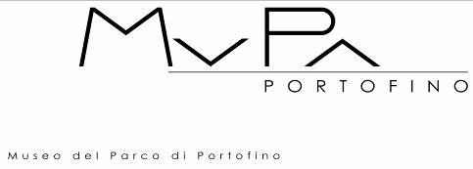

MUSEO DEL PARCO DI PORTOFINO
CENTRO INTERNAZIONALE DI SCULTURA ALL’APERTO
Molo Umberto I n. 11, Portofino

The Museo del Parco di Portofino is to permanently host the sculpture “IMPRONTE” by Maria Cristina Carlini

Presentation with the artist
Saturday 28 September 2019, 11.30am
following guided tour to the collection and cocktail in the Park

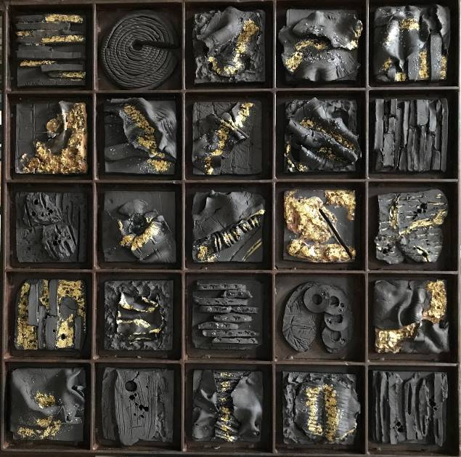

Maria Cristina Carlini, Impronte, 2018,
stoneware, iron, gold leaf, cm 95x94x5

press release, 11.09.2019

The prestigious Museo del Parco di Portofino is to permanently host the new sculpture Impronte by the international artist Maria Cristina Carlini.

At the presentation on Saturday 28 September at 11.30, the work of Maria Cristina Carlini will officially become part of the Museo del Parco di Portofino, Centro Internazionale di Scultura all’Aperto - directed by Daniele Crippa and curated by Serena Mormino in collaboration with the Associazione Culturale AMARTE - and its important collection numbering over 200 works by established international artists.

The work of Maria Cristina Carlini is composed of twenty-five different signs or ‘imprints’, a single stoneware and gold leaf composition on an iron core, representing suggestions of experiences and memories that unite the past with the present in a universal sense. The indissoluble link between the mineral, vegetable and animal kingdoms continues to be one of the major themes explored by Carlini over the course of her long career, expressed in this piece through fossil-like shapes modelled in stoneware, traces of a past life impressed into clay, both enigmatic and still alive.
As Carlini explains: “In my works I attempt to convey the memories evoked by materials from ancient times. Since they have been constantly in contact with humanity, these ancestral remains awaken atavistic recollections in the observer, archaic memories that speak directly to the primitive human being in us all.”
In addition, Carlini has always sought to convey the strength of the equilibrium that exists between the elements that foster life on Earth, which is continually under threat from humankind. In each of her creations she incorporates a clear message of respect for nature and the planet’s resources, especially important and timely today when a sustainable lifestyle is increasingly urgent.

For these reasons, and with the artist’s consent, the park’s director and curator have selected Impronte, an artwork that enters its new context as a sort of memory of the earth, recalling signs, rock engravings and fossil remains that can be found both in the Ligurian mountains and in areas of the artist’s native Lombardy.

The presentation provides an ideal opportunity for visiting the Museo del Parco, a place of rare beauty and charm, where the richly abundant nature is reflected in the green waters of a sheltered inlet of the Ligurian Sea, creating a jewel case of art and nature. In fact, the sculpture park occupies the land of a magnificent botanical garden planted over approximately three hectares of terraces and previously owned by Baron Mumm, who as well as cultivating his vineyards, created during the early part of the last century a collection of rare plants from all over the world. This cultural location founded in the early 1980s is in continuous evolution, enriched every year with new works by major international artists, among them, to mention just a few: Alviani, Arman, Atchugarry, Angi, Basso, Beuyes, Bressani, Ceccobelli, Chiari, Cogorno, Corner, Costa, Cracking Art Group, De Molfetta, Depero, Dorfles, Fiume, Fontana, Galliani, Guttuso, Kosice, Marangoni, Marchegiani, Mondino, Patterson, Pignatelli, Polesello, Pomodoro, Man Ray, Rotella, Spoerri, M. Thun, Tolomeo, Vautier, Vigo, and now Carlini. The park is a reference point for contemporary art enthusiasts, but also for whoever is keen to enjoy the beauty of a vivid dialogue between art and nature.

Biographical notes. Italian sculptor Maria Cristina Carlini has nurtured her passion for ceramics since her early years. It has accompanied her throughout her life and was her point of departure in investigating a range of materials, such as iron, corten steel, sheet metal, resin, recycled wood.
In the early 1970s she moved to Palo Alto, California, where she attended the California College of Arts and Crafts. Later she lived in Brussels, where she continued to experiment with clay-related techniques, pursuing this direction further on her return to Italy. Highly representative of her work are the monumental sculptures in which iron and stoneware combine to create a very personal and indissoluble union.
Maria Cristina Carlini’s work has received notable acclaim: she has exhibited in numerous solo and group exhibitions in various public and private international venues, and her monumental sculptures are on permanent display in Europe, America and Asia.
Her most recent permanently installed major work is the ten-metre-high La nuova città che sale [The New Rising City], located at the Milan Rho Fair and presented by Philippe Daverio for Expo 2015.
Numerous books have described Maria Cristina Carlini’s intense artistic activity, and renowned critics have written about her work, among them Luciano Caramel, Guo Xiao Chuan, Martina Corgnati, Gillo Dorfles, Carlo Franza, Flaminio Gualdoni, Yacouba Konaté, Frédérique Malaval, Paolo Levi, Laurence Pauliac, Elena Pontiggia and Cortney Stell.
Maria Cristina Carlini lives and works in Milan. www.mariacristinacarlini.com

Exhibition details
Title The Museo del Parco di Portofino is to permanently host the sculpture “IMPRONTE” by Maria Cristina Carlini
Venue Museo del Parco di Portofino, Centro Internazionale di Scultura all’Aperto, Molo Umberto I n. 11, Portofino
Presentation Saturday 28 September 2019, 11.30am
Opening Hours from June to September all day (except Tuesday) 10am-13pm / 15pm- 19pm; from October to May guided tours on request only

Info to the public www.museodiportofino.it - serenamormino@gmail.com

Press office
IBC Irma Bianchi Communication
Ph. +39 02 8940 4694 - mob. + 39 328 5910857 - info@irmabianchi.it
Text and image downloads from www.irmabianchi.it

