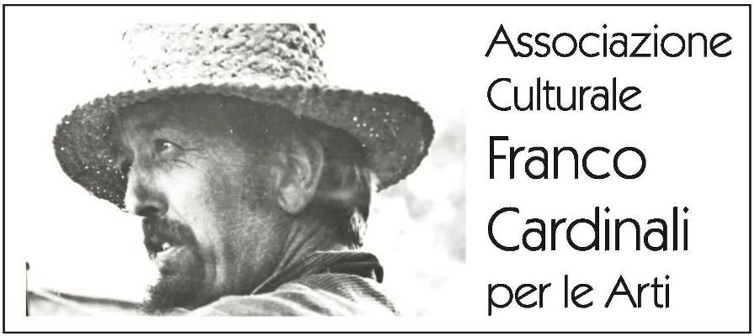

PALAZZO GIURECONSULTI
Milan, Piazza Mercanti 2

Franco Cardinali. Inquietudine necessaria
curated by Raffaella Resch

11 January - 14 February 2019
opening Thursday 10 January, 6.00pm

press release, 18.12.2018

Thirty years after Franco Cardinali’s posthumous exhibition at the Academy of Brera, the city of Milan pays homage to this artist of great calibre with an anthological titled “Franco Cardinali. Inquietudine necessaria” (Franco Cardinali. An Essential Anxiety), curated by Raffaella Resch, in the historical frame of Palazzo Giureconsulti, from 11 January to 14 February 2019.

More than forty works on display offer a comprehensive view of the Liguria artist’s work. He was educated in the Parisian environment of Montparnasse within the École de Paris, the wide group of artists and intellectuals who worked in Paris in the interwar period. At the beginning, Cardinali was affected by Picassian and Modigliani’s influences, as in the oil on canvas Enfant au jardin/Child in the garden (1955) of primitive forms. Then, he progressed to Informal art and the experimental movements of the Seventies, as per the curator’s words, «in an autonomous and mature way, with a sort of nomadism of styles, with a restlessness, that characterises also his whole life». The artist, in a continuous search for new techniques and forms of expressions, intensely lived and shared the artistic turmoil with the most original spirits of his time, following his own individual path with absolutely unique and peculiar results. Among his friends worth mentioning are his relationships with Jean Cocteau, with whom he exchanged letters, and with Jacques Prévert, who dedicated a poem to one of his pictorial works; he also met Pablo Picasso, from whom he got an interest in working with ceramics.
In his works, an artist always expresses himself, in a sort of involuntary autoportraitisme. In the same way, Cardinali’s famous friend Cocteau, the French poet, saw the strong figure of the painter born in Liguria in his production, he recognized «his mountaineer figure of stone cutter».

Later, Cardinali proceeded along an artistic path that went from Figurative Art, interpreted with strong colours and traits, to a materic abstract inspired by the natural world, made up of environments, animals and symbolic elements from reality and his own imagination. Franco Cardinali’s art is permeated with this “essential anxiety”, as revealed by the title of the exhibition. In his works one can in fact read a personal and artistic dissatisfaction, especially in the use of deep hatching, restless landscapes – as in Fragments de cathédral/Fragments of cathedral (1983) – and in the creasing of surfaces, as in Chant d’amour sur la falaise/Love song on the cliff (1985). In order to express «his need for absolute free self-determination – Resch says – in any time and in respect to any contest; a freedom perceived like a furious necessity of following the inspiration of the moment, because art, according to Cardinali, in order to be authentic and personal, is nothing else but an inner discussion with one’s own ghosts».

Art for Franco Cardinali was a constant reflection, a permanent evolution, a continuous introspection, a work without end in order to perfect one’s own painting technique and message. He mixed up traditional oil colours with earthy and clay materials to create thick mixed-material, worn surfaces, that reveal a deep and intense contact with nature. Hence, works on canvas were born, like Fossile lunaire/Lunar fossil (1967), oil with sand and casein, or even earlier the oil Crustacés/Shellfish (1962), up to Ancienne écriture/Old writing (1982), oil and sand, that portray curious and upsetting bestiary as if they were fossils imprinted on the weft. The pictorial matter digs beyond the external dimension, goes beyond the canvas, and gives us back the world explored by Cardinali, in that thin and ephemeral balance between art and life.

Associazione Culturale Franco Cardinali in cooperation with the The Chamber of commerce of Milan Monza Brianza Lodi organizes the exhibition; it reveals the artistic view of an artist whose works belong to important public institutions and private collections in Italy, Europe and the United States, mostly in New York and Los Angeles.

The event has the patronage of the Council of Milan, the Council of Chiusi della Verna, the Council of Città di Castello, of the Aquileia UNESCO Club and the Union of Craftsmen of the Province of Milan and the Province of Monza and Brianza.

A comprehensive bilingual catalogue, Italian-English, published by Scalpendi Editore, completes the exhibition. It displays all the works on display as well as a rich selection of the artist’s production, with a critical text by Raffaella Resch and a testimony by the artist’s friend Benito Boschetto.

Short biography. Franco Cardinali (1926-1985) was born in Rapallo, Liguria, in 1926. He moved to Paris in 1950. In 1953, he debuted in Milan with a solo exhibition at the Galleria San Babila and two years later displayed together with the artists of the Cité Vercingetorix, with the support of Jean Cocteau, with whom he began a strong friendship, and met Jacques Prévert: both promoted him in the artistic environments of Paris and the Côte d'Azur. In the summers of 1955 and 1956, Cardinali took part in the exuberant artistic activity of Vallauris and displayed at the Charpentier Gallery in the group École de Paris (School of Paris), with works selected by Raymond Nacenta. Then he met the great Picasso.
He divided his time between Vallauris and Paris until 1968, when a deep need for solitude led him to move to Tuscany in a village in the mountains, La Rocca della Verna, where he built his house and studio and went on with his research for twelve years.
In November 1980, still torn apart by dissatisfaction, he left for the Côte d'Azur to visit his friend Jean Haechler, who then became his mentor and Maecenas. He moved to Saint Paul de Vence permanently in 1982 and in December held a solo exhibition in Nice, followed by one in Geneva in February 1983, one in Paris in March and one in Sion, Switzerland, in April. His last exhibition was in June, a solo one in Saint Paul de Vence. He committed suicide on 12 April 1985, aged only 59 years old.

Special thanks go to the main sponsor Aboca for the support given to the exhibition.

With the patronage of

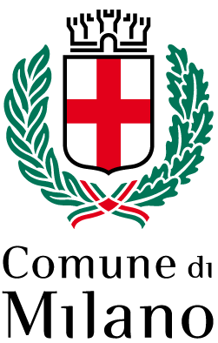 | 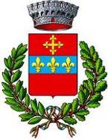  Comune di  Chiusi della Verna |   Comune di  Città di Castello | 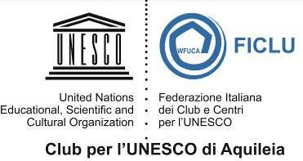 | 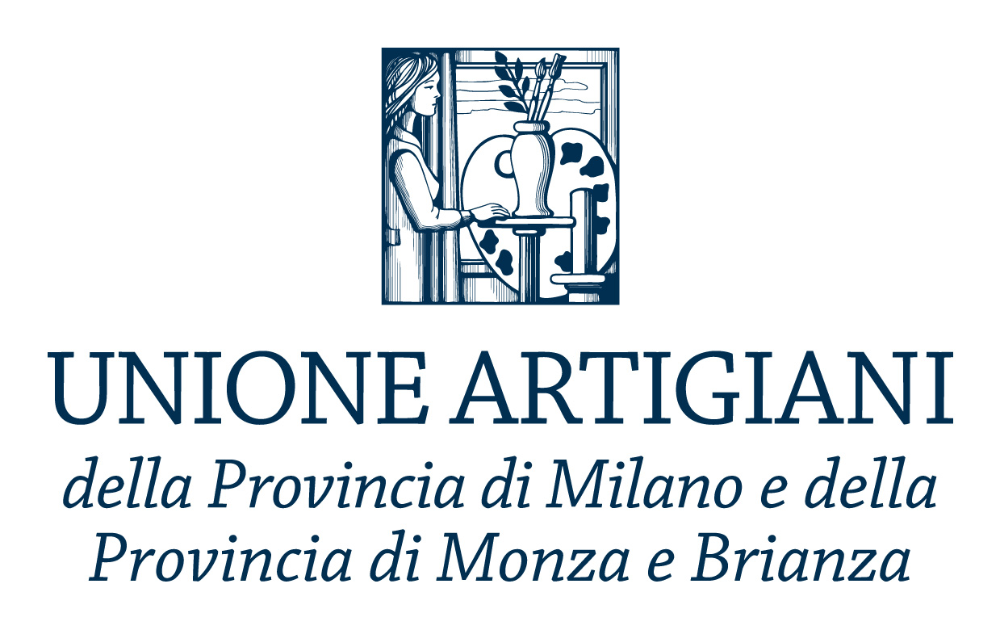

Main Sponsor



Exhibition details
Title Franco Cardinali. Inquietudine necessaria
Curated by Raffaella Resch
Venue Palazzo Giureconsulti, Piazza Mercanti 2, Milan
Dates 11 January - 14 February 2019
Opening Thursday 10 January, 6.00pm
Opening Hours every day 10.00am - 6.30pm
Entrance free
Catalogue Scalpendi Editore

Info to the public Ph. +39 02 8515.5920 | infogiureconsulti@mi.camcom.it | www.palazzogiureconsulti.it

Press office
IBC Irma Bianchi Communication
Ph. +39 02 8940 4694 - mob. + 39 328 5910857 - info@irmabianchi.it
Text and image downloads from www.irmabianchi.it

