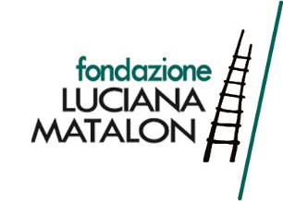

SISYU
Satori, la percezione dello spirito
/
SISYU
Satori, perception of the spirit

curated by Nello Taietti
critical essay by Vittoria Coen

11 May - 23 June 2018

under the patronage of
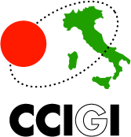
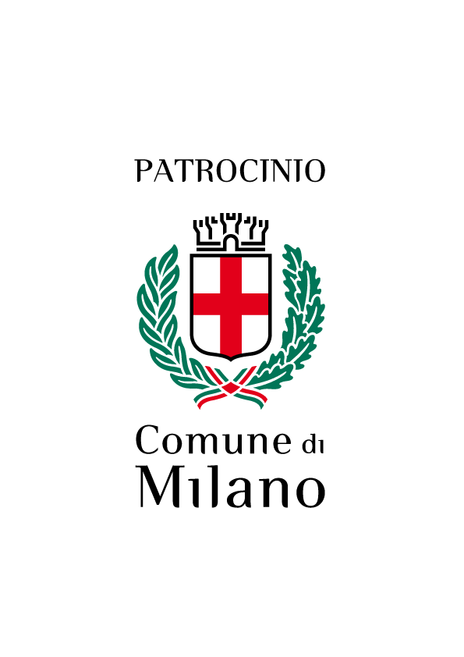
press release, 24.04.2018

From 11 May to 23 June, the Matalon Foundation hosts the first solo exhibition in Italy by the Japanese artist and calligrapher Sisyu called “Satori, la percezione dello spirito/Satori, perception of the spirit”, which by using a philosophical approach combines tradition and innovation.

The exhibition, curated by Nello Taietti, presents a selection of about 40 works, among which there are large paintings on canvas that reinterpret Japanese classical art (also erotic art). Floating calligraphic sculptures that project their long shadows on the walls and give an additional value to tri-dimensionality. A large video installation that stages writings by using an evocative game of lights and shadows. In their entirety, they reveal the versatility of Sisyu’s art. Known indeed for having combined Japanese calligraphy with other forms of art such as sculpture, multimedia arts and painting, she considers art as a process always in motion, where sculptures, lights and shadows combine and blend.

Her works translate calligraphic art into a contemporary language, and offer a new dimension and new artistic perspectives. It is clear in the inks on papers such as Shatter the Past Tear the Present (2011) where the brush stroke is the main character, and in the iron sculptures Solitude (2007), You have loved me (2009) and Beauty (2011). Here the words in their 3D form - floating in the air or standing on a pedestal - create shadows that establish an essential connection with them. The viewer can also find this connection in the mixed-media works made by using acrylics on canvas and thin iron sculptures that conjure some of their details and forms, complementing each other in an overview endowed with a strong effect. For example, Ukiyoe Seven (2017), the portrait of a made up woman who wears traditional Japanese clothes. The features of her face and the upper part of her body are revisited in the opposite sculpture. Furthermore, Shunga celebrates the pleasure of lovemaking (2018) that represents the bodies of two lovers joined in a whirling embrace.
In the critical text dedicated to the exhibition, Vittoria Coen says: “Sisyu expresses herself, thus, using different media, from the oldest to the virtual ones, with results and effects of strong grandeur, which is generated by especially bright colours and a special feeling for light. The chromatic explosions generated by blurred and sfumato brush strokes, where the calligraphic way of expression overlaps, tell the viewer of a sort of metamorphosis where the subjects live. Fantastic creatures inhabit the inner world of the artist who plays with wavy and spiral-like movements”.

In Sisyu’s artistic research, what is fundamental is the fusion of different expressive techniques. They are vehicles of energy and vitality in a constant tension towards spirituality as per the curator Nello Taietti’s words: “Sisyu’s works express the infinite beginning from the finite, in response to that need for eternity, expression of everyone’s spiritual life”. It is a spirituality that transpires from many works among which there is the majestic Feasting crow, feasted crow (2017) made up of six panels (175.5x370cm). It deals with the life and death theme: the image of a crow busy with its meal hints at the struggle for survival and represents life itself in contrast with death. The acrylic on canvas made by using very dark hues of colour and the floating red sculptures further contribute to express the intensity of the moment.

Through her works, the artist creates a message that is able to reach the international audience, without the need of knowing Japanese characters and calligraphic codes. She talks about her art highlighting how to her calligraphy is a way to find calm in the chaos of life: "The brush is not easy to control. You need a high level of concentration. When you are able to command the brush, then you master that concentration, you are able to free yourself from all your bonds. You are free to concentrate only on that moment". Lastly, for Sisyu the technological component is fundamental because – Japan being a country of tradition and technology – she believes that combining these two elements is the best way to pass on to the world her life experiences.
The exhibition is under the patronage of Milan City Council, of the Consulate General of Japan in Milan and the Japanese Chamber of Commerce and Industry in Italy.
A small publication with critical contributions by the curator Nello Taietti and Vittoria Coen accompanies the exhibition.

Thanks to

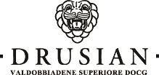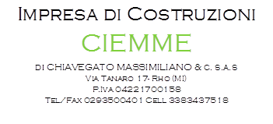

Exhibition details
Title SISYU. Satori, la percezione dello spirito/ SISYU. Satori, perception of the spirit
Curated by Nello Taietti
Critical essay by Vittoria Coen
External cooperation Giuliana Picarelli
Venue Fondazione Luciana Matalon, Foro Buonaparte 67 - Milan
Dates 11 May - 23 June 2018
Opening Hours Tuesday - Saturday from 10 to 19. Closed Sunday - Monday
Info Ph. + 39 02 878781 - fineart@fondazionematalon.org - www.fondazionematalon.org

Press office
IBC Irma Bianchi Communication
Ph. +39 02 8940 4694 - mob. + 39 328 5910857 - info@irmabianchi.it
texts and images downloadable from www.irmabianchi.it

