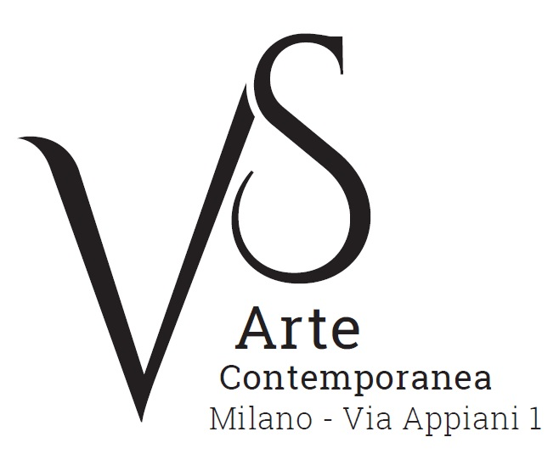

Sguardi e Luoghi / Looks and Places

1 February - 3 March 2018

press release, 30.01.2018

VS Arte gallery presents in Milan the group exhibition “Sguardi e Luoghi/Looks and Places” from 1 February to 3 March. The display outlines a contemporary figurative layout through the works by four young artists, Tarik Berber, Filippo Cristini, Max Gasparini and Tina Sgrò, focusing on the man-environment combination. The focal point of the human figure is the look - as one can clearly see in the works by Tarik Berber and Max Gasparini -, next to the places, architectures, and indoor and outdoor spaces represented by Filippo Cristini and Tina Sgrò.

The large sized canvas by Tarik Berber from the series Windsor Beauties portray female figures whose expressiveness is transmitted mostly by their faces and especially by their look or the negation of it: closed eyes communicate the emotional state. The works on display are inspired by the portraits of the Duchess of York and her friends, made by Sir Peter Lely, a Dutch painter who was active in mid-seventeenth century England, as one can clearly deduce from the reprised seventeenth century drapery of the fabrics and dresses.
The female figure is the main character also in the works by Max Gasparini who paints close-ups of faces and bodies - their realism and refinery of details create a strong contrast with the media used in making them. He uses salvaged materials among which there are hessian bags, old bed linen, cardboard, and metal sheets that are now oxidised. The black and white portraits come out from the rust of the metal sheets with their eyes closed as in Argentum or take form from the strokes of a spatula in the spots on a canvas - previously submerged in black -, as in the work Ariel that captures the dreaming look of a young woman. There are several cross-references to mythology and alchemy. They are themes to which Gasparini is dedicated also using their elements and symbols.

In the exhibition layout next to the human figure there is the representation of the place in its meaning of space, both real and abstract.

The large sized canvases by Filippo Cristini are characterized by the intensity of their colours and their marked materiality. They offer visions of urban spaces, outskirts, post-industrial areas and natural environments, where the classical representation of landscape blends with that by the artist – made up of history and memories. On display, there are works cinematographically inspired such as Il sogno Assiromilanese/The Assyrianmilanese dream, an urban view from which the majestic architecture of Milan Central Station emerges, and La Zona/The Zone, which represents a wide desert space in the twilight zone.
Tina Sgrò’s places are instead closer to the dream-like dimension, both in familiar environments and in scenes taken from images and photographs, where time appears suspended. They are indoor spaces of houses, living rooms, bedrooms, places that belong to the artist’s subconscious and by her are reinterpreted via painting. They are places where the human presence is perceived only by the traces left by its actions. Details – such as the position of a chair in the work Noia/Boredom, and objects of daily usage, for example the glasses on a table in Bollicine/Sparkling - suggest the transit of a figure who departed the scene, leaving the space to tell of its existence.

VS Arte was born in 2017 from the passion for art and collecting of its two founders, Vincenzo Panza and Samantha Ceccardi.
Vincenzo Panza has 30 years’ experience in the management of multinational companies and Samantha Ceccardi has been active in the organization of events and great shows for more than 20 years.
VS Arte is a new reality that combines art and economic dynamics in a unique venue, “Appiani Arte per Immagini” the prestige of which is tied to Alfredo Paglione, a well-known art dealer and patron of the arts, whose gallery has been the reference for all of the greatest artists in 1900s, nationally and internationally. It hosted prominent national masters such as Guttuso, Sassu, Manzù, Fontana and De Chirico, and great international ones such as Picasso, Rauschenberg, Grosz, Gropper and Levin. Its rooms have been a meeting place, dynamic and fruitful, for literates, musicians, and intellectuals of great calibre such as Raffaele Carrieri, Carlo Levi, Dino Buzzati, Salvatore Quasimodo, Leonardo Sciascia, Mario Luzi and Giuseppe Ungaretti. This place produced an osmosis between art and poetry, creating a rare, productive and creative environment that VS Arte, supported by Alfredo Paglione, wants to maintain with greatly acclaimed exhibitions and events in order to allow new artists to emerge and at the same time to celebrate the works by the great masters.
VS Arte’s projects focus on the preservation, management and celebration of works of art, the promotion and circulation of contemporary art and its development in Italy and abroad.

Exhibition details
Title Sguardi e Luoghi/Looks and Places
Sede VS Arte, via Appiani 1 - 20121 Milan
Date 1 February - 3 March 2018
Opening Thursday 9 November, 6.30pm
Opening hours Tuesday - Saturday, 3.30pm - 7.30pm
Entrance free
Info to the public Ph. +39 335 8004220 - info@vsarte.it - www.vsarte.it

Press Office
IBC Irma Bianchi Communication
Ph. +39 02 8940 4694 - mob. +39 328 5910857 - info@irmabianchi.it
text and image downloads from www.irmabianchi.it

