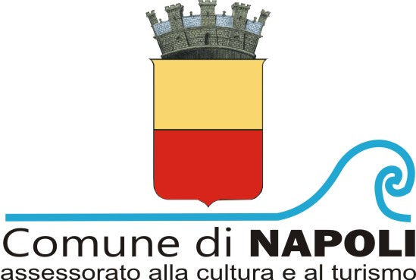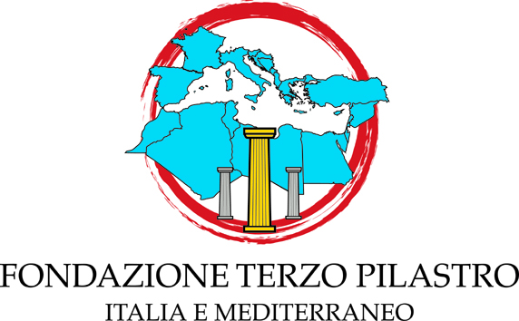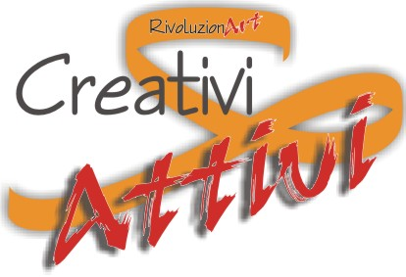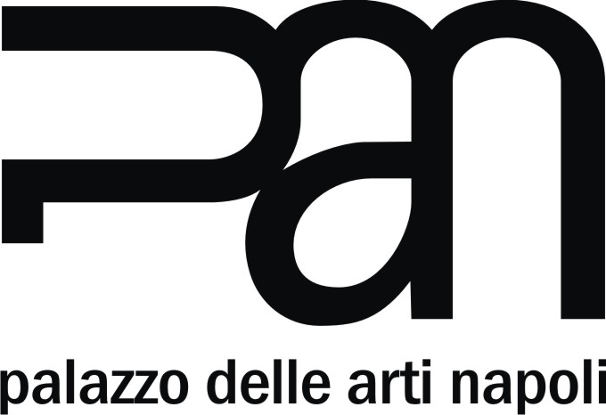

Pan | Palazzo delle Arti di Napoli
via dei Mille 60, Naples

Nel nome della madre. Adele Ceraudo
In the name of the mother. Adele Ceraudo
curated by Daniela Wollmann

24 February - 19 March 2018
grand opening and performance on Friday, 23 February at 5:30pm

press release, 10.01.2018

The eclectic artist Adele Ceraudo's solo exhibition of more than 50 works is hosted at Pan | Palazzo delle Arti of Naples from 24 February to 19 March. These works retrace the significant moments of her 10-year long artistic career, and are characterized by several forms of expression such as drawing, painting, photography, installation, video and performance, and by a series of works where she experiments with the fusion of different languages of art. The main theme of the exhibition “Nel nome della madre. Adele Ceraudo/In the name of the mother. Adele Ceraudo” is femininity, which is analyzed in depth from several human and social points of view.

The exhibition is organized in collaboration with the Department for Culture and Tourism of the Council of Naples and the cultural association CreativiATTIVI/rivoluzionART as part of its project “la bottega delle sensazioni/the shop of senses”. It was devised and curated by Daniela Wollmann.
The exhibition is promoted and implemented thanks to the contribution of the Fondazione Terzo Pilastro - Italia e Mediterraneo.

Adele Ceraudo has always put at the centre of her art the Woman and describes all her characteristics, from the components linked to joy, positivity and seduction to the most tragic parts linked to violence and pain.
Whether she is telling of a personal experience or more generally speaking, the artist expresses herself trying to represent the female universe comprehensively: the figure of the woman is Mother Nature, the energy of the world. She tries to express the concept of femininity, meant as a female component, which is present not only in the multitude of women, but also in every human being. Her art - endowed with an unrestrained emotional charge - is a social message focusing on the respect for the mind and body of all women.
She is very attached to drawing, which is the protagonist of her works and is characterized by a careful and detailed rendering. In her artistic way of expression one can find strong mastery of techniques, composition and proportions - obtained by using a simple ballpoint pen - and, at the same time, find her thrust towards new technologies or new media, which become whole with the drawing itself. The making of a work begins with the idea of an image; it takes shape through a performance, in which the artist acts, while being captured by photos. Once the images are selected, Adele Ceraudo creates the drawing, which is scanned in high-resolution and transferred on different media (canvas, paper, PVC, Plexiglas) to become a painting, as she intervenes again pictorially and materially.

The exhibition describes the artistic and inner evolution of Adele Ceraudo, who in her first works in 2008 from the series “Just wearing Ink” celebrated the female body, portraying a model. Only after she concluded this series, in 2010, she focused on her own body - a constant presence in her works and an essential element of her expressiveness.
In the collection “Le affinità elettive/The elective affinities”, made between 2011 and 2013, the artist offers her very personal reinterpretation of icons from the past and the history of art from a contemporary point of view. She compares herself to the classical standards, but modifies their meanings. This is clear in Leonardo's Uomo Vitruviano/Vitruvian Man, in Crocifissione/Crucifixion or San Sebastiano/Saint Sebastian - where the subjects have female features and specifically the body and face of the artist herself - or in Pietà/Piety and Il ratto di Proserpina/The abduction of Proserpine, which is endowed with a strong visual impact due to its chromatic details in red.
In her reinterpretation “Nuotando nell’Aria/Swimming in the air” (2013-2015), inspired by “La Maddalena Penitente/Penitent Mary Magdalene” by F. Hayez, Adele Ceraudo tells the story of her personal growth of knowledge and discovery of femininity, also from the point of view of sensuality. Within this series, what emerges is a strong iconographic realism - linked to bodies, contortions, sculptural appearances of anatomies, their movement and small details, which are rich in symbols and meanings, all expressions of strong emotions. The drawing Senza titolo/Untitled is very significant. Here the face of the artist is repeated four times, with a slight superimposition. This work explains the title of the exhibition, which focuses on woman's condition and her daily ambivalent state between happiness and pain, her daily life living in this state, even in its extreme forms. In this work the female figure is meant as a person, a mother, a wife, a daughter, a friend, represented in a state that conveys emotions of extreme happiness, symbolically upset by the ear that consistently insinuates in each face, disturbing the composition as a whole.
On display, there is also a group of seven drawings and seven photographs selected from the last series of works called “New York 2016”. They highlight the psychological, emotional and metaphysical dimension, rather than the dimension of aesthetic perfection. This recent series - made in 2016-2017 - is born from the cooperation between the artist and the photographer Giorgio Possenti.
A series of portraits - made during a longer period, 2010-2017 - are all made by using a ballpoint pen. The subjects are women and men met by the artist during her life, from the Nobel Prize winner Rita Levi Montalcini to the director Lina Wertmuller, from the former President of the Chamber of Deputies Irene Pivetti to the sports-woman Josefa Idem, from the author Aurelio Picca to the artist Sandro Koop. In them, the perception of each single personality is very strong. Their personalities emerge from the connotations, gazes, and wrinkles, and from their natural and very realistic expressions.
A group of six videos tells about the artist, her story and her way of making art from 2009 to today. These videos accompany the exhibition, completing the rich display.

On the occasion of the grand opening and during the entire period of the exhibition, every day Adele Ceraudo will perform in a theatrical-scenic piece called “Da Madonna a donna/From Madonna to woman”, with the support of a video - directed by Andrea Cagno - and music curated by Marius Arcioni. It is homage to the person of Virgin Mary and a transformation from Her iconographic image to the living person, the woman, as well as to the artist herself as a reference to the female universe.

A bilingual Italian-English catalogue accompanies the exhibition, with texts by the curator Daniela Wollmann, the art Historian Gianpasquale Greco and Luigi Polillo, translated by Maria Rosaria Tomas. This edition too is part of the project “la bottega delle sensazioni/the shop of senses” and is curated by Daniela Wollmann.

Short biography. Adele Ceraudo was born in Cosenza in 1972. She lived in Rome for a long time and now lives in Milan. After the Artistic Lyceum, she attended the Faculty of Architecture of Florence, where she studied drawing, which in time became essential to her work. She expressed her eclectic personality dedicating herself - next to her artistic work - to graphics, illustration, acting and sometimes working with important photographers among which there are Matteo Basilé and Alessandro Rossellini.
She displayed in several private and public venues, in Italy and abroad.
Worth mentioning are her participations in the 54th edition of the Biennale of Venice, the Contemporary Art International Fair of Istanbul in 2011, in the FuoriSalone of Milan in 2014 and, in 2015, in Arte Fiera Bologna.
In Melbourne in 2014-2015, she was the godmother of G.A.I.A., a project supporting artistic-cultural exchanges between Australia and Italy, and displayed her works in a solo exhibition with works inspired by the great masters from the past and iconic images from the Italian History of Art, which were reinterpreted from a female point of view.
In 2016, she was among the guests of the series of conferences TEDx Cesena, with the projection of a video that accompanied her while she recounted her artistic career and life experiences. In 2017, in Italy she took part in prestigious group exhibitions, events linked to the theme of femicide, and in a charity auction, displaying next to artists the likes of Alighiero Boetti, Giovanni Gastel, Gustav Klimt, Mimmo Paladino, CY Twombly and others. www.ceraudoadele.com

Exhibition details
Title Nel nome della madre. Adele Ceraudo/In the name of the mother. Adele Ceraudo
Curated by Daniela Wollmann
Venue Pan | Palazzo delle Arti of Naples - Locali Loft - Via dei Mille 60, Naples
Dates 24 February - 19 March 2018
Grand opening and performance Friday, 23 February at 5:30pm
Performance times Every day
Opening hours Monday-Saturday 9am-7pm | Sundays 9am-2pm
Entrance fee FREE
Catalogue Italian-English. Texts by Daniela Wollmann, Gianpasquale Greco and Luigi Polillo
Info to the public danielawollmann08@gmail.com - https://www.facebook.com/groups/472097702884826/

Press office
IBC Irma Bianchi Communication
Ph. +39 02 8940 4694 - mob. + 39 328 5910857 - info@irmabianchi.it
texts and images downloadable from www.irmabianchi.it

