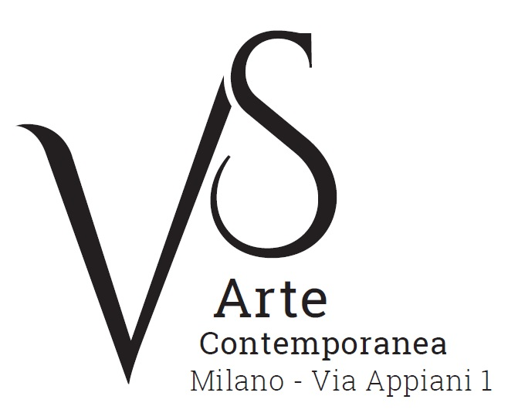

Tosi e Sironi: due maestri, due amici
/
Tosi and Sironi: two masters, two friends

curated by Elena Pontiggia

10 November 2017 - 20 January 2018
opening Thursday 9 November, 6.30pm

press release, 17.10.2017

The exhibition “Tosi e Sironi: due maestri, due amici/Tosi and Sironi: two masters, two friends”, curated by Elena Pontiggia and hosted by VS Arte Gallery, will be launched on Thursday, 9 November. The display, which will be open from 10 November to 20 January, presents a group of works by the two great artists, among which there are paintings, watercolours, papers, ink works and illustrations.

The exhibition - the first one after many years that Milan dedicates to Arturo Tosi – gathers some fundamental works of the artist’s career: they come from the Arturo Tosi Association, in Rovetta, and from private collections. The lay out of the display begins from the paintings of the young Tosi and, through the amazing “alcoholic” nudes of 1895 (true examples of informal art before its time), up to the works from the 1920s and 1930s, such as the famous Landscapes and Still Life works. In addition, there are on display some precious watercolours, which are among the few survivors of a fire deliberately lit in the artist’s studio in 1944.

Next to Tosi’s work, there is Sironi’s. Sironi was a friend and career companion of the painter from Varese, with whom he shared the experiences of the Novecento Italiano. By Sironi there are on display, among others, a series of papers and ink works, from the famous slates for the trench magazine “Il Montello”, painted at the battlefront in 1918, to the illustrations for “Il Popolo d’Italia/the People of Italy” of 1920-21, up to the majestic figures of the 1920s.

A catalogue with a text by Elena Pontiggia accompanies the exhibition.

During the exhibition the book “Arturo Tosi e il Novecento. Lettere dall’archivio di Rovetta/Arturo Tosi and the Twentieth Century. Letters from the Rovetta Archive”, curated by Elena Pontiggia, will be presented. It publishes important never seen before documents on Tosi, and the artists and intellectuals who spent time with him.

Arturo Tosi (b. 1871 in Busto Arsizio – d. 1956 in Milan) has been one of the main characters of Italian painting of the Twentieth Century. After a period – during his youth - characterized by an original use of sign and matter, which he himself defined “alcoholic period”, he joined the Novecento Italiano, founded in 1922 by Sironi, Funi and other artists, who gathered around the critic Margherita Sarfatti. His fluid and pasty brush stroke connects with a painting school that from Fontanesi and Piccio gets to the Scapigliatura movement and Gola, meanwhile he shares with Sarfatti’s group the sense of synthesis and a solid architectural structure (in his case which is borrowed from Cézanne). In 1931, he won the Prize for Painting at the Quadriennale of Rome. He got the attention of the main critics, from Waldemar George – who in 1933 in Paris published an important monography of the artist -, to Argan, from Carrieri to Savinio.

Mario Sironi was born in Sassari in 1885 and in 1886 relocated with the family to Rome. In 1898 his father dies. Around 1903-4 he spent time with Balla, and became friends with Boccioni, Severini and others. Later in 1913, he joined Futurism. When the war broke, he went to fight at the battlefront. In 1919, he moved to Milan and painted his first city landscapes: powerful and synthetic forms, classically inspired, which are however marked by a modern dramatic force. At this time, he became closer to Fascism. In 1922, he was among the founders of the Novecento Italiano, in Margherita Sarfatti’s group. In the 1930s, Sironi focused especially on great wall painting, with many monumental works. In 1943, he joined the Republic of Salò and on 25 April escaped execution by firing squad thanks to the intervention of Gianni Rodari. In 1948, he lost his daughter, Rossana, who killed herself at 18. Mario Sironi died in Milan in 1961.

VS Arte was born in 2017 from the passion for art and collecting of its two founders, Vincenzo Panza and Samantha Ceccardi.
Vincenzo Panza has 30 years’ experience in the management of multinational companies and Samantha Ceccardi has been active in the organization of events and great shows for more than 20 years.
VS Arte is a new reality that combines art and economic dynamics in a unique venue, “Appiani Arte per Immagini” the prestige of which is tied to Alfredo Paglione, a well-known art dealer and patron of the arts, whose gallery has been the reference for all of the greatest artists in 1900s, nationally and internationally. It hosted prominent national masters such as Guttuso, Sassu, Manzù, Fontana and De Chirico, and great international ones such as Picasso, Rauschenberg, Grosz, Gropper and Levin. Its rooms have been a meeting place, dynamic and fruitful, for literates, musicians, and intellectuals of great calibre such as Raffaele Carrieri, Carlo Levi, Dino Buzzati, Salvatore Quasimodo, Leonardo Sciascia, Mario Luzi and Giuseppe Ungaretti. This place produced an osmosis between art and poetry, creating a rare, productive and creative environment that VS Arte, supported by Alfredo Paglione, wants to maintain with greatly acclaimed exhibitions and events in order to allow new artists to emerge and at the same time to celebrate the works by the great masters.
VS Arte’s projects focus on the preservation, management and celebration of works of art, the promotion and circulation of contemporary art and its development in Italy and abroad.

Exhibition details
Title Tosi e Sironi: due maestri, due amici/ Tosi and Sironi: two masters, two friends
Curated by Elena Pontiggia
Venue VS Arte, via Appiani 1 - 20121 Milan
Dates 10 November 2017 - 20 January 2018
Opening Thursday 9 November, 6.30pm
Opening hours Tuesday - Saturday, 3.30pm - 7.30pm
Entrance free
Info to the public Ph. +39 335 8004220 - info@vsarte.it - www.vsarte.it

Press Office
IBC Irma Bianchi Communication
Ph. +39 02 8940 4694 - mob. +39 328 5910857 - info@irmabianchi.it
text and image downloads from www.irmabianchi.it

