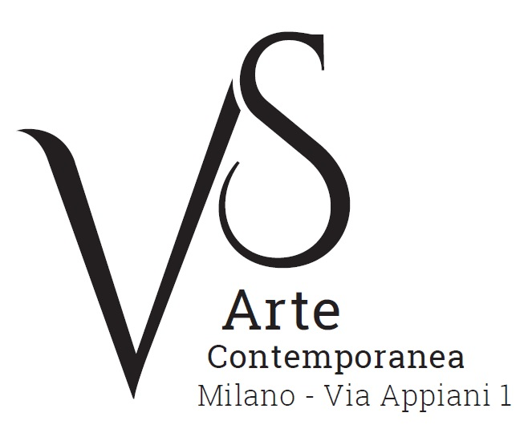

Angelo Accardi. Lost and found
curated by Mimmo Di Marzio

22 September - 4 November 2017
opening Thursday 21 September, 6.30pm

press release, 26.07.2017

Never seen before canvases of large, medium and small sizes – which play with the constant dualism between real and unreal, appearance and meaning, rich in symbols and hidden visions - are on display together with sculptures and installations at VS Arte Gallery in the exhibition “Angelo Accardi. Lost and found”, curated by Di Marzio, from 22 September to 4 November.

Angelo Accardi is an artist interested in the study of society and man, in his works he describes scenes from daily life, urban landscapes that are animated by symbolic presences, mostly animals that represent the key to interpret hidden realities and are witnesses of the tension and fear typical of our times.
On architectural backgrounds, which are extremely realistic, such as houses and museums, ostriches appear. For example in the new canvases of the large series such as Misplaced and Blend and in the specially-made works where the ostriches have bright hues, with green, red, blue or yellow feathers. In addition, rhinos appear in these contexts, revealing a clear ironic flair. However, taking a good look at them the visitor perceives a danger, a discomfort in their barging onto the scene. This represents the state of anxiety and uneasiness people feel towards the contemporary world.

The works, which are endowed with a realistic characterization, very detailed and carefully designed, made by using mixed media with acts of gestural painting, analyse the relationship with time where the past is constantly compared with the present. The backgrounds – examples of architectures and rooms with mentions of art masterpieces by Velasquez, Picasso, Liechtenstein and Bacon that hint at previous periods of time or examples of video frames taken from famous and niche films – represent a sort of stability that is perturbed by the arrival of irreverent animals, symbols of today’s time. Sometimes the visitor also meets other elements that are connected with the contemporary world, pop characters or characters from cartoons, which are linked to mass culture, such as Minions or The Simpsons. They reveal the evolution of the visual language with irony.
In Angelo Accardi’s works the human presences appear static, crystallized, and in juxtaposition with the bulky birds, which are constantly in motion, observe, analyse and become the main characters of the scene.
The curator Mimmo Di Marzio says, "Accardi’s painting is disorientating, rich in evocations and references, yet strongly intimate. His surreal visions are in contrast with the realism of the representations and permanently destroy the line between reality and fiction, a line that had already been questioned by the net civilization".
The artist decontextualizes the wild exotic animals, thus they are inserted in environments that are foreign to them and, at the same time, he provokes in the visitors a surprise effect that stimulates the consciousness and invites them to reflect on daily life.

Also, on display the visitor can admire a selection of sculptures and installations, which are made by using different materials, among which there are iron, metal scraps and sheets, and melted plastic, the subjects of which are once again the ostriches, which placed next to the canvases look like sentries. Fascinating situations of “artwork within artwork” are created, where the displayed reality reproduces what is painted on the canvas, thus generating a feeling of estrangement in the visitors. Thus, they “lose and find” the contact with the real world in a metaphorical “lost and found”.

Short biography. Angelo Accardi was born in Sapri (Salerno) in 1964. He attended the Academy of Fine Arts of Naples while making abstract works. At the beginning of the 1990s he opened up a workshop in Sapri and started his artistic research on figuration in the social context - with the collections Human Collection and Misplaced -, which becomes the characteristic of his style. In the same period, in Italy and abroad, he was present in prestigious galleries. The series Human Collection - with its muffled atmospheres where the figures are coated in a glaze of moisture - marked a fundamental turning point in his artistic career: the series was exhibited for the first time in Vancouver. After that, 15 canvases were on display in a touring exhibition in Florence, Innsbruck, Barcelona and Budapest. In 2006, he took part in “Galleria Italia/Gallery Italy” in Shanghai.
In 2008, he took part in important art projects and his works began to be appreciated nationally and internationally. In 2011, the art historian Marco Vallora selected him for the 54th Biennial of Venice. Later there followed several solo and groups exhibitions in Italy and abroad (Canada, Germany, Spain) and as of today his works are dealt with in national and international galleries from important cities such as Geneva, London, Lugano and Miami.
He lives and works in Sapri. www.angeloaccardi.com

VS Arte was born in 2017 from the passion for art and collecting of its two founders, Vincenzo Panza and Samantha Ceccardi.
Vincenzo Panza has 30 years’ experience in the management of multinational companies and Samantha Ceccardi has been active in the organization of events and great shows for more than 20 years.
VS Arte is a new reality that combines art and economic dynamics in a unique venue, “Appiani Arte per Immagini” the prestige of which is tied to Alfredo Paglione, a well-known art dealer and patron of the arts, whose gallery has been the reference for all of the greatest artists in 1900s, nationally and internationally. It hosted prominent national masters such as Guttuso, Sassu, Manzù, Fontana and De Chirico, and great international ones such as Picasso, Rauschenberg, Grosz, Gropper and Levin. Its rooms have been a meeting place, dynamic and fruitful, for literates, musicians, and intellectuals of great calibre such as Raffaele Carrieri, Carlo Levi, Dino Buzzati, Salvatore Quasimodo, Leonardo Sciascia, Mario Luzi and Giuseppe Ungaretti. This place produced an osmosis between art and poetry, creating a rare, productive and creative environment that VS Arte, supported by Alfredo Paglione, wants to maintain with greatly acclaimed exhibitions and events in order to allow new artists to emerge and at the same time to celebrate the works by the great masters.
VS Arte’s projects focus on the preservation, management and celebration of works of art, the promotion and circulation of contemporary art and its development in Italy and abroad.

Exhibition details
Title Angelo Accardi. Lost and found
Curated by Mimmo Di Marzio
Venue VS Arte, via Appiani 1 - 20121 Milan
Dates 22 September - 4 November 2017
Opening Thursday 21 September, 6.30pm
Opening hours Tuesday - Saturday, 3.30pm - 7.30pm
Entrance free
Info to the public Ph. +39 335 8004220 - info@vsarte.it - www.vsarte.it

Press Office
IBC Irma Bianchi Communication
Ph. +39 02 8940 4694 - mob. +39 328 5910857 - info@irmabianchi.it
text and image downloads from www.irmabianchi.it

