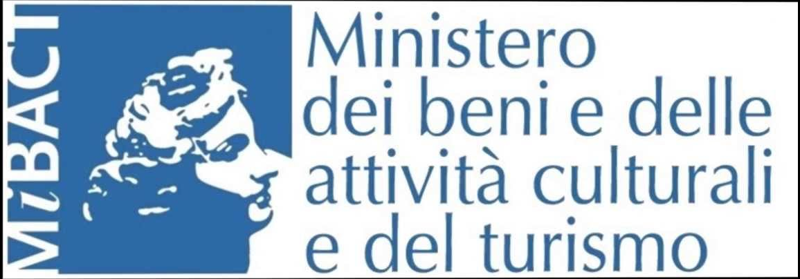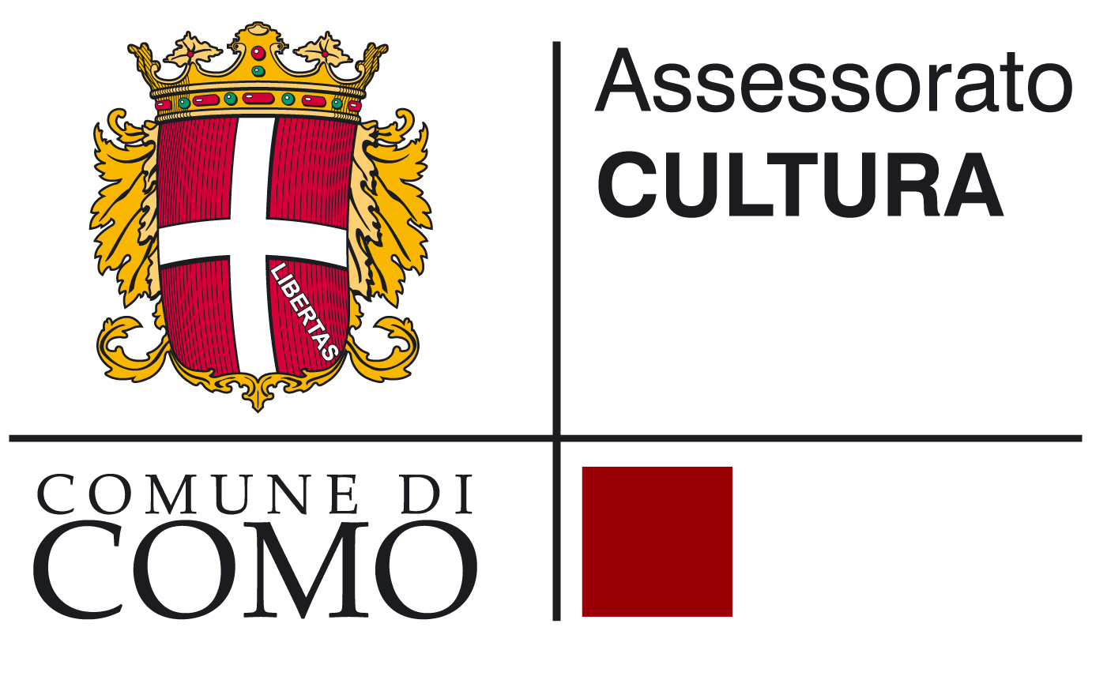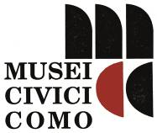

CHURCH OF ST. PETER IN ATRIO
Como, via Odescalchi

Prima di Como. Nuove scoperte archeologiche dal territorio
/
Before Como. New archaeological discoveries of the territory

curated by Lucia Mordeglia e Marina Uboldi

30 September - 10 November 2017

press release, 24.07.2017

From 30 September to 10 November, archaeological finds of great historical importance are on display for the first time in the picturesque Church of St. Peter in Atrio. They are the result of research carried out in Como over the last ten years.
The well-structured exhibition "Prima di Como. Nuove scoperte archeologiche dal territorio/Before Como. New archaeological discoveries of the territory" is organized by the National Trust, Archaeological Department, together with the City Museums of Como. Next to an overview of the last finds, the display shows the scientific innovations used on the most ancient stages of people’s settlements, which developed during the first millennium BC. It highlights the value and meaning of the rich archaeological heritage of the territory of Como before the foundation of the Roman settlement.

Funeral urns and vases for the offerings of unusual shapes, ornaments in bronze, iron, amber and coloured opaque glass, fashion accessories, amulets - all status symbols of ancient peoples -, and very precious weapons dating back to the so-called “Golasecca” protohistoric culture characterize the set-up of the exhibition. The display is also accompanied by photographs and hand-drawn reconstructions, videos and 3D images that, thanks to new technologies, provide in-depth information that is able to appeal to a wide public.
The main themes of the exhibition are: the grave goods from the first Iron Age coming from the digs in S. Fermo della Battaglia, Via per Mornago (2006) and in Grandate, that emerged in 2011 during the works for the new Pedemontana motorway; the enigmatic religious/monumental area of the New Hospital of Saint Anne (2007 dig), from the 6th century BC, which consists of a large circle with a diameter of 70m, circumscribed by a double fence of rocks and with a central hemicycle platform and seven different lithic and ground radials, the purpose of which is very difficult to identify; the holy repository from the Iron Age found on Mount Saint Zeno in Val d’Intelvi; the latest archaeo-biological data on the climate, vegetation and human consumption during the protohistoric age; and lastly the results of the new research by Prof. Bruno Chaume from the University of Bourgogne, who is the Director of the programme Vix et son Environnement/Vix and its Environment, on the ceremonial chariot from the 5th century BC at Ca’ Morta – he highlighted the close relationship with the contemporary Hallstattian chariots, found in Central Europe.

These latest finds contribute to enlarge the rich archaeological heritage of the proto-historic centre that came before the foundation of Como during the first Millennium BC. In fact, before the Roman city, the land features around the present city show the existence of villages and groups of houses: several finds and tomb remains prove it. In the following centuries, especially between the 6th and the 5th BC, the build-up area reached its maximum expansion and richness, developing especially along the south ridge of Spina Verde, the regional park that spreads on the hill ridge stretching North-West of Como. Essential for the development of the settlement is its role as a centre of contacts and exchanges among the Po Valley, which was permanently inhabited by the Etruscans, the Celtic World and the Hallstattian area (from the city of Hallstatt near Salzburg) in Central Europe.

The uninterrupted settlement of civilizations in the same area up until now, together with the increase of construction activities during the aftermath of WWII, has hidden or erased all signs of the ancient settlement. However, the effort for preservation of the National Trust, Achaeological Department, with the joint work of the City Administrations, has allowed the recovery of more and more testimonies from the past of the city and its inhabitants, thus guaranteeing their preservation.
Scientific research has recently taken advantage of the cooperation with important international study centres, such as CNRS (Centre National de la Recherché Scientifique/National Centre of Scientific Research) and the Universities of Berlin and Mainz. With this support, the research is now able to emphasise the role of the civilization of Golasecca under the relationships with other contemporary ones from the Mediterranean and Central Europe. Golasecca was a pre-Roman culture that developed in the first millennium BC in the territory of West Lombardy, East Piedmont, and the Swiss Canton of Ticino and originated from the location of Golasecca, on the Varese side of Ticino River.

The exhibition is also an invitation to visit the archaeological heritage of the city and its surroundings: the City Museums of Como - where the original Celtic chariot and the relics of the past finds in the necropolis of Ca’ Morta are preserved -; the Spina Verde Park; the Circle of Saint Anne’s Hospital; and, lastly, concerning the Roman period, the area of the thermal bath of Viale Lecco and the Pretoria Door.

The scientific consultants, authors of the texts in the catalogue that accompanies the exhibition, are public officials for archaeology and professionals with long curriculum vitae of studies in the field. The scientific project has been drawn up by Lucia Mordeglia - National Trust, Archaeological Department, Fine Arts and Landscape for the Provinces of Como, Lecco, Monza-Brianza, Pavia, Sondrio, Varese -, Marina Uboldi, City Museums of Como, Stefania Jorio, formerly in the National Trust, Archaeological Department for the Lombardy Region, with the cooperation of Marta Rapi, Professor of Prehistory and Protohistory at the University of Milan, Mauro Rottoli, Archaeology Laboratory of the City Museums of Como, and Mimosa Ravaglia, Archaeologist, Como.

Exhibition details
Title Prima di Como. Nuove scoperte archeologiche dal territorio/
Before Como. New archaeological discoveries of the territory
Curated by Lucia Mordeglia e Marina Uboldi
Venue Church of St. Peter in Atrio, via Odescalchi, Como
Dates 30 September - 10 November 2017
Opening hours Tuesday - Friday, h 15-18; Saturday and Sunday, h 10-18; Monday closed

Guided tours for schools are available only upon booking: Tuesday and Thursday, 10am-12pm.
Bookings at: Archaeological Society of Como, Piazza Medaglie d’Oro 6 - 22100 Como
Ph. +39 031 269022 - didattica@archeologicacomo.it

Entrance free

Info to the public Musei Civici di Como, Museo Archeologico “P. Giovio”
Piazza Medaglie d’Oro 1 - 22100 Como
Ph. +39 031 252550 - musei.civici@comune.como.it - uboldi.marina@comune.como.it

Press office
IBC Irma Bianchi Communication
Ph. +39 02 8940 4694 - mob. + 39 328 5910857 - info@irmabianchi.it
text and image downloads from www.irmabianchi.it

