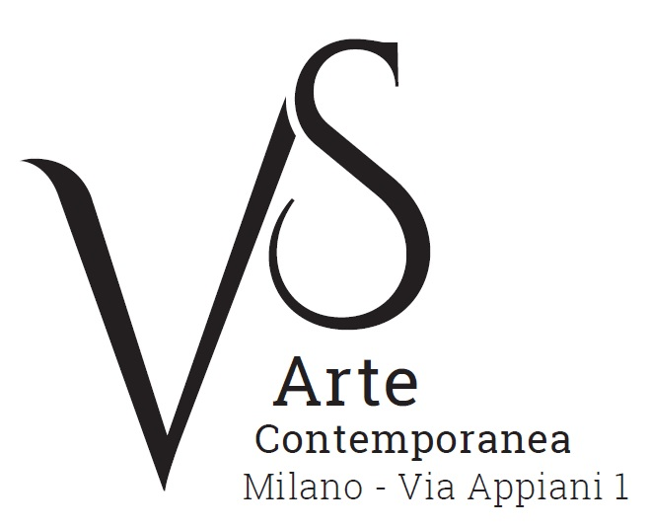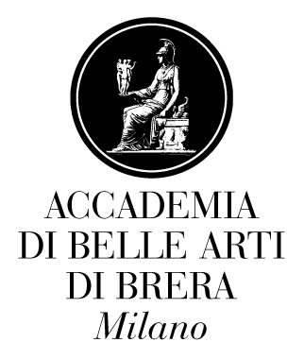

VS Arte
via Appiani 1, Milan

as an event of
ACCADEMIA APERTA 2017/OPEN ACADEMY 2017
Third Edition

Vs Arte hosts the group exhibition of young artists from the Academy of Fine Arts of Brera
curated by Omar Galliani

13 - 29 July 2017

From 13 to 29 July 2017 VS Arte Gallery of Milan, in cooperation with the Academy of Fine Arts of Brera, hosts a group exhibition curated by Omar Galliani as one of the events of the third edition of “Accademia Aperta/Open Academy”. It presents a series of works by young artists.

“Accademia Aperta/Open Academy” is an important project that aims to present the educational activities and research of the students from the several Schools of the Academy by displaying works at Palazzo Brera and – for the first time – in the city.
Omar Galliani, who is an internationally known artist, selected a group of works for VS Arte, made by the students from the Painting class of which he is the teacher.
Vincenzo Panza and Samantha Ceccardi, gallery owners of VS Arte, welcome the event: “We are honored to be part of this prestigious event that aims to discover and support new talents. We indeed reckon that one of the important goals of our Gallery is to give young artists the opportunity to make their works known to the public, by helping them to open themselves to a life-long career in the art world”.

The central theme that connects all the works on display is the shared desire for a return to manual skills. Even though they are made by using different ways of expression, that highlight the uniqueness and originality of the work of each artist, the works on display favour the use of traditional materials and techniques such as drawing, painting and intaglio.
The pencil drawings by Dario Baroli portray the moody face of the same character in an ingenious way, while the charcoal works by Elena Bisoglio evoke the moods of the human soul by using games of light and shadows. Lorenzo Brivio draws neoclassic figures, which are doubled on paper by using a particular technique: it uses sterile dressings. Instead Carolina Corno uses pyrography on leather: she repeatedly impresses her name as a sort of litany, in a gesture that conveys pain and strength at the same time.
Worth mentioning is Rachele Cicerchia's work, a still life made by using acrylic and engraving on canvas, that realistically represents hanging carcasses of butchered animals. More metaphysical is instead Mattias Fiorini's work made by using charcoal pencil on wood pulp cardboard: it concentrates on small details, water sparkles or transparent stones, that are enlarged and transformed into macrocosms.
On display the visitor can also admire the charcoal drawing on paper by Federico Soffiantini, the illustrations by Ginevra Tarabusi - which take inspiration from Luis Sepúlveda's The story of a seagull and the cat who taught her to fly. A work - tempera paint on board - by the Chinese artist Kaijia Zheng stands out: a polyptych of four elements, four human faces that are made vague by the abrasion of layers of applied paint.
Omar Galliani highlights: “The students I show you here are those with whom the connection has gone deeper. VS Arte kindly opened its spaces to these ‘signs’ that are connected to each other while still keeping their own individuality. It is a choice that is mainly grounded on the differences of their ways of expression and not their conformity”.

The display set-up is curated by Omar Galliani and a text written by him accompanies the exhibition.

VS Arte Exhibition Details
Title Accademia Aperta 2017/Open Academy 2017 – Third Edition
Venue VS Arte via Appiani 1 - 20121 Milan
Dates 13 - 29 July 2017
Opening Hours Tuesday - Saturday 15.30 - 19.30
Entrance free
Info to the public Ph. +39 335 8004220 - info@vsarte.it - www.vsarte.it

Event Details
Accademia Aperta 2017
Palazzo di Brera
13 July - 12 August 2017
Monday - Saturday, h 11.00-18.00
Free entrance

Press Office for VS Arte
IBC Irma Bianchi Communication
Ph. +39 02 8940 4694 - mob. + 39 328 5910857 - info@irmabianchi.it
text and image downloads from www.irmabianchi.it

Accademia di Brera Communication Office
Ph. +39 02 86955294 - comunicazione@accademiadibrera.milano.it
www.accademiadibrera.milano.it - facebook.com/Accademiadibelleartidibrera/

