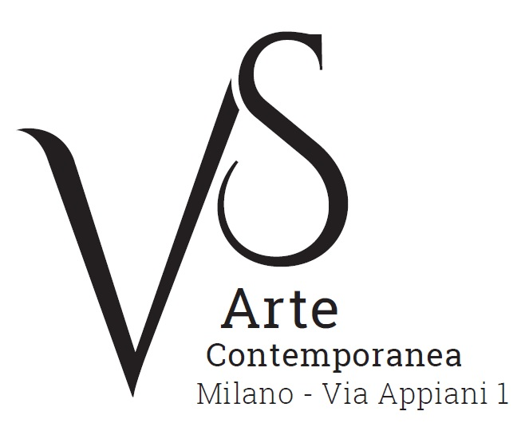

Roma: oltre la Pop Art e il Gruppo Uno
Opere di Biggi, Festa, Giosetta Fioroni, Mambor, Rotella, Schifano
/
Rome: beyond Pop Art and Group One
Works by Biggi, Festa, Giosetta Fioroni, Mambor, Rotella, and Schifano

9 June - 8 July 2017

press release, 16.06.2017

From 9 June to 8 July VS Arte Gallery of Milan presents the group exhibition “Roma: oltre la Pop Art e il Gruppo Uno. Opere di Biggi, Festa, Giosetta Fioroni, Mambor, Rotella, Schifano/Rome: beyond Pop Art and Group One. Works by Biggi, Festa, Giosetta Fioroni, Mambor, Rotella, and Schifano”: in about twenty meaningful works, the exhibition illustrates the important artistic moment that started in the 1960s.

The exhibition gathers the most recent productions by some of the main characters of Pop Art in Rome - Tano Festa, Giosetta Fioroni, Renato Mambor, Mimmo Rotella and Mario Schifano - and the founder of Group One, Gastone Biggi.

In the 1960s Piazza del Popolo in Rome was the location of gatherings and discussion of most of the representatives of the Italian Pop Art, which got its inspiration from the means of mass communication such as advertising billboards, cinema and television. The “School of Piazza del Popolo” differs from the American one in the fact that it also has a cultured dimension, originating from De Chirico’s metaphysics and surrealism. This is clear in the works on display: Nostalgia d’Africa/Nostalgia for Africa (2008) and Memorie di un benzinaio/Memories of a petrol pump attendant (2010) by Renato Mambor. Cavallo/Horse (from the 1970s) by Mario Schifano. The papers from the series Gli Argenti/Silvers (1960s) by Giosetta Fioroni. The enamel on canvas by Tano Festa and Marilyn by Mimmo Rotella.

Backing up the masters of the Italian Pop Art there is Gastone Biggi (Roma 1925 - Langhirano 2014), who in the 1960s was the main character of abstract art of Group One together with Giuseppe Uncini, Nicola Carrino, Achille Pace and others. Their working as a group represents a way out from the exasperation of individualism typical of the previous decade.
“We want to work in the consciousness and clarity of mind of our beings that really are a part of the world in the image and likeness of the systems at the base of the universe. A part that depersonalises the inner reality, deeply inside the laws of the world”, is written in the group’s manifesto, subscribed to by Biggi, Carrino, Frascà, Pace and Uncini in 1963. Group One rediscovers the idea of a precise sign in opposition to what is informal; of a sequence in opposition to the uniqueness of one gesture; of an appeal to rationality in opposition to instinctive irrationality. These features are clear in the works by Gastone Biggi, among which there are Racconto di una profondità/Tale of depth (1958), Primavera oscura/Dark Spring (1995) and Liberes (2010).
VS Arte was born in 2017 from the passion for art and collecting of its two founders, Vincenzo Panza and Samantha Ceccardi.
Vincenzo Panza has 30 years’ experience in the management of multinational companies and Samantha Ceccardi has been active in the organization of events and great shows for more than 20 years.
VS Arte is a new reality that combines art and economic dynamics in a unique venue, “Appiani Arte per Immagini” the prestige of which is tied to Alfredo Paglione, a well-known art dealer and patron of the arts, whose gallery has been the reference for all of the greatest artists in 1900s, nationally and internationally. It hosted prominent national masters such as Guttuso, Sassu, Manzù, Fontana and De Chirico, and great international ones such as Picasso, Rauschenberg, Grosz, Gropper and Levin. Its rooms have been a meeting place, dynamic and fruitful, for literates, musicians, and intellectuals of great calibre such as Raffaele Carrieri, Carlo Levi, Dino Buzzati, Salvatore Quasimodo, Leonardo Sciascia, Mario Luzi and Giuseppe Ungaretti. This place produced an osmosis between art and poetry, creating a rare, productive and creative environment that VS Arte, supported by Alfredo Paglione, wants to maintain with greatly acclaimed exhibitions and events in order to allow new artists to emerge and at the same time to celebrate the works by the great masters.
VS Arte’s projects focus on the preservation, management and celebration of works of art, the promotion and circulation of contemporary art and its development in Italy and abroad.

Exhibition details
Title Roma: oltre la Pop Art e il Gruppo Uno. Opere di Biggi, Festa, Giosetta Fioroni, Mambor, Rotella, Schifano/Rome: beyond Pop Art and Group One. Works by Biggi, Festa, Giosetta Fioroni, Mambor, Rotella, and Schifano
Sede VS Arte, via Appiani 1 - 20121 Milan
Date 9 June - 8 July 2017
Opening hours Tuesday - Saturday, 15.30 - 19.30
Entrance free
Info to the public Ph. +39 335 8004220 - info@vsarte.it - www.vsarte.it

Press Office
IBC Irma Bianchi Communication
Ph. +39 02 8940 4694 - mob. +39 328 5910857 - info@irmabianchi.it
text and image downloads from www.irmabianchi.it

