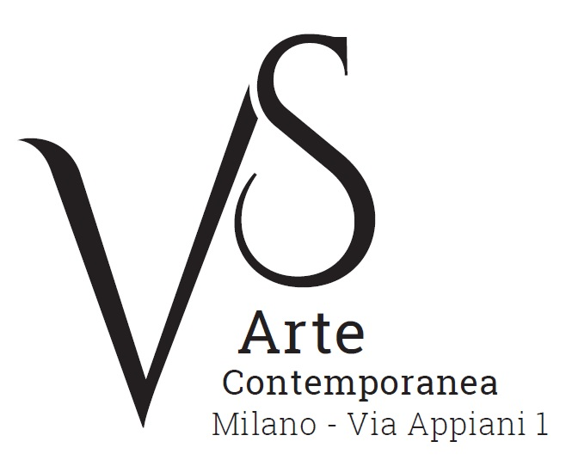

Luca Vernizzi. Spazio e solitudine/Luca Vernizzi. Space and solitude
curated by Chiara Gatti

5 May - 3 June 2017
opening Thursday 4 May, 6.30pm

press release, 14.04.2017

The VS Arte gallery of Vincenzo Panza and Samantha Ceccardi presents the solo exhibition Luca Vernizzi. Spazio e solitudine/Luca Vernizzi. Space and solitude, curated by Chiara Gatti, that is on display from 5 May to 3 June 2017.
The artist is back a few months after the exhibition that was on display last autumn at the Triennial of Milan, with a new lay out dedicated to the theme of the painted object.
In between the classic iconography of still nature and a conceptual reinterpretation of images, what stands out is a selection of about twenty recent works next to a group of papers, small drawings, independent preliminary designs and sketches where the object represents the alibi for an investigation into the surrounding space.

As a builder of unique shapes, master of synthesis and purity of lines that frame each element in a geometric rigor, in the footsteps of Cézanne, Vernizzi looks at reality in search of those particular rules that control the visible: a Cartesian system, a metric structure, an imperceptible grid on which constellations of apples or peaches are placed like stars in a household galaxy.
The look at working life, everyday existence and the hints at the suspension of time in the rooms of memory, they are all macro-themes that crown the artist's main need to give order and value to pure forms. Each “withdrawal” stolen from the shelves of a kitchen, of a under-stairs cupboard, is projected in an unlimited dimension. Cardboard boxes, open umbrellas, chairs, laundry and shirts become abstract presences, that are cut out in the empty rarified and dazzling surface of a white canvas or board.
Chiara Gatti says: “The syntax of the composition is dominated by iconic bodies, which are never didactic, never narrative. Vernizzi is not chasing a story, but the essence of things in their eternal loneliness. And he reflects on the mechanisms of vision, on the nature of the gaze lost in the distance, he goes into depth; he thinks on the broad breath of air, on the air that revolves around matter. He needs this air in his cold way of proceed, as if the weight of the object, its physical presence, intensified its own stature in proportion to the space and silence that engulfs it. The more the space, the more the solemnity”.
In this idea one can perceive the inheritance of the Italian metaphysical painting, joined to a certain cult of the object in itself; it reminds the viewer of the English pop art, of the tables and chairs by David Hockney (Giovanni Testori also mentioned Peter Blake) to which the artist is connected also by the portraits, some of which are on display in the exhibition. Presented with the same rigorous lexicon of the objects, they are parallel universes, suspended entities in waiting, figures that are hypnotic and isolated in their own solitude.

A catalogue in Italian and English with a critical text by Chiara Gatti accompanies the exhibition.

Short Biography. Luca Vernizzi was born in Santa Margherita Ligure in 1941, even though he now lives and works in Milan. His first exhibition took place at the Pagani Gallery in 1968; before that he had worked for a few years as an art critic for the newspaper “Corriere della Sera” where he worked together with Leonardo Borgese. Later, while teaching at the Academy of Brera, he dedicated himself to artistic research, continuing his literary activity by publishing aesthetic reflections and lyricisms. Exhibitions of his works are set up in public as well as private venues, in Italy and abroad. Worth mentioning are the exhibitions at Arengario of Milan, which is now known as Museo del Novecento (the 1900 Museum), with the patronage of the Council (1979), in Beijing, in the Archives of the Forbidden City, with the patronage of the Culture Department of the Popular Republic of China (1996), at the Borges Cultural Centre of Buenos Aires, promoted by the Embassy (2004), the installation of the monument in honour of Pope John Paul II, the installation at the Sanctuary of Divine Love in Rome (2011). In the Autumn of 2016 his works were on display in the solo exhibition “L’inerenza e l’altrove/Pertinence and elsewhere” at the Triennial of Milan, introduced by texts by Sandro Mancini, Elena Pontiggia and Elisabetta Sgarbi.

VS Arte was born in 2017 from the passion for art and collecting of its two founders, Vincenzo Panza and Samantha Ceccardi.
Vincenzo Panza has 30 years’ experience in the management of multinational companies and Samantha Ceccardi has been active in the organization of events and great shows for more than 20 years.
VS Arte is a new reality that combines art and economic dynamics in a unique venue, “Appiani Arte per Immagini” the prestige of which is tied to Alfredo Paglione, a well-known art dealer and patron of the arts, whose gallery has been the reference for all of the greatest artists in 1900s, nationally and internationally. It hosted prominent national masters such as Guttuso, Sassu, Manzù, Fontana and De Chirico, and great international ones such as Picasso, Rauschenberg, Grosz, Gropper and Levin. Its rooms have been a meeting place, dynamic and fruitful, for literates, musicians, and intellectuals of great calibre such as Raffaele Carrieri, Carlo Levi, Dino Buzzati, Salvatore Quasimodo, Leonardo Sciascia, Mario Luzi and Giuseppe Ungaretti. This place produced an osmosis between art and poetry, creating a rare, productive and creative environment that VS Arte, supported by Alfredo Paglione, wants to maintain with greatly acclaimed exhibitions and events in order to allow new artists to emerge and at the same time to celebrate the works by the great masters.
VS Arte’s projects focus on the preservation, management and celebration of works of art, the promotion and circulation of contemporary art and its development in Italy and abroad.

Exhibition details
Title Luca Vernizzi. Spazio e solitudine/Luca Vernizzi. Space and solitude
Curated by Chiara Gatti
Venue VS Arte, via Appiani 1 - 20121 Milan
Dates 5 May - 3 June 2017
Opening Thursday 4 May, 6.30pm
Opening Hours Tuesday to Saturday 3.30pm - 7.30pm
Entrance free
Info to the public Ph. +39 335 8004220 - info@vsarte.it - www.vsarte.it

Press Office
IBC Irma Bianchi Communication
Ph. +39 02 8940 4694 - mob. +39 328 5910857 - info@irmabianchi.it
text and image downloads from www.irmabianchi.it

