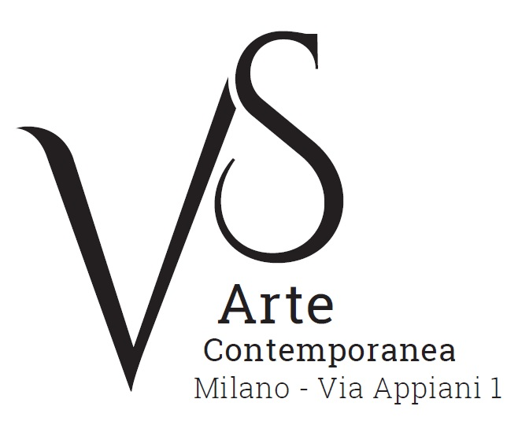

“VS Arte” opens in Milan
at the “Appiani Arte” historical venue
with the exhibition

Aldo Damioli. Città della mente/Aldo Damioli. Cities of the mind
curated by Elena Pontiggia

10 March - 9 April 2017
grand opening on Thursday, 9 March at 6.30pm

press release, 8.02.2017

VS Arte, founded by Vincenzo Panza and Samantha Ceccardi, lauches its exhibition programme in Alfredo Paglione’s “Appiani Arte” historical venue in Milan in order to offer a strong point of reference for lovers of modern and contemporary art, nationally and internationally.

The important solo exhibition “Aldo Damioli. Città della mente/Aldo Damioli. Cities of the time” curated by Elena Pontiggia opens a series of events and presents an anthology of Damioli’s recent works on display until the 9th April.
Aldo Damioli (Milan, 1952) is among the main representatives of conceptual painting that originates from De Chirico’s metaphysics; in his works he paints imaginary cities, contemporary metropolises that are architecturally extremely plausible, but each one characterized by a specific aesthetic code that puts them into crystallized dimensions, creating environments outside reality which live in the artist’s mind.
These urban landscapes, which are characterized by a clever use of lights and geometrical forms, still in their grandeur, are the background for scenes of daily life: in them, the human element seems almost engulfed in a Zen state - serene, silent and suspended in an eternal present.

The twenty works on display are made by using acrylic on canvas – from 40x50cm up to 2m – and are united by the same theme “Città della mente/Cities of the mind”: they illustrate visionary worlds. This is easily seen in the representations of New York, which is painted as it were Venice and transformed into a sort of non-place and non-time, so much as to seem real. An example of it is the work Venezia New York/Venice New York (2013) where the lights of New York buildings at night illuminate a group of people on board a few boats.
The city of Milan is always observed at night. In Milano/Milan (2015), a truck goes through the dark streets of the historical centre, overshadowed by modern skyscrapers. Portraying Paris, Damioli revives the atmospheres that were celebrated in the French chansonniers’s songs (A Parigi/In Paris, 2015), while in the paintings of Chinese cities the themes relate more to the geometry of Tao (Pechino/Beijing, 2016).

Elena Pontiggia says: “A lot has been said about Damioli’s modern connection with Canaletto in his ‘Venice-New York’ works, but his ideal masters can also be the enlightened Eighteenth-century or the art in-between the German New Objectivity and the magic realism typical of Donghi, both reinterpreted with a hint of irony”.

A catalogue accompanies the exhibition with the reproductions of the main works on display together with a text by Elena Pontiggia.

VS Arte was born in 2017 from the passion for art and collecting of its two founders, Vincenzo Panza and Samantha Ceccardi.
Vincenzo Panza has 30 years’ experience in the management of multinational companies and Samantha Ceccardi has been active in the organization of events and great shows for more than 20 years.
VS Arte is a new reality that combines art and economic dynamics in a unique venue, “Appiani Arte per Immagini” the prestige of which is tied to Alfredo Paglione, a well-known art dealer and patron of the arts, whose gallery has been the reference for all of the greatest artists in 1900s, nationally and internationally. It hosted prominent national masters such as Guttuso, Sassu, Manzù, Fontana and De Chirico, and great international ones such as Picasso, Rauschenberg, Grosz, Gropper and Levin. Its rooms have been a meeting place, dynamic and fruitful, for literates, musicians, and intellectuals of great calibre such as Raffaele Carrieri, Carlo Levi, Dino Buzzati, Salvatore Quasimodo, Leonardo Sciascia, Mario Luzi and Giuseppe Ungaretti. This place produced an osmosis between art and poetry, creating a rare, productive and creative environment that VS Arte, supported by Alfredo Paglione, wants to maintain with greatly acclaimed exhibitions and events in order to allow new artists to emerge and at the same time to celebrate the works by the great masters.
VS Arte’s projects focus on the preservation, management and celebration of works of art, the promotion and circulation of contemporary art and its development in Italy and abroad.

Aldo Damioli was born in 1952 in Milan, where he lives and works. He took part in several important exhibitions in Italy and abroad: in 2001 at the Gallery of Modern Art in Bologna, in 2002 at the Museum of Modern Art in Budapest, in 2005 at the 2nd Biennial of Beijing. From 2005 on, he exhibited in the MARCOROSSI - Spirale Arte - galleries in Milan, Verona and Monza and took part in Fuori tema Italian feeling, 14th Quadrennial, at the Museum of Fine Arts of Rome and in 2006 in Ironica. In 2007, he was invited to take part in two group exhibitions in Milan: Nuovi pittori della realtà at Pac, and Arte italiana 1968-2007 at Palazzo Reale, both curated by Maurizio Sciaccaluga. In 2011, he took part in the 54th Biennial of Venice; in 2012, in the Biennial Italy-China at Villa Reale in Monza; in 2015 he exhibited at the 56th Biennial of Venice. Again, in 2015 he took part in the exhibition Figure Luminose at the Castle of Belgioioso, and in 2016 in Identità Metropolitane at Villa Clerici, both organized by Vera Agosti.

Exhibition details
Title Aldo Damioli. Città della mente/Aldo Damioli. Cities of the mind
Curated by Elena Pontiggia
Venue VS Arte at “Appiani Arte” historical venue, via Appiani 1 - 20121 Milan
Dates 10 March - 9 April 2017
Grand opening Thursday, 9 March at 6.30pm
Opening hours Tuesday to Saturday, 3.30pm-7.30pm
Entrance free
Info to the public Ph. +39 335 8004220 - info@vsarte.it - www.vsarte.it

Press Office
IBC Irma Bianchi Communication
Ph. +39 02 8940 4694 - mob. +39 328 5910857 - info@irmabianchi.it
text and image downloads from www.irmabianchi.it

