sequela

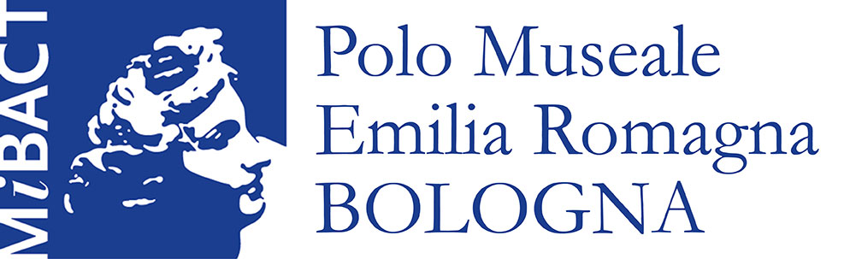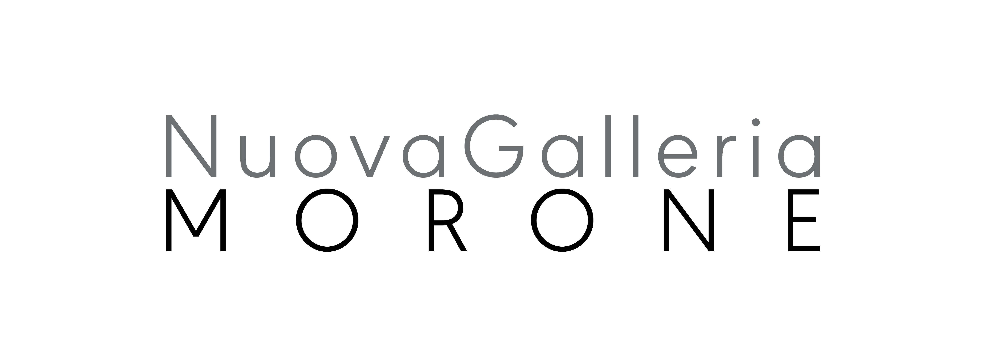

EX Church of San Mattia
Via Sant'Isaia, 14 – Bologna

SEQUELA
curated by Leonardo Regano
from January 28th to February 12th 2017

press release, 16.01.2017
In the evocative location of the Ex Church of San Mattia, in Bologna, is organized the group show “Sequela”, from January 28th to February 12th, promoted by the Polo Museale dell'Emilia Romagna and Nuova Galleria Morone of Milan.
The exhibition, curated by Leonardo Regano, originates from a secular reflexion on the sense of the sacred in contemporary life, and on how the connection with spirituality is now lived and told by visual art. The title chosen, stemmed from the Gospel, refers here to Bonhöffer's text “The Cost of Discipleship” (1937), as it recall from the German theologian, the need to have a less dogmatic relation with religion, and to be closer to biblical revelation. The need of a private but direct contact with religiosity, that allows to overcome the crisis of value that Occidental culture endures now.
The visual arts, touchstone of an ever-changing society, have since now understand this new need of spirituality. “Sequela” is a encounter between three generation of artists, chosen to tell how this approach to the sacred and to spirituality have been lived and have changed during the past forty years.
In this dialogue between different languages and creative experiences, the Ex Church of San Mattia offers important reflection points to the artists involved, which can help them temper their work, also regarding the hosting place.

Artists involved:
Bill Viola, Gencay Kasapçi, Maria Cristina Carlini, Daniela Comani, Davide Benati, Fausta Squatriti, Letizia Cariello, Elisabeth Scherffig, Julia Krahn, Domenico Grenci, Francesco Diluca, Giulia Dall’Olio, Elizabeth Aro, Maria Lai, Maurizio Osti, Mariella Bettineschi.
On Saturday 28th January, will be presented the performance of Julia Krahn at 8.00 PM.

Exhibition's information:
Title: SEQUELA
Curated by Leonardo Regano
Organizated by: Polo Museale dell’Emilia Romagna , Nuova Galleria Morone, Milano
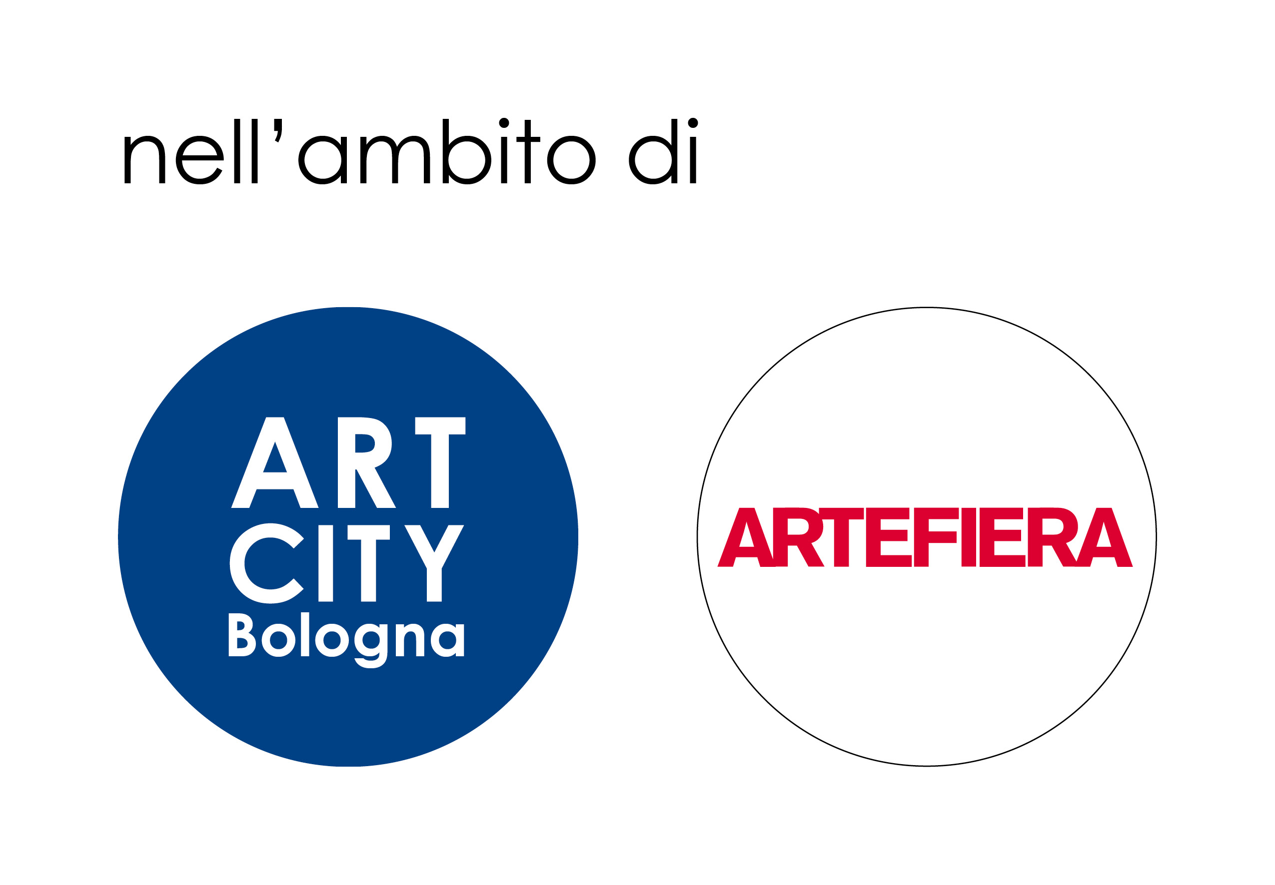
Location: Ex Chiesa di San Mattia via Sant’Isaia 14 - Bologna
Date: January 28th – February 12th 2017

Timetable
Inauguration Friday 27th January at 6.30 PM for invitation only
Saturday 28th January 10-24 PM; Sunday 29th January 10-20 PM;
from Thursday to Sunday 16.00 – 20.00 PM, other days on appointment

Free Entrance
Information and reservations
URP - Ufficio Segreteria e Relazioni con il Pubblico Polo Museale Emilia Romagna
tel. 051 4209467 - fax 051 251368 e-mail: pm-ero.urp@beniculturali.it

Nuova Galleria Morone
via Nerino, 3 20123 Milan, Italy
tel. 02 72001994 fax. 02 72002163
info@nuovagalleriamorone.com

Press office
Polo Museale Emilia Romagna tel. 0514209406 - pm-ero.urp@beniculturali.it

for Maria Cristina Carlini:
IBC Irma Bianchi Communication Tel. +39 02 8940 4694 - mob. + 39 328 5910857 - info@irmabianchi.it For texts e images www.irmabianchi.it

Thanks to
LabOratorio degli Angeli Srl, via degli Angeli 32 - 40124 Bologna for the technical support for the set up
Letizia Cariello thanks Galleria Massimo Minini, Brescia
Giulia Dall’Olio thanks Massey Luben Gallery, New York and Galerie Isabelle Lesmeister, Regensburg
Daniela Comani thanks galleria Studio G7, Bologna

