Event organized on the occasion  of the Giornata del Contemporaneo | 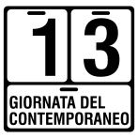 | promoted by AMACI | 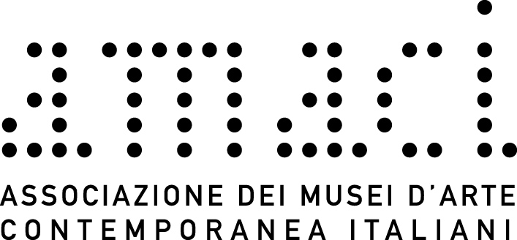

ARTE IN STUDIO. MARIA CRISTINA CARLINI
via Savona 97, Milan

Saturday 14 October 2017, from 10am to 7pm

AMACI
Giornata del Contemporaneo / The Day of Contemporary Art

press release, 27.07.17

On the occasion of the 13th Giornata del Contemporaneo / Day of Contemporary Art promoted by AMACI - Association of Italian Museums of Contemporary Art, the artist Maria Cristina Carlini Saturday 14 October 2017 from 10am to 7pm welcomes the public with guided tours to her studio, a former industrial building in the Tortona district in Milan, transformed into a large loft with two outdoor gardens.
For the occasion the sculptress presents her latest creations, as well as her early works. In the gardens the visitor can admire the large sculptures, while in the evocative interior, where there are two furnaces for ceramics, medium and small size sculptures and works on paper are mainly displayed.
During the visit it is also possible to consult several publications that have accompanied the international artistic career of Maria Cristina Carlini from the Seventies up to today.
On display there are also videos showing on a loop the monumental works permanently installed in the world with commentaries by Martina Corgnati, Camillo Fornasieri, Gino Di Maggio and Philippe Daverio.
The exhibited works highlight the artist’s close relationship with nature and its elements, which have always been a source of inspiration for her art, also characterized by the constant experimentation of different materials - such as stoneware, iron, corten steel, salvaged wood and resin - that give life to works of extreme strength and essential shapes that hint at the earth, at man, at his history and evolution.

Short biography. The sculptress Maria Cristina Carlini started to work with stoneware in Palo Alto, California, after that she extended her artistic research. She exhibited in important solo and group exhibitions in private and public venues, nationally and internationally. Her sculptures are permanently on display on three continents: Europe, America and Asia.
Among the latest monumental sculptures placed permanently are: La nuova città che sale/The new rising city, presented by Philippe Daverio, located at Fiera Milano Rho on the occasion of Expo 2015 and Vento/Wind permanently exhibited at the Parco dell’Arte at Idroscalo (Milan).
Several publications have marked the artistic career of Maria Cristina Carlini and leading critics wrote of her, such as: Luciano Caramel, Claudio Cerritelli, Martina Corgnati, Gillo Dorfles, Carlo Franza, Flaminio Gualdoni, Yakouba Konaté, Elena Pontiggia.
Maria Cristina Carlini lives and works in Milan. www.mariacristinacarlini.com

Event details
Title Arte in Studio. Maria Cristina Carlini
On the occasion of the 13th Giornata del Contemporaneo / Day of Contemporary Art promoted by AMACI
Venue Studio Maria Cristina Carlini, via Savona 97 - Milan
Date Saturday 14 October 2017, from 10am to 7pm
Entrance free
Info to the public mob. +39 328 5910857 - info@irmabianchi.it

Press office for Maria Cristina Carlini
IBC Irma Bianchi Communication
Ph. +39 02 8940 4694 - mob. +39 328 5910857 - info@irmabianchi.it
text and photo downloads from www.irmabianchi.it

