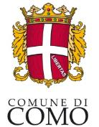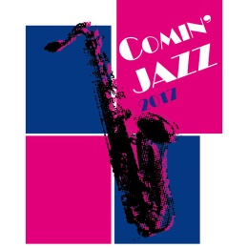

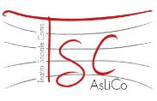 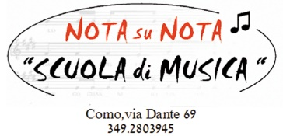 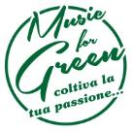…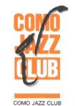

COMIN’ JAZZ 2017
Jazz music festival of the city of Como

9 - 15 March 2017

press release, 24.02.2017

An extraordinary week of music takes over Como with Comin’ Jazz, a jazz music festival. The festival, which is on its first year, involves the whole city - from Thursday, 9 March to Wednesday, 15 March -, thanks to its rich agenda of events and concerts. It is directed towards the genre lovers, as well as the newbie. Also, part of the programme is intended for schools.

Luigi Cavadini, the council member in charge says “The Department of Culture of the Council of Como, in co-operation with Teatro Sociale, Nerolidio Music Factory, Nota su Nota, Music For Green, and the Jazz Club of Como, devised Comin’ Jazz in order to revamp the musical calling of the city, support the local talents and bring to Como internationally known musicians, within the dynamic and creative contest of a Festival”.

Also, Como can count on a well established tradition of jazz, as already in the 1980s and 1990s great international artists played in its squares and theatres. In the following years, many musicians from the region trained and specialized in this genre, especially thanks to professionalism of the Conservatory of Como and other music schools.

The scheduled events offer an exciting variety of approaches and interpretations of this kind of music.

The present first year of the Festival coincides with the centenary of the publication of the first jazz record, "Livery Stable Blues" by Original Dixieland Jass Band of Nick La Rocca, who was the son of an Italian emigrant in Louisiana. This date symbolizes the birth of jazz, a musical genre that could already be heard a few years earlier in the black quarters of New Orleans.

Comin’ Jazz was born in partnership with the Festival di Cultura e Musica Jazz/Festival of Culture and Jazz Music of Chiasso that will take place on 16-18 March 2017 and that this year will celebrate its 20th anniversary.

For the occasion of the Festival, the Council of Como has organized and promoted Aperitivi in Jazz/Happy hour in jazz, collateral events that will take place in the city clubs.

EVENTS
- Thursday 9 March h 20.30 - Teatro Sociale
GAVINO MURGIA MEGALITICO QUARTET
- Friday 10 March h 21.30 - Nerolidio Music Factory
TSUNAMI TRIO, special guest Emanuele Cisi
- Saturday 11 March h 18 - Chiostrino di Sant’Eufemia
DISNEY JAZZ SONG CON I BLUE VIBE, presentation by Alceste Ayroldi
- Sunday 12 March h 14 and 20.30 - Teatro Sociale
IL CANTO DEL RITMO, masterclass and concert by Enzo Zirilli, Jason Rebello, Marco Micheli
- Sunday 12 March h 18 - Chiostrino di Sant’Eufemia
LA RIVOLUZIONE DI UN INCONTRO, rendez vous ’59 Miles Davis & Bill Evans
- Monday 13 March h 9.30 - Nota su Nota
LA STORIA DEL JAZZ, for schools
- Monday 13 March h 20.30 - Teatro Sociale
film YO-YO MA E I MUSICISTI DELLA VIA DELLA SETA
in co-operation with I lunedì del cinema
- Tuesday 14 March h 21.30 - Nerolidio Music Factory
PERCUSSION STAFF
- Wednesday 15 March h 21.30 - Nerolidio Music Factory
MARCO BIANCHI LEMON QUARTETT

APERITIVI IN JAZZ/HAPPY HOUR IN JAZZ
COMO CLUBS
- Thursday 9 March from h 19 - BeBop Caffè, via Pasquale Paoli 51
MINA IN JAZZ, curated by Nota su Nota
- Thursday 9 March from h 19 - Fresco, viale Lecco 23
PAOLO TOMELLERI DUO
- Friday 10 March from h 19 - Il Gap, via Sirtori 12
CECILIA CASELLA DUO
- Friday 10 March from h 19 - I giardini di Tavà, via Dottesio 1
BEBOP A LULA SWING ALL AROUND
- Friday 10 March from h 19 - Caffè Mazzini, piazza Mazzini 13
ALESSANDRA POZZI DUO
- Friday 10 March from h 19 - Ox, piazza De Gasperi 6
THE LIVING EMERALD TRIO
- Friday 10 March from h 19 - Cava dei sapori, via Guido da Como 2
GIULIA LARGHI TRIO
- Friday 10 March from h 19 - Bistrot, viale Geno
HYDE &SEEK QUARTET
- Saturday 11 March from h 19 - BeBop Cafè, via Pasquale Paoli 51
WET BLUES FEELINGS
- Saturday 11 March from h 19 - Vintage Jazz, via Olginati 14
MICHELE BOZZA DUO
- Saturday 11 March from h 19 - Bistrot, viale Geno
JAM SASSION BY GIUSEPPE EMMANUELE TRIO
- Sunday 12 March from h 19 - Al Quaranta4, via D’Annunzio 44
GIGI CIFFARELLI &CO.
- Wednesday 15 March from h 19 - Al Quaranta4, via D’Annunzio 44
LAURA FEDELE TRIO
- Wednesday 15 March from h 19 - Vintage Jazz, via Olginati 14
ANTONIO CERVELLINO TRIO
- Wednesday 15 March from h 19 - Arte dolce Lyceum, via Cesare Cantù 36
SABRINA OLIVIERI DUO
- Wednesday 15 March from h 19 - Il Gap, via Sirtori 12
DJ SET SWING AL AROUND

Festival Details
Title Comin’ Jazz 2017
Dates 9 - 15 March 2017

Info to the public Ufficio Cultura Comune di Como
Ph. +39 031 252451/472 - cultura@comune.como.it
full programme on www.visitcomo.eu

Press office
IBC Irma Bianchi Communication
Ph. +39 02 8940 4694 - mob. + 39 328 5910857 - info@irmabianchi.it
text and photo downloads from www.irmabianchi.it

