Fiat Chrysler Motor Village
London

Laura Zeni
MOVEMENT

6 - 18 October 2015
opening Thursday 8 October, from 6pm to 9pm
the artist will be at the exhibition along with live music and refreshments

press release, 02.10.15
On the occasion of the important launch of the new FIAT 500 on the English market, Fiat Chrysler Motor Village, with the coordination of Monica Colussi, has invited the artist Laura Zeni to exhibit her works in London, in the exhibition space in Wigmore Street: from 6 to 18 October they will host the exhibition “Laura Zeni. Movement”, accompanied by a critical text curated by Sveva Manfredi Zavaglia.

After the success of her recent exhibitions in the British capital, Laura Zeni presents a group of about 40 works, some of which are never seen before and made especially for this extraordinary occasion. The works on display - works on canvas, on paper, installations, sculptures and design objects - highlight the importance of movement, harmony of lines and colours consistent with the new FIAT 500.
It is a dynamism that the artist expresses through her constant investigation on man, his frames of mind, his relationship with the world and nature; she conveys it through her typical profiles, the lively cutouts of bodies and the stylised forms, made up of geometrical elements, repeating and intertwining themselves in crammed compositions.
This is how the exhibition layout is born, where the large diptych Movement (2015) stands out: a patchwork of colours in evolution that reminds the visitor of movement and speed, two elements that are also present in the acrylic pieces on paper from the series with the same name (there quick monochromatic strokes give life to dynamic results).
The London exhibition is enriched by the never seen before vases of Moving Pots (2015), made of salvaged Plexiglas, in tune with the artist's philosophy that focuses on the respect for nature and environmental sustainability, such as the small iron frames of Radar (2014-2015) and the table Moving (2015).
A video, also visible from the outside, illustrates the key moments of Laura Zeni's artistic career.
In the works from the series Trame/Weaves (2013) the accuracy of details gives life to balanced and attuned surfaces, while Ritratti interiori/Inner portraits (2012), profiles of heads animated by thoughts and states of mind, represent the invitation by the artist to adopt a conscious behaviour in the several fields of life and, for this exhibition, a plea to "guidare con la testa/drive with one's own head".

In regard to Laura Zeni's works Sveva Manfredi Zavaglia says in her critical text: “There is no doubt about the magic, cheerfulness and the almost dreamy poetic sweetness of the artist's images. Her works on display are never an end unto themselves; they show an ease in the use of different techniques, such as painting, design, graphics and installation, that together contribute to reveal the image. She often uses a range of basic or black and white colours, rhythmic and simple strokes, mixed techniques rich in melodies and romantic elements: small and large canvases, acrylic on canvas, paper and sculpture. The intentional repeating element - almost reliable but never predicted - brings the viewer to reflect light-heartedly, and is full of mystical and philosophical reflections. It is an imaginary surrealist approach which doesn't fail to describe the most hidden feelings of the human soul lightly but with a strong visual and emotional effect”.

The artist will be at the launching to meet and greet the public; tasty refreshments will be available and there will be live music to enjoy by DJ Alexis that will liven up the evening.

Short Biography
Laura Zeni, born in Milan, graduates from the Accademia di Brera and takes part in several exhibitions in Italy. In 2008 she is at the “Fuori Salone del Mobile” and in 2012 she opens a solo exhibition curated by Fortunato D'Amico at Superstudio Più in Milan, accompanied by a catalogue published by Skira. In 2013 she exhibits at the Spazio Tadini in Milan and takes part in the collective show at Macs - Mazda Con-Temporary Space in Milan; she takes part in the “Fuori Salone del Mobile” at Superstudio13 and in AAM at the Eventiquattro location of Sole24Ore. She also exhibits in Alba (Cuneo) and at the Spoleto International Art Fair 2013.
In 2014 she is at the Town Hall in Cremona with a personal exhibition and participates at “Arte Fiera Cremona” with Galleria Scoglio di Quarto. During the Milan Design Week 2014 she is at Superstudio Più at the event “Double Room” by Porcelanosa Grupo and at the Temporary Museum for New Design. In the same year at the Triennale di Milano she holds a solo exhibition curated by Fortunato D’Amico; she is invited at the group exhibition at the Priamàr Fortress in Savona, in the International Festival Art Expo Spoleto 2014 and at Spazio Tadini in Milan. In 2015 she is the first artist to hold a personal exhibition at Oscar Farinetti’s Eataly Smeraldo in Milan; she is also present at DAI Studio in Rome and Spazio Tadini in Milan with personal exhibitions. In the same year she exhibits in London at La Galleria Pall Mall, ArtMoorHouse and Le Dame Art Gallery. She takes part in the Biennale Italia-Cina in Turin. www.laurazeni.it

The exhibition is made thanks to the intervention of the following sponsors: Triphylla, SAID, Pixartprinting and Cantina Santadi

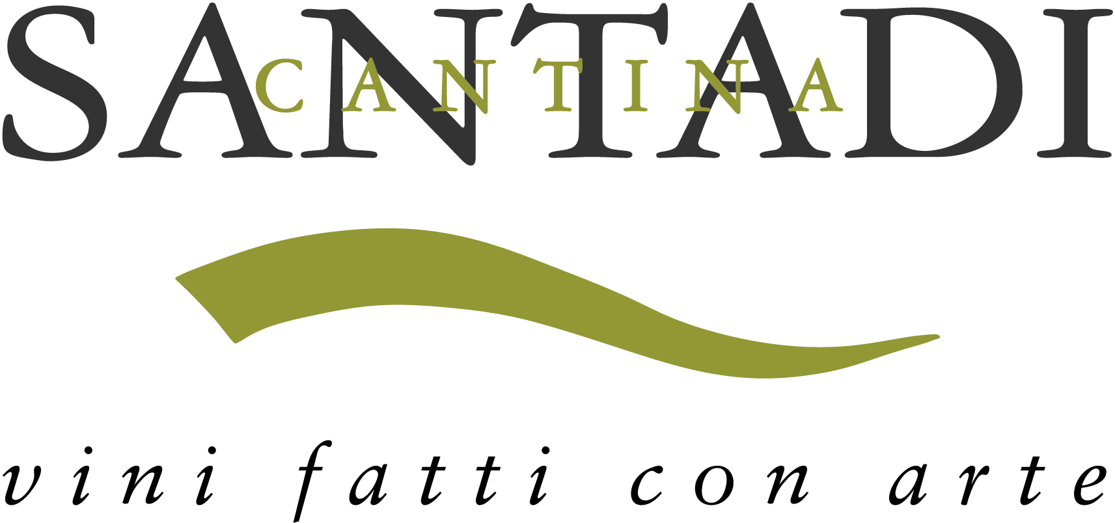

Special thanks to Dj Alexis

Details
Title Laura Zeni. Movement
Venue Motor Village Marylebone - 105 Wigmore Street - London W1U 1QY
Dates 6 - 18 October 2015
Opening Thursday 8 October, from 6pm to 9pm
Entrance free
Hours Mon - Fri h 10am-5pm, Saturday and Sunday by appointment only h 11am-3pm
Info Ph. +44(0)7802 647424 - monicacolussi@me.com
Ph. +44 (0)020 7399 6650 - www.motorvillageuk.com

Artist Liaison
Monica Colussi Ph. +44(0)7802 647424 - monicacolussi@me.com

Press Office for Laura Zeni
IBC Irma Bianchi Communication
Ph. +39 02 89404694 - info@irmabianchi.it
text and image downloads from www.irmabianchi.it

