Organized by In cooperation with
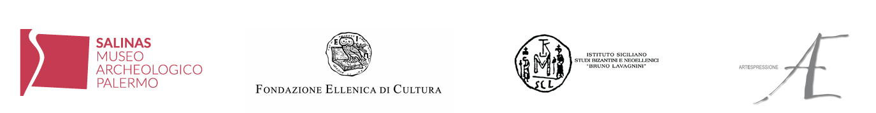

REGIONAL ARCHAEOLOGICAL MUSEUM “ANTONINO SALINAS”
Palermo, Piazza Olivella 24

VENIA DIMITRAKOPOULOU
PRIMORDIAL FUTURE
Matter

curated by Afrodite Oikonomidou and Matteo Pacini
with critic text by Franco Fanelli

16 November 2018 - 3 February 2019

Thursday, 15 November
Press Preview with the artist at 11:30am
Grand opening at 6:00pm

press release, 13.11.2018

The Greek sculptress Venia Dimitrakopoulou returns to Italy with a unique solo exhibition hosted by the Regional Archaeological Museum “Antonino Salinas” of Palermo from 16 November 2018 to 3 February 2019, titled “Venia Dimitrakopoulou. Primordial future – Matter”.

The complex creative world of the artist is portrayed at the Salinas Museum, through a remarkable selection of works - sculptures, papers and installations, some of which are displayed for the first time - in an exhibition, curated by Afrodite Oikonomidou and Matteo Pacini, which creates a dialogue with the archaeological collections displayed permanently in the museum halls. The Salinas Museum is indeed the oldest museum in Sicily and hosts the most important public collection dedicated to Greek and Punic arts on the island. Under the guidance of its Director, Francesca Spatafora, in the last few years the museum has broadened its scope to include contemporary art forms.
The entire project is under the auspices of the Hellenic Ministry of Culture and Sports, the Embassy of Greece in Rome, the National Museum of Contemporary Art - Athens (EMST), the Department for Cultural Heritage and Sicilian Identity - Sicily Region and the City of Palermo. It is also part of the events within the project ‘Palermo - Italian Capital of Culture 2018’.

The Palermo exhibition is the first part of the Italian Trilogy (Trilogia Italia), which is organized by the Hellenic Foundation for Culture – Italy in cooperation with the Sicilian Institute of Byzantine and Modern Greek Studies “Bruno Lavagnini” and the art gallery Artespressione of Milan, representing the artist in Italy during this event which will also visit Turin and Trieste. The exhibition, which will present site-specific works, especially created for each city, will be held in important exhibition sites: in addition to the SALINAS MUSEUM of Palermo, there are the GALLERY of the SANDRETTO RE REBAUDENGO FOUNDATION in Turin, from 22 February to 31 March 2019, then the SARTORIO MUSEUM and SAN GIUSTO CASTLE in Trieste, from 12 April to 14 June 2019.
The “Trilogy” highlights the theme running through the whole artistic production of the Greek sculptress: the continuous dialogue between the past and the present, starting from the rich archaeological heritage that bonds the Greek culture to that of Italy. Hence, the title “Primordial Future” expanded with a specific subtitle for each of the three exhibitions: in Palermo it is “Matter”, in Turin “Logos” and in Trieste “Sound”. «The three exhibitions – the artist clarifies – are connected by the same thread, the one I hold tight in my hand so as not to get lost and which here I call “Primordial Future”. This thread comes from the depths of time, and conscious of the present, I feel that it can lead us to the future, making it a bit less uncertain».

Matter is the main theme in all the works displayed at the Salinas Museum – from volcanic stones to fragile handmade Chinese paper, from bronze to marble and plaster – which evidences the way archeology exists in contemporaneity and how the immersion in the past enables the comprehension of the present. The artist herself explains it: «In Palermo, I show the volcanic stones, the heads of fallen warriors and heroes, as well as works made on Chinese paper. The Shirts of Nessus, the Secret Armor and the Linethoughts. I will attempt a dialogue between the ephemeral and the eternal, the fragile and the resilient, exploring the way in which archaeology unveils matter in the present. Matter is the theme and the title of the exhibition here».

Venia Dimitrakopoulou decides to contemplate and sense the spaces of her exhibition tour one by one, creating new site-specific works in order to stay “tuned” with the creative act just as she imagines it: «a continuous process, a flow in which everything is open to the unexpected».
Thus, at the Archeological Museum of Palermo, plaster works, bronzes and volcanic stones from Aegina (the island where the artist has her studio) become heads and faces of ancient warriors, heroes and demigods, often with their mouths half open, as in Agamemnon (2005-2009-2018) and Pelops (2009). Next to them, Spears (2018) in marble and bronze tell of the past of the Aegean through hidden features and rise up as bastions, tools of defence. In these works, the raw material determines the aesthetic shape of the sculptures, which - connecting with the environment where they are displayed - emphasize the historical references and characteristics of their place of origin and narrate a personal story that guides visitors in their contemplations and interpretation.

Venia Dimitrakopoulou’s contemporary creations develop indeed in a constant balance between modern experimentation and aesthetics, traditional materials and techniques and range from small scale to monumental works. In this regard, the monumental sculpture Promahones is significant. Installed in the garden of the National Archaeological Museum of Athens, it is re-enacted in Palermo in a series of photographs Promahones-Shadows (2014). Composed of giant slanting steel disks, open at the extremities, the sculpture, as per Franco Fanelli’s words, «greatly enriches the entanglement of shadows projected by these shapes, doubling them, multiplying them».
By using stone, marble, plaster, metal or paper – which are suitable to express a stylistic nomadism that goes from the traditional sculpture to the installation, from video to action, from writing to the graphic sign – the artist investigates the characteristics and behaviours of matter. She breathes life into figures and objects thus born. An example of this, is the video Zoodochos Pighi/Life-giving Spring (2011), a dramatic work in the etymological meaning of the word, in which the hands of the artist rise up to symbolize the generating force of the sculptural dimension, in an incessant metamorphic process of creation and destruction of shape.

All Dimitrakopoulou’s works have a deep anthropocentric nature and reflect on the role of human existence in space and time. A feature that the artist willingly catches in her creative process, calling the observers to take part in her artistic expression, to live it as a relation with himself or herself, through inner experiences, mentally and sentimentally. As it is in the series on paper Shirts of Nessus and Linethoughts (both from 2018) where – by using automatic writing on the shape of an ancient tunic or banner – the intimate dimension of the artist appears in different languages. She frees her emotions and thoughts and then hides them partially behind a line, almost as if to delete them, but never completely.

The three exhibitions of Venia Dimitrakopoulou in Italy are part of the “Tempo Forte Italy - Greece 2018 programme, an initiative promoted by the Embassy of Italy in Athens and sanctioned during the First Intergovernmental Meeting between Italy and Greece held on 14 September 2017 in Corfu. It is aimed at promoting and supporting the strengthening of cultural relationships between the two Mediterranean countries, in accordance with a balance among various cultural fields, from tradition to contemporary, from the past to the future.

A catalogue, published by Umberto Allemandi with an introductory text by Franco Fanelli, art critic and professor at the Academy of Fine Arts in Turin, accompanies the entire exhibition tour.

Short biography: Venia Dimitrakopoulou was born in Athens, Greece, in 1965. She learnt sculpture at the first Workshop of Sculpture in the Athens School of Fine Arts while studying theatre at the Athens Conservatoire Drama School. She has also attended drawing classes at the Atelier Vivant of the École Nationale Supérieure des Beaux-Arts (ENSBA). She lives and works in Athens and on the island of Aegina. She is a member of the Chamber of Fine Arts of Greece (EETE).
She has presented her work in solo exhibitions and participated in group shows in Greece and abroad. Her work is located in public spaces as well as private collections in Greece and abroad.
In 2014, Venia Dimitrakopoulou. Promahones was published by Hatje Cantz, a publication that focuses on her large-scale sculpture Promahones, presented at the Benaki Museum in Athens during the winter of 2014-2015. Since 2016, this public sculpture has been installed in the garden of the National Archaeological Museum of Athens.
In recent years, she has been active in Italy with solo exhibitions and participating in well known art events. In November 2015, she presented her artistic activity and work in Venice, to the students of the University Ca’ Foscari, in the context of Biennale Sessions of the Venice Biennale 2015 and in collaboration with Fondo Ambiente Italiano (FAI) Sezione giovani di Venezia and the Hellenic Foundation of Culture in Italy. The two meetings, entitled “Images of Contemporary Greece in Venice” and “Interview by Giorgia Florio of Venia Dimitrakopoulou”, curated by Caterina Carpinato, were realized in collaboration with the University Ca’ Foscari, Venice, and the art gallery Artespressione of Paula Nora Seegy in Milan.
In 2016, one of her drawings was selected to become the cover of the revised publication of Mario Vitti’s History of Modern Greek Literature (Cafoscarina publications, Venice). In the April of the same year, she had her first personal show in Italy, at the art gallery Artespressione Milan (curated by Charis Kanellopoulou and Matteo Pacini).
Ιn January 2017, the President of the Italian Republic, Sergio Mattarella made her a Cavaliere dell’Ordine della Stella d’Italia, in recognition of her contribution, through her artistic work, to creating bonds with Italy, a country with which she feels deeply connected.
She participates in the working group, “Tempo Forte”, a cultural initiative of the Italian Embassy in Greece that promotes cultural dialogue and the establishment at an intergovernmental level of common aspects of the identity of the two countries. As part of this programme, Venia Dimitrakopoulou will present a series of personal exhibitions entitled “Primordial Future” in Palermo, Turin and Trieste, from November 2018 till June 2019.
www.dimitrakopoulou.com

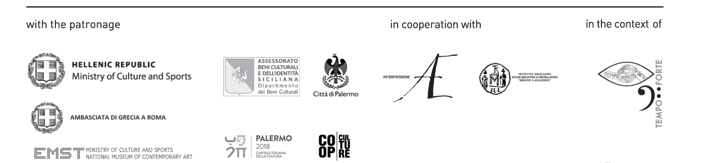

Exhibition details – Palermo
Title Venia Dimitrakopoulou. Primordial Future - Matter
Exhibition organized by Hellenic Foundation for Culture, Italy
Curated by Afrodite Oikonomidou and Matteo Pacini
Venue Regional Archaeological Museum “Antonino Salinas”, Piazza Olivella 24, Palermo
Dates 16 November 2018 - 3 February 2019
Press Preview Thursday, 15 November at 11:30am
Grand opening Thursday, 15 November at 6:00pm
Opening hours Tuesday-Saturday 9:30am-6:00pm; Sundays and public holidays 9:30am-1:00pm
Entrance fee included in the museum ticket, € 3.00; free under 18 and every first Sunday of the
month
Catalogue published by Umberto Allemandi with introductory text by Franco Fanelli

Info to the public CoopCulture ph. +39 091 7489995 | www.coopculture.it

Future exhibitions
Title Venia Dimitrakopoulou. Primordial Future - Logos
Venue Gallery of the Sandretto Re Rebaudengo Foundation, Turin
Dates 22 February - 31 March 2019

Title Venia Dimitrakopoulou. Primordial Future - Sound
Venue Sartorio City Museum and San Giusto Castle, Trieste
Dates 12 April - 14 June 2019

Press office
IBC Irma Bianchi Communication
Ph. +39 02 8940 4694 - 02 8940 0732 - mob. + 39 328 5910857 - info@irmabianchi.it
Text and image downloads from www.irmabianchi.it

