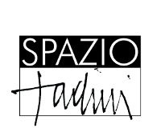
via Jommelli, 24 - Milan

Laura Zeni. Mangia con la Testa/
Laura Zeni. Eat with Your Own Head
Mostra d’arte e design perché nutrirsi è anche una scelta/
Exhibition of art and design, because to feed yourself is also a choice

curated by Melina Scalise and Francesco Tadini

12 March - 3 April 2015
grand opening on Wednesday, 11 March at 6.30pm

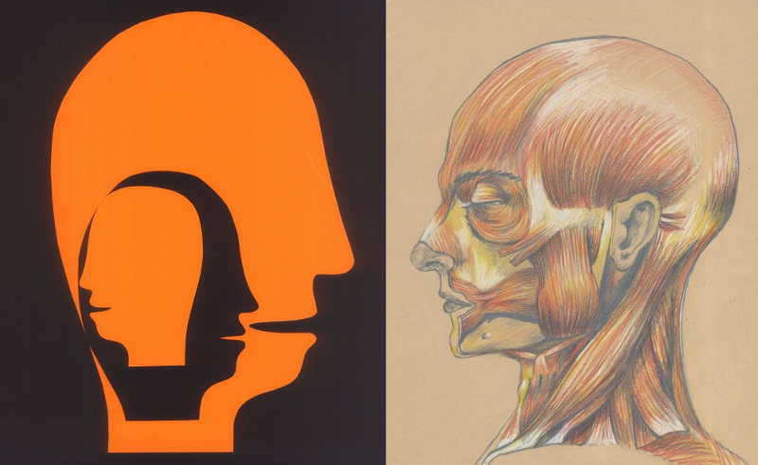

press release, 05.03.2015

From 12 March to 3 April Spazio Tadini hosts the exposition “Laura Zeni. Mangia con la testa/Laura Zeni. Eat with Your Own Head” curated by Melina Scalise and Francesco Tadini, an exhibition of art and design which expresses the message “to feed yourself is also a choice”.

In regard to food the invitation of the artist is to ascribe to it not only a nutritious value but also that of communion and balance with nature. It is a work portrayed by heads that sometimes evoke in a stylized way the art by Arcimboldo to which is added an actual variation of his style in objects that embellish the table, from the tablecloth to the centrepiece, from the plate made together with Porcelanosa to the design objects from the Lazenart line. What stands out are the made ad hoc installations, the distinctive Radar pieces, as well as several works on canvas, some of which have never been seen before.

We are what we eat. Like never before in the year of the Expo we have been wondering about our future starting from a fundamental need such as nutrition. There is not a political program that hasn't tried to answer the question which is born not only from the horrible problem of world hunger but also from the growing cohabitation of different peoples, traditions and religions despite all. It is a melting pot that creates new needs and renews every aspect of everyday life. To this it must be added a new awareness of the relationship man-nature, technology and exploitation or respect for the natural resources.

In this fast paced universe some artists are trying to represent the change. The truly Italian Laura Zeni is among the artists who are more active on the front of sustainability. After the recent exhibitions at the Triennale, DAI Studio in Rome and the long display in the large spaces of Eataly in Milan, Zeni goes back to the Casa Museo Spazio Tadini with “Mangia con la Testa/Eat with Your Own Head”.
In regard to the exhibition the curator Francesco Tadini says: “With the series of works Teste/Heads and Radar the artist makes a special effort comparable to 'La Comédie humaine' by Honoré de Balzac: ‘competing with the Registry of births, marriages and deaths’ encompassing all aspects of his society. The 137 works by Balzac, which include novels, shorts stories and essays, become the thousand profiles by Laura Zeni almost two hundred years later: a fresco of a past age that evokes the Facebook icon and, at the same time, tries to find the speed of the global network in the thousand sides of individual identity through the simple stroke of a felt pen”.

Melina Scalise states that “due to the fundamental contribution that Joseph Beuys gave to the foundation of the movement of The Greens in Germany, he knew that art was able to tend towards a superior balance between man and nature. Nowadays other artists base their own work on the development of these topics. Among others an example of that is included in the idea of the Terzo Paradiso/Third Paradise by Pistoletto”.
Laura Zeni makes her artistic work circulate on the Italian scene with simple designs and objects, which are immediately understood and with no misunderstanding invite people to eat, drink, live... with their own heads.

Short Biography
Laura Zeni, born in Milan, graduates from the Accademia di Brera under the guidance of Raffaele De Grada. Since 1980s until today, she has taken part in several solo and group exhibitions in Italy. In 2008, she is at the fair “Fuori Salone del Mobile” with Jannelli & Volpi. In 2012, on the occasion of the fair “White”, she opens the solo exhibition “Laura Zeni. Illuminazioni”, curated by Fortunato D'Amico, at the MyOwnGallery of Superstudiopiù in Milan, accompanied by a catalogue published by Skira. In 2012 she holds, in the premises of Banca Intermobiliare in Milan, the solo exhibition “Laura Zeni…che Meraviglia!”, followed in 2013 by the solo exhibition “Laura Zeni. Indian Pattern”, at the Spazio Tadini gallery in Milan, both curated by Fortunato D'Amico. In 2013 she takes part in the collective show at Macs - Mazda Con-Temporary Space in Milan, in “Fuori Salone” at Superstudio 13 and in “AAM - Arte Accessibile Milano” at the Eventiquattro location of Sole 24 Ore. She also exhibits in Alba, at the Church of San Giuseppe and at the Spoleto International Art Fair 2013. She is at the 9th International Biennale of Contemporary Art of Florence and during 2013 she takes part in a series of events organized by the association "Arte da Mangiare".
In 2014, on the occasion of the collateral events for ArteCremona Fair 2014, she exhibits at the prestigious "Sala degli Alabardieri" at the Town Hall in Cremona and participates at the Fair with Galleria Scoglio di Quarto. During the Milan Design Week 2014 she is at Superstudio Più at the event Double Room by the Porcelanosa Group and at the Temporary Museum for New Design. In the same year at the Triennale of Milan she holds the solo exhibition “Laura Zeni. Coltivare la mente” curated by Fortunato D’Amico; she takes part in the group exhibition “Le celle - L’anima” at the Priamàr Fortress in Savona, in the International Festival Art Expo Spoleto 2014 and in “MPG 2014 - Mostra per Gioco” at Spazio Tadini in Milan. In December-January 2014-2015 she is the first artist to hold a personal exhibition at Eataly Smeraldo in Milan. www.laurazeni.it

Details
Title Laura Zeni. Eat with Your Own Head
Curated by Melina Scalise and Francesco Tadini
Venue Spazio Tadini, via Jommelli, 24 - Milan
Dates 12 March - 3 April 2015
Grand opening Wednesday 11 March at 6.30pm
Opening hours Tuesday to Saturday 3.30pm - 7pm
Info Ph. +39 02 26 82 97 49 - ms@spaziotadini.it
www.spaziotadini.it

Press Office for Laura Zeni
IBC Irma Bianchi Communication
Ph. +39 02 89404694 - info@irmabianchi.it
text and image downloads from www.irmabianchi.it

