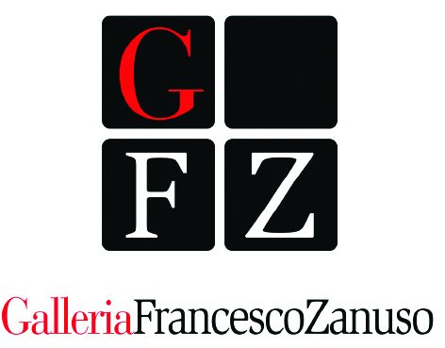

Francesco Zanuso Gallery
Corso di Porta Vigentina, 26 - Milan

Maria Mulas. Ritratti e architetture/
Maria. Mulas. Portraits and architectures

21 May – 5 June 2014

press release, 30.04.2014

“Maria Mulas. Ritratti e architetture/Maria Mulas. Portraits and architectures” is the title of the important photographic exhibition held at the Francesco Zanuso Gallery from 21 May to 5 June. The exhibition opens up simultaneously with the Photofestival of Milan, where the artist is present and which is connected with the Biennale of Venice 2014 on the theme of architecture. In fact, through a fascinating set-up, it emphasizes the subjects most dear to Maria Mulas: the portraits and the architectures.

The portraits of famous artists and great characters reveal, with extreme realism and sometimes a trace of irony, the personal features of the subjects, lifestyles, habits and attitudes in a tale across art, history and contemporaneity critically told and at the same time highly descriptive.
The array of photo shots on display shows a manifold overview of personalities, glimpses of social life in-between spontaneity and artificiality, among which stand out the historical art critic Lea Vergine and successful artists such as Louise Bougeois, Henry Moore, Keith Haring and Christo; the double portraits of Joseph Beuys, Claes Oldenburg, Coosje van Bruggen, Bruce Nauman and the core of works portraying Andy Warhol.

In one of her writings Rossana Bossaglia thoroughly expresses this concept of making art “Maria Mulas, famous photographer – not only of people – is sought-after and coveted for the free frankness of her relationship with the person she portrays; she uses cuts, means, different lights according to the situations, not meaning the portrait as a mere exercise in style; she catches features and expressions, she especially understands at once if the subject should be defined in a typical gesture or surprised in his/her dynamism, if he/she would benefit from a light effect that gives prominence or from the immersion in dimmed lights. She is, after all, herself without insolence, careful to give us back not only pictures but also characters...”.

Even though it is with completely different objects in the photo shots of the architectures, the subtle game between the real and the symbolic visions of what is represented continues. Thanks to the manipulations of the photographic films, made through manual reprocessing, superimpositions, distortions, decompositions and re-compositions, the frames are transformed into abstract compositions, where the remnants of the original shapes are not too clear and sometimes are indiscernible.
In Omaggio al Terragni/Homage to Terragni and in Astrazione#1/Abstraction#1 and Astrazione#2/ Abstraction#2, which are focused on New York and were created in the Seventies and Eighties, what is evident is a strong limitation in readability and visibility of the real structures, hidden by symmetrical and mirror elements, while in the photo Rotonda della Besana/Rotunda of Besana street of 1972, in the dizziness of alternating arches and columns, hints at the original architectural structure are more visible. An expressivity in continuous evolution is in Venezia Astratta/Abstract Venice, as well as in other works made in the Nineties the place represented is more easily identified.
In the portraits and architectures of Maria Mulas the perfect union between aesthetics and technique comes to light, and harmony, rhythm and feeling emerge, all evident traits of her artistic vision.

Biographical info
The artistic career of Maria Mulas began in Milan in the Sixties with the creation of photographs inspired from the world of theatre and the theme of portrait, a subject continuously brought back in the expressive journey of the artist and which will be one of the essential poetic elements of her work.
The first solo exhibition of Mulas was dedicated to a selection of portraits, that revealed a strong attention to social criticism, and was held at the Diaframma Gallery of Milan in 1976; after this expository event the show at the Il Milione Gallery of Milan followed in 1979, where portraits of intellectuals were presented to the public, as the result of a technical experiment with the 20mm wide-angle lens performed during the Biennale '78 and at the P.A.C. in '79.
In the same year, in some European cities, together with Lea Vergine she performed a study on the female artists working in the historical avant-gardes, creating portraits which would be then presented at the exhibition “L’altra metà dell’avanguardia/The other side of the avant-garde”, held at Palazzo Reale in Milan and at Palazzo delle Esposizioni in Rome in 1980. Later her works were on display in solo and group exhibitions in important galleries and public venues among which there are the Gallery of Modern Art of Bologna in 1990, Palazzo dei Diamanti in Ferrara in 1991, Palazzo Reale in Milan in 1998 and in 2012 and the Pecci Museum in Prato in 2013.
The art of Maria Mulas is on permanent display in several museums and many important characters of the art world, such as Francesco Bonami, Achille Bonito Oliva, Rossana Bossaglia, Vittorio Sgarbi, Lea Vergine and Stefano Zecchi, have written about her work.

Details
Name Maria Mulas. Ritratti e architetture/Maria Mulas. Portraits and architectures
Venue Francesco Zanuso Gallery
Corso di Porta Vigentina, 26 - Milan
Dates 21 May – 5 June 2014
Meet the artist and cocktails Thursday, 29 May at 6pm-9pm
Opening hours Monday-Friday 3.30pm-7pm
visits by appointment only on mornings and other times
Entrance free
Info tel. 335 6379291 - francesco.zanuso@gmail.com

Press office
Irma Bianchi Comunicazione
tel. 02 8940 4694 - cell. 328 5910857
info@irmabianchi.it - skype: irmabianchicomunicazione1
text and photo downloads from http://www.irmabianchi.it/mostra/maria-mulas-ritratti-e-architetture

