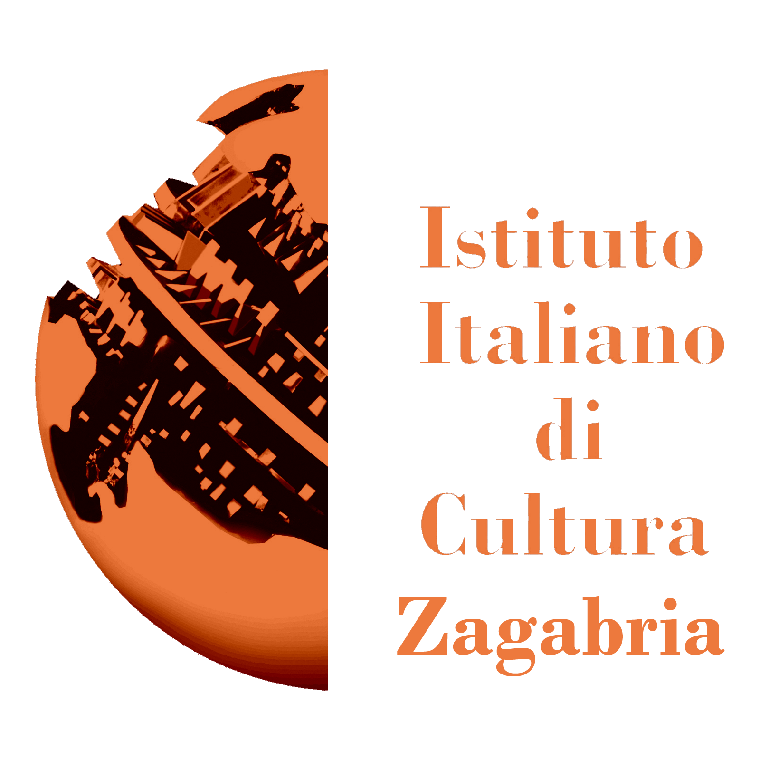

Italian Cultural Institute of Zagreb
Preobraženska 4, 10000 Zagreb - Croatia

during the Semester of the Italian EU Presidency

Terra, fuoco, ferro, legno. Maria Cristina Carlini/
Earth, fire, iron, wood. Maria Cristina Carlini

curated by Martina Corgnati

from 1 October to 4 November 2014
grand opening on Tuesday, 30 September at 7pm

press release, 24.09.2014

The city of Zagreb, which for years has been active in the field of international contemporary art, welcomes the solo exhibition of the sculptress Maria Cristina Carlini at the Italian Cultural Institute. The exhibition is part of the project "Confini/Limits", curated by Martina Corgnati, made on the occasion of the Semester of the Italian EU Presidency, with the patronage of the Ministry of Foreign Affairs.
For this important event the following artists have been involved: Maria Cristina Carlini, Agostino Ferrari, Agnese Purgatorio and Donatella Spaziani, who in turn exhibit at the Italian Cultural Institutes of Cologne, Strasbourg, Zagreb and Tirana.
Maria Cristina Carlini presents a group of works made from 2002 to today, from which emerges a deep insight into the materials and their relationships, and becomes interpreter of a sculpture meant as a continuous exploration of primeval forms, very often apparent from the very nature of the material itself. The works on display are made of wood, sandstone, iron and corten steel, and are accompanied by a selection of large drawings made by mixed-techniques on paper illustrating the conception phase and the projects.

The exhibition “Terra, fuoco, ferro, legno. Maria Cristina Carlini/Earth, fire, iron, wood. Maria Cristina Carlini” is open to the public from 1 October to 4 November and plans an exhibition at the Italian Cultural Institute of Tirana from 27 February to 31 March 2015 as the last stop of its European journey.

During the event the video “Sculptures. Maria Cristina Carlini” is broadcasted, made by Matteo Bernardini, which retraces the phases of the artistic career of the artist, describing the artist at work in her studio and her numerous works - from the monumental pieces to the smaller ones - with a commentary by Martina Corgnati.

SHORT BIOGRAPHY
The artistic career of Maria Cristina Carlini, an important contemporary Italian sculptress, holds solo and group exhibitions in several public and private venues, nationally and internationally, among which there are Paris, Madrid, Miami, Denver, Beijing, Hong Kong, Shanghai; some of her works are permanently on display in several cities of Europe, America and Asia.
Among the last exhibitions worth mentioning are the solo ones at Villa Recalcati, Varese, at the Mudima and the Stelline Foundations in Milan, the big anthological “Fare secondo Natura/Do according to Nature” at the Govone Castle (Cuneo) with about a hundred works, and the important group exhibition at the Gallerie d’Italia in Milan.

Important critics wrote about her, such as Luciano Caramel, Claudio Cerritelli, Martina Corgnati, Gillo Dorfles, Carlo Franza, Flaminio Gualdoni, Yakouba Konaté and Elena Pontiggia.

Details
Title Terra, fuoco, ferro, legno. Maria Cristina Carlini/
Earth, fire, iron, wood. Maria Cristina Carlini
curated by Martina Corgnati
four venues:
Italian Cultural Institute of Cologne
1 July - 28 August 2014
Italian Cultural Institute of Strasbourg
2 - 22 September 2014
Italian Cultural Institute of Zagreb
Preobraženska 4, 10000 Zagreb - Croatia
1 October - 4 November 2014
grand opening on Tuesday, 30 September at 7pm
Italian Cultural Institute of Tirana
27 February - 31 March 2015

For further info:
Italian Cultural Institute of Zagreb
ph. +385 (1) 4830208/9 - segreteria.iiczagabria@esteri.it - iiczagabria@esteri.it

Press Office
Irma Bianchi Comunicazione
Ph. +39 02 8940 4694 - info@irmabianchi.it
text and photo downloads from www.irmabianchi.it

