

With the patronage of
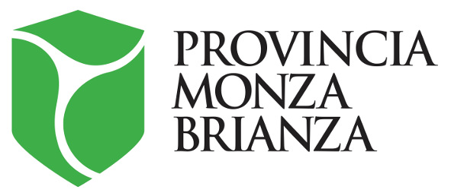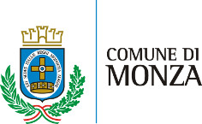

Royal Villa of Monza, Orangery
Viale Brianza, 1

INDART
Industries Join Art

Scientific Committee
Flavio Arensi, Valerio Dehò, Alberto Fiz, Franco Marrocco and Elena Pontiggia

6 - 23 September 2018
Grand opening on Wednesday, 5 September at 6:30pm

press release, 30.08.2018

The splendid setting of the Orangery of the Royal Villa of Monza hosts the first edition of the exhibition “INDART - Industries Join Art” from 6 to 23 September. It is an innovative event, it promotes the artistic production supported and sponsored by a patronage culture intertwined within the industrial fabric of the country.
The event sees twenty main characters, contemporary artists combined with ten prominent Italian companies, who with their talent and creativity have transformed the raw materials provided by the sponsor companies into twenty never seen before art works.
The selection of the artists and their matching with the companies have been made on the basis of the characteristics of each artist by a Scientific Committee, which is made up of important personalities of the art world: Flavio Arensi, Valerio Dehò, Alberto Fiz, Franco Marrocco and Elena Pontiggia.

The artists are: Giovanni Albanese, Arcangelo, Maurizio Cannavacciuolo, Anna Caruso, Tommaso Cascella, Aldo Damioli, Ulrich Egger, Massimiliano Galliani, Omar Galliani, Giuseppe Gallo, Paolo Grassino, Riccardo Gusmaroli, Elio Marchegiani, Matteo Negri, Gianni Piacentino, Roberto Pugliese, Rosa Maria Rinaldi, Giampaolo Truffa, Luca Vernizzi, Dany Vescovi.

The exhibition is devised and organized by the events and communications agency Visionplus in cooperation with the VS Arte gallery, the Kamil Art Gallery and the auction house Artcurial, with the patronage of Lombardy Region, the Province of Monza and Brianza, and the Council of Monza.

A series of materials from different sources, among which there are aluminium, textiles, Plexiglas, paper, steel, rubber and glass, are all associated due to their metamorphic property and great creative potential. They have been transformed into twenty art works by talented artists. Among them, there are paintings, collages, sculptures and installations, made especially for the occasion.

The Scientific Committee has selected artists who belong to different generations, united by their capability of interpreting the industrial materials by using versatility and irony in creating works, which are meant to develop a renewed synergy among fields that are usually detached. Thus, art and the production world meet outside any convention, creating an aesthetic connection destined to renew itself in time, where the made in Italy is the protagonist.

Aldo Damioli and Riccardo Gusmaroli used textiles by Anemotech. Giampaolo Truffa and Luca Vernizzi fabric and yarn by Ermanno Scervino. Paolo Grassino and Gianni Piacentino mechanical components by CMS Group. Tommaso Cascella and Roberto Pugliese glass by Meregalli Vini Group. Ulrich Egger and Giovanni Albanese iron by OMP Group. Arcangelo and Rosa Maria Rinaldi laces by Iluna Group. Giuseppe Gallo and Anna Caruso nonwoven fabric by Montrasio Italia. Elio Marchegiani and Dany Vescovi adhesive paper and reels by Pilot Italia. Matteo Negri and Maurizio Cannavacciuolo cardboard and paper materials and plexiglas by Studio FM. Omar Galliani and Massimiliano Galliani high-quality papers by the paper factory Burgo Distribuzione.

The INDART project also aims at giving Italian contemporary art an occasion for visibility beyond the national borders, thanks to a large-scale project that connects the town of Monza with the splendid setting of the Principality of Monaco. They are two towns that historically have already been very close. It was indeed in the wonderful rose garden of the Orangery of the Royal Villa of Monza that in 1970, Princess Grace of Monaco, patroness of the historical «International Contest of New Roses», personally gave away the prizes for the rose experts who won.

On the last day of the exhibition, on 20 September, at the Orangery of the Royal Villa of Monza, there will be a dinner dedicated to the funding of the activities of the Maria Letizia Verga Committee for the study and cure of leukaemia in children. It will be a symbolic passing of the baton between Monza and Montecarlo. INDART is indeed a project with a strong social value, where art is not merely made for itself, but also and especially as a means for a positive contribution to the society where it is born and from which it takes inspiration.

Later the exhibition will be on display from 28 September to 5 October in the Principality of Monaco at the Kamil Art Gallery. At the end of the event, an auction will be organized during the Gala Dinner at the exclusive location of the Yacht Club de Monaco. It is a prestigious event in which H.S.H. Princess Stephanie of Monaco will take part, as president of one of the two organizations that will benefit from the selling of the works. Part of the proceedings will fund the activities of the organization Fight Aids Monaco, which have been committed to fighting AIDS for years now and has been active in the field of information, prevention and support of patients. Another part will fund the Maria Letizia Verga Committee of Monza for the study and treatment of leukaemia in children, which for 39 years have been promoting and funding projects for research, treatment and care of the children and their families. Two Charitable Organizations of which the work is without a doubt recognized nationally and internationally.

Piero Addis, Director of the Royal Villa of Monza, says, “It is with great pleasure that the Orangery premieres the exhibition INDART - Industries Join Art. The bond between the artists and their patrons is at the basis of most of the greatest work in the History of Art, a sign of the vital relationship between each society and its artistic production. The charitable aims of this project indicate a further exchange within this union. The Royal Villa was born at the end of the 18th century as a place of international gatherings. This is its essential value, reconfirmed by the relation with the Principality of Monaco that already begun in 1970 with Princess Grace and that today renews itself”.

A comprehensive catalogue accompanies the exhibition with texts in Italian and French.

VISIONPLUS
INDART – Industries Join Art is a product devised and made possible by Visionplus, events and communications agency with a 15-year long experience, able to stretch among the different types of projects in the field of communication and events with creativity, flair and professional rigour.
Visionplus has its roots in an essential mission: transforming each project into something memorable and unique. Its approach is characterized by the care of each single detail, the special attention to the communication needs and a strong sensitivity for the emotional aspect. Thus, each project becomes the vehicle of tailor made messages, a captivating moment, and an experience up to date with the present trends and open to the novelty of contemporaneity. www.visionplus.it

A project of with the cooperation of for
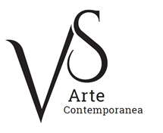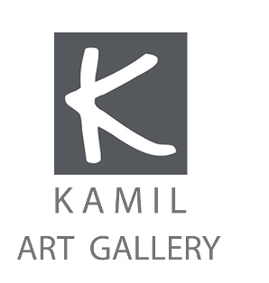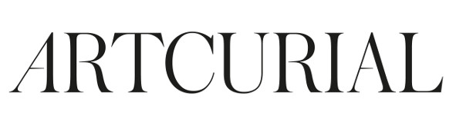

Exhibition details - Royal Villa of Monza, Orangery
Title INDART - Industries Join Art
Scientific committee Flavio Arensi, Valerio Dehò, Alberto Fiz, Franco Marrocco, Elena Pontiggia
Venue Royal Villa of Monza - Orangery, Viale Brianza 1, 20900 Monza
Dates 6 - 23 September 2018
Grand opening Wednesday, 5 September at 6:30pm
Opening hours Tuesday-Friday 10am-7pm; Saturday-Sunday 10am-7:30pm. Mondays closed.
Entrance fee free
Info to the public Ph. +39 039 2326183 - info@visionplus.it - www.indart.it
www.instagram.com/indart_industriesjoinart
www.facebook.com/indart.industries.join.art
www.reggiadimonza.it

Exhibition and auction details – Principality of Monaco
Title INDART - Industries Join Art
Exhibition venue Kamil Art Gallery, Emilie Palace, 3 Av. Princesse Grace, 98000 Monaco
Dates 28 September - 5 October 2018
Grand opening Thursday, 27 September at 7pm
Opening hours Monday-Friday at 10am-7pm. Saturdays and Sundays closed
Entrance fee free
Info to the public Ph. +377.92.16.00.10 - info@kamil.mc

Auction and Gala dinner venue Yacht Club de Monaco (upon invitation only)
Dates Friday, 5 October 2018

Press office for the exhibition at the Royal Villa of Monza, Orangery
IBC Irma Bianchi Communication
Ph. +39 02 8940 4694 - mob. + 39 328 5910857 - info@irmabianchi.it
Text and image downloads from www.irmabianchi.it

