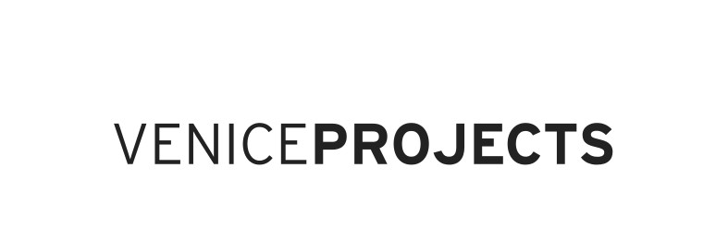
GLASSTRESS
WHITE LIGHT / WHITE HEAT

Curated by Adriano Berengo e James Putnam

Collateral event 55. Esposizione Internazionale d’Arte – la Biennale di Venezia

Presentation
Adriano Berengo – Berengo Studio – Glasstress

Adriano Berengo
- Berengo Studio

Venice Projects – Berengo Studio – Glasstress

Internazional relations

Lebanon - China
- Glasstress World

Adriano Berengo
Adriano Berengo was born in Venice in 1947 and lives between Venice and Beirut.
He graduated in Foreign Languages and Languages from the “Ca’ Foscari” University in Venice in 1974 and completed his education with post-graduate studies in Comparative Literature at the “SUNY-State University of New York”, obtaining his Ph.D. degree in 1976; the same year he founded the interdisciplinary journal “Gradivia”.
From 1977 to 1981 he worked as a teacher of English Literature and Language in Italy.
In 1982 he started working as artistic director at the glassworks “Vetreria Salviato&C”.
In 1989 he founded the “Berengo Studio” with the aim of promoting glass as an artistic medium.

Berengo Studio
The “Berengo Studio” was founded in 1989 by Adriano Berengo with the aim of bringing contemporary international artists closer to the world of glass so that, in collaboration with master glassmakers, they can translate their artistic research into the three-dimensional language of glass paste.
The Studio works primarily with established or emerging authors, whose works are mostly exhibited in major museums and private collections, without neglecting, however, the young artists making their debut.
The artists who work with the Berengo Studio normally use a variety of expressive materials other than glass, that’s why in their approach to this new medium they always contribute an original and freer interpretation of the possibilities offered by this extraordinary material.

Venice Projects – Berengo Studio – Glasstress
Special attention to the relation between glass and contemporary art led to the creation of Venice Projects, a new gallery based in Venice, which focuses its attention on projects by conceptual artists, designers and architects.
Venice Projects in turn produces Glasstress, an official exhibition in the framework of the Venice Art Biennale, where the best fruits of these meetings are presented. Glasstress was present in the 2009 and 2011 editions of the Biennale and is now back for the 2013 edition of the Biennale.

International relations
The activity of the Berengo Studio and Venice Projects is deeply branched and extended in a global sense:
- approximately 80% of collectors reside outside the Italian territory
- the galleries participate in numerous art fairs held in different continents
- the organization of Glasstress has allowed consolidating contacts with prominent artists, curators, critics, museum directors and gallery owners in many countries
- the direct production of the works creates a very special collaborative relationship with the artists, who find an interlocutor from an expressive point of view and not just a business partner.

In particular, the activity of the Berengo Studio and Venice Projects has involved over the years the establishment of preferential relations with certain geographical areas, namely:

Lebanon
In the course of its activities, Adriano Berengo has developed close ties with the Lebanese artistic and cultural reality. In 2014 Glasstress will be presented again in Beirut, as was the case in 2012. Among the artists presented by Venice Projects and Glasstress, there is a young Lebanese woman, Marya Kazoun, who this year will present her work at the Venice Pavilion on the occasion of the Venice Biennale.

China
The World Economic Forum invited Adriano Berengo among the New Champions of the 2012 edition of Summer Davos in Asia, held in Tianjin, China (cf. annexed page of the catalogue of the New Champions Participants). On that occasion, Adriano Berengo gave birth to the project to invite five prominent Chinese artists to work at the Berengo Studio and propose their works to the Dalian museum on the occasion of the 2013 edition of the Summer Davos in Asia.

Glasstress World
In 2011 and 2012 Glasstress was hosted by major international institutions, namely:
- Riga Bourse National Museum, Latvia (20.08 > 11.12.2011)
- Millesgården Museum in Stockholm (27.08.2011 > 15.01.2012)
- MAD Museum of Arts and Design, New York (14.02.2012 > 10.06.2012)
- BEC, Beirut Exhibition Centre, Lebanon (15.07 > 02.09.2012)

Adriano Berengo has received a request to move the Glasstress exhibition to other nations in the 2013-2014 period, including:
- London, UK: invitation to exhibit received from the Wallace Collection and the London College of Fashion, partners of Glasstress 2013
- Moskow, Russia: invitation to exhibit at the Multimedia Art Museum.
- Kuwait: invitation received from Abed Al Kadiri, director of the CAP - Contemporary Art Platform Kuwait
- Istanbul, Turkey: invitation received from the Italian Cultural Institute and the Italian Embassy in Turkey.
- Vienna, Austria: invitation to exhibit at the MAK, Austrian Museum of Applied Arts
- Seoul, Korea: invitation to exhibit at the Hangaram Design Museum

