 MyMicroGallery

THE HEART BEAT OF MOTHER EARTH

Curated by Stefania Carrozzini

Date: June 16 - June 29, 2016
Opening Reception: Thursday June 16 - 6:00 – 8:00 pm

Onishi Project: 521 West 26th Street, New York, NY 10001, USA
t. 212.695.8035 / info@onishiproject.com / www.onishiproject.com
Gallery hours: Tuesday – Saturday, 11:00 a.m. – 6:00 p.m.

Aurélie Beer / Stefania Bertini Cavelti / Rosaspina Buscarino
Nicola Bottalico / Paolo Nicola Rossini / Robyn Saurine
Gio Sciello / Nara Walker / Laura Zeni

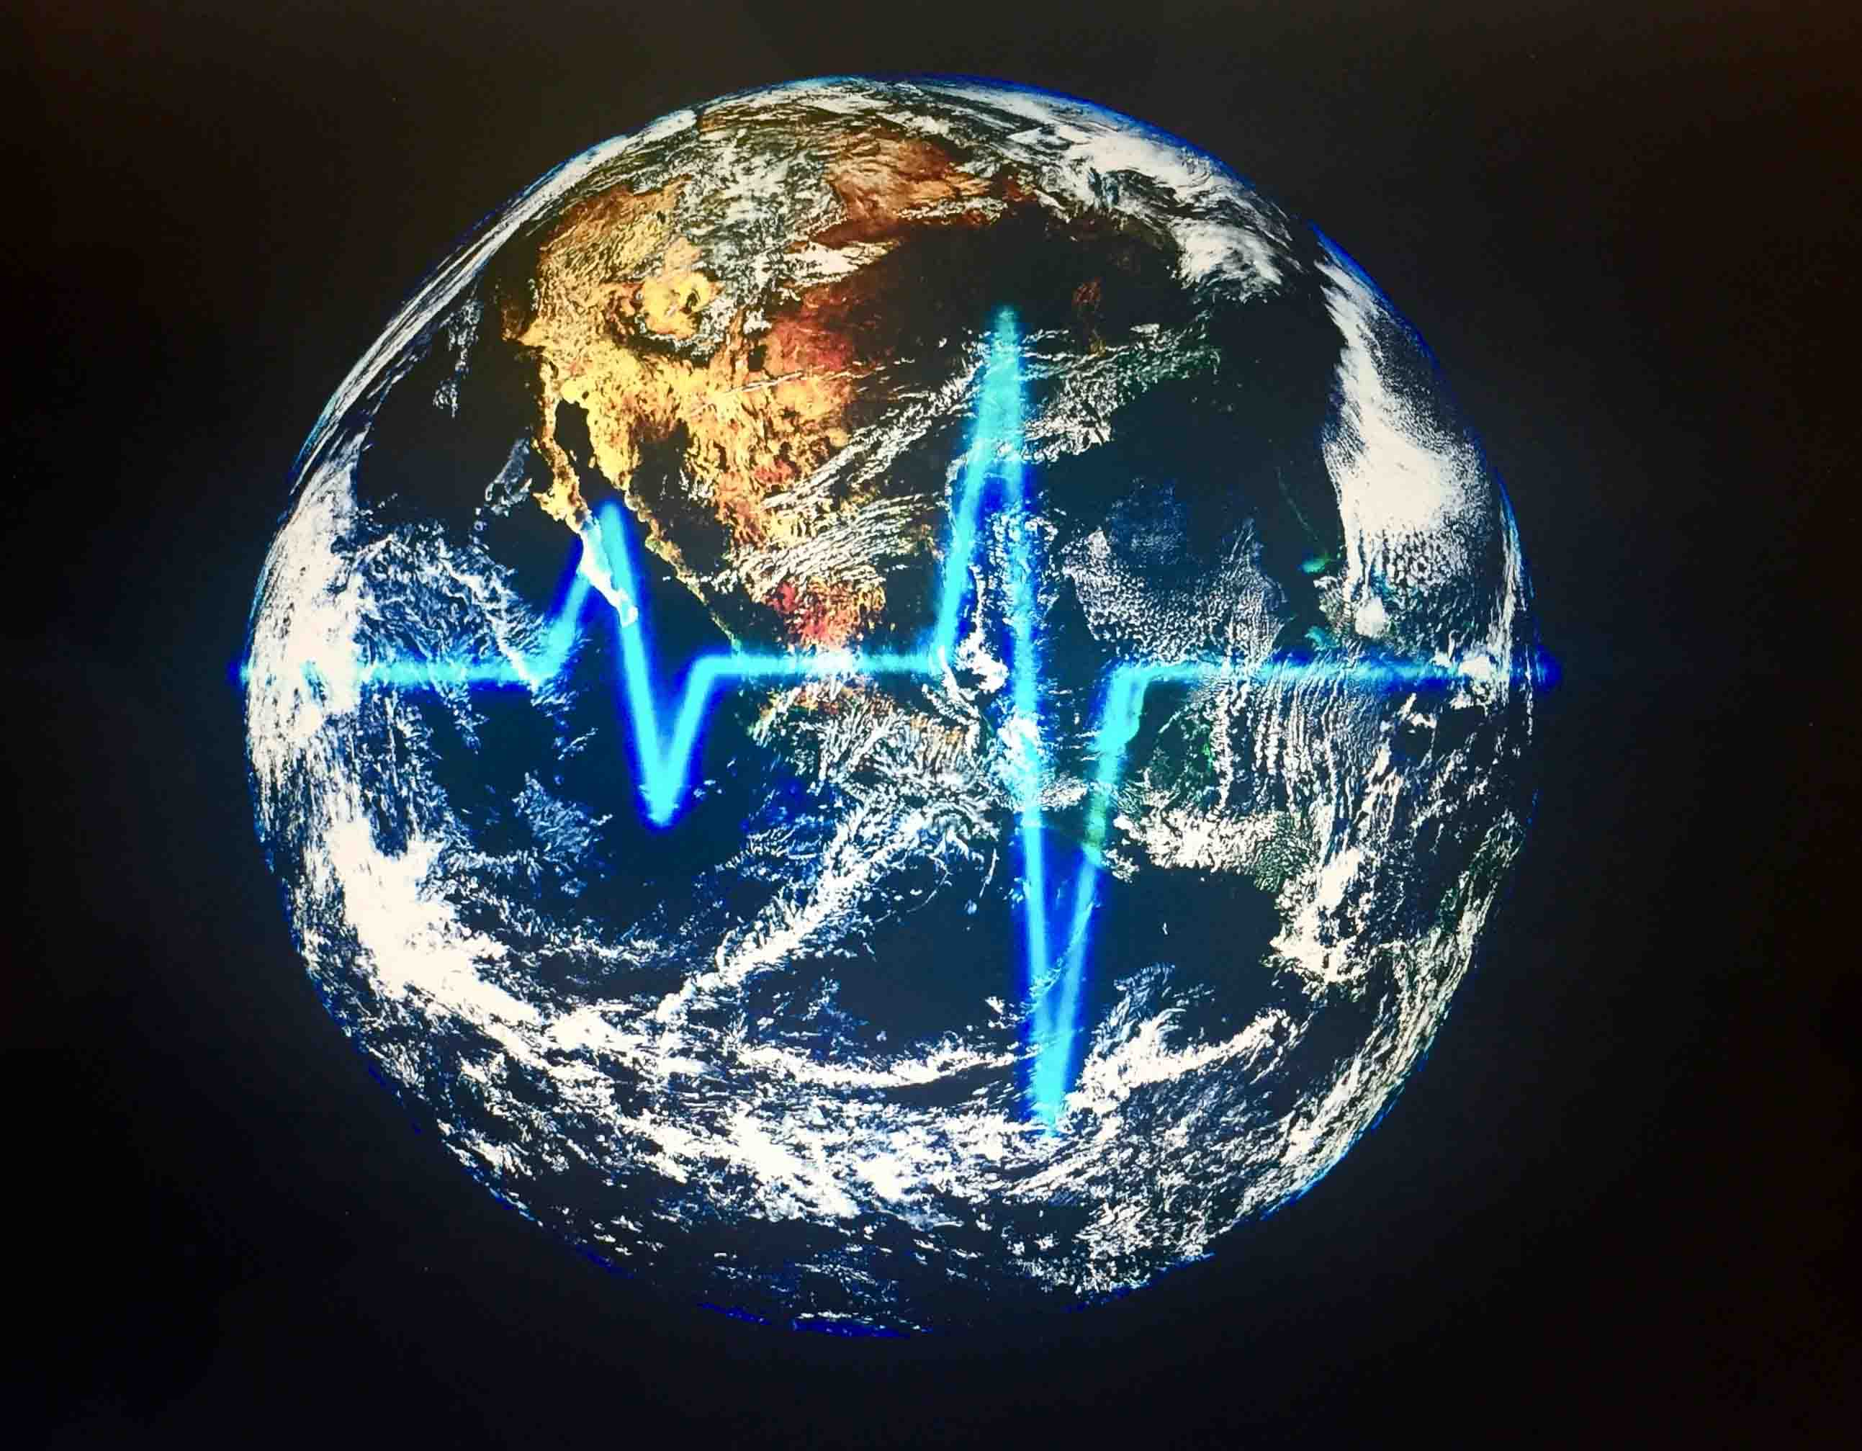

Onishi Project together with MyMicroGallery, is proud to announce, from the 16th to the 29th of June, the exhibition “The Heart Beat of Mother Earth” a travelling project, created and curated by Stefania Carrozzini.

The exhibition gathers the work of nine artists coming from different countries, Australia, Peru, Italy, Switzerland, who are showing work which ranges from a figurative language to an abstract one, from photography to painting, presented together as a system of symbolic associations and correspondences with the theme. The various interpretations of the artists hark to a dimension which goes beyond their existential reality, subjective and individual touching on aspects which concern an aesthetics of feeling, the indissolubility between micro and macrocosms.

Conceived therefore, apparently as a meeting of personal cosmologies, in reality the exhibition stages the continuous challenge of the artists to find the point of connection between the Self and the universe, the subjective with the collective, and it invites one to reflect on the point of connection between ourselves and Entirety, to create a place of real belonging which has its vital point in art and creation.

“The Heart Beat of Mother Earth” draws its inspiration from a scientific fact recently brought to our knowledge: the electromagnetic frequencies of the Planet Earth have changed and have accelerated. The well known Schumann Resonance put “the heart beat” of the planet at 7.83 hertz. Now the peak of activity has increased and has been recorded at about 8,5Hz.

The Earth is changing its vibration frequency and we are too. Human beings, those who dwell on the planet, cannot fail to be affected by this change. The idea therefore, comes from an undeniable and scientific fact, only to then set in motion a series of symbolic and creative reflections and resonances which this theme engenders, as well as the coming of awareness as to how the artist, in his or her freedom as an author and creator, in reality is part of a greater fate. An evolutionary fact which takes into account not only the means of expression and technique, but also the transformation of feeling and of thought, an evolution which touches the very heart of creation.

“The heart beat of mother earth is our heart beat, it is the rhythm of our breathing, it reminds us of the pulsations we felt when we were in our mother’s womb, when we heard her heart. Art has to be like this memory, a powerful and vital voice which entices us and each time we hear it takes us back to the source, to our essence and original nature, a universally perceptive awareness which embraces the cosmos and becomes one with it. The heart beat of Mother Earth reminds us who we are, where we come from and where we are”. (From the catalogue)

The Heart Beat of Mother Earth is a travelling exhibition and the next venues will be Milan.

Catalogue will be available at the gallery. For more information please visit our website at: www.onishiproject.com or contact the gallery at: 212.695.8035.

MyMicroGallery: Via Giovanni Boccaccio, 24 20123 Milan Italy Tel +39 338 430 5675 – USA + 1 917 213 2875 www.mymicrogallery.com

