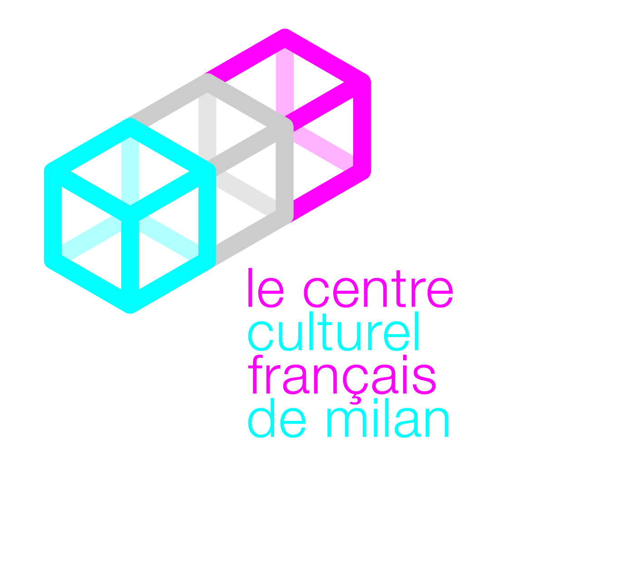
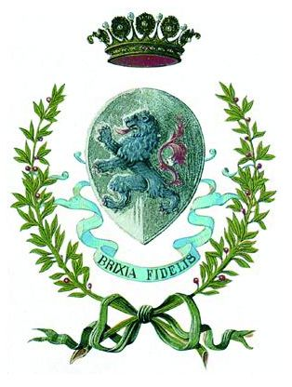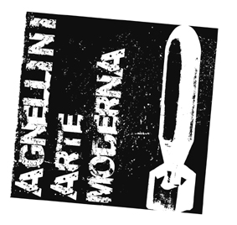

AGNELLINI ARTE MODERNA

Council of Brescia
Culture and Tourism Dept.
of the city of Brescia

Press release 10.03.2010

Il Nouveau Réalisme (I cinquant’anni, 1960-2010)/
The New Realism (The fifty years, 1960-2010)
Curated by Dominique Stella

4 October 2009 – 3 April 2010 EXTENDED TO 22 May

Venue Agnellini Arte Moderna Gallery

After the great success in regards to critics and the public of the historical exhibition Il Nouveau Réalisme (I cinquant’anni, 1960-2010)/The New Realism (The fifty years, 1960-2010) celebrating the 50 years of the movement, the Agnellini Arte Moderna Gallery of Brescia extends it until 22 May 2010. The interesting and thorough group exhibition, curated by Dominique Stella, gathers all the representatives of this extraordinary artistic current which marked the Twentieth Century.

The exhibition is made with the patronage of the Culture and Tourism Department of the Council of Brescia, Hon. Mayor Mr. Adriano Paroli and council member Andrea Arcai, and the French Cultural Centre of Milan.

Absolute protagonists of the exhibition are the so-called “Nouveaux Réalistes/New Realists”, of whom one can admire more than fifty interesting works: Arman, César, Christo, Gérard Deschamps, François Dufrêne, Raymond Hains, Yves Klein, Martial Raysse, Mimmo Rotella, Niki de Saint Phalle, Daniel Spoerri, Jean Tinguely and Jacques Villeglé.
All the selected works, among which there are some from the ’50s, are of great artistic and historical value.
Especially for this occasion Jacques Villeglé has created a new work which is comprehensive of all the names of the artists on display, made through his sociopolitical signs.
César and Arman face the problem of industrial production and its recycling: the invasion of mass production and the consequent waste are the main themes at the core of their research. Mechanical tools and motorcycles, but also everyday household goods, such as kitchen tools, fabrics, cardboard, iron and scraps, are compressed or assembled in a complete celebration of industrial “beauty”. In such regard, what stands out on display are Compression de moto/Compression of a motorbike, a compression of 1970 by César and Accumulation colombienne/Colombian hoarding, a hoarding of coffee makers of 1962 by Arman.
Of great relevance for the birth of the movement of the 'Nouveau Réalisme/New Realism' was the figure of Yves Klein, here on display with some of his most significant creations, among which there are La terre bleue/The blue Earth made in 1957 and The Venus of Alexandria of 1960, examples of his creativity, the invention of his unmistakable blue which was patented in 1956.
The collection of Dufrêne, Hains, Rotella and Villeglé brings the vision of a world "like a painting" as Pierre Restany used to say: the “strappi/rips” come out from the will of hoarding in a reality that goes beyond the approval of the gesture “Lacéré anonyme” (Ripped anonymous). The Circo Orfei/Orfei Circus by Rotella (1963) or Rue du Poison/Poison Street by Villeglé (1954) are indeed a good example of it.
Very significant are the “quadri-trappola/trap-paintings” by Spoerri who elevates the usual and ordinary to objects of art: on his tables the art works consist of casual objects, cutlery and food leftovers. The artist thus stops a situation, fixes it, doesn't embellish it, he doesn't add nor take away, he gives life, among others, to Variant d'un petit déjeuner/Variation of a small breakfast (1965).

The work of Raysse, who was also a signatory of the manifesto, even though with some points of divergence, is part of the movement producing a Pop perspective which gets him close to the approach of the American artists, like in Le seins du supermarché/The breasts of the supermarket, assembly work of plastic of 1961. Sure enough Raysse then found a favourable acknowledgment in the United States in Los Angeles in 1963.
Niki de Saint Phalle and Deschamps joined the group of the Nouveaux Réalistes in 1961: on display one can admire by the first artist Femme bleue luminaire of 1985, as well as a rare work created together with Jean Tinguely, New Year’s Letter, mixed techniques of 1973; by Deschamps what stands out is Hello Amy, rags assembled on canvas of 1963.
In 1963 Christo also joined the group and he was welcomed for his wrappings, often monumental, that are proof of his extremist style in the way he approaches objects: among the several works on display there is Package, fabric and rope on wood of 1963.

“The Nouveau Réalisme/New Realism”, says Dominique Stella, “is a movement of thought which the personality of Pierre Restany conceptualized through speech and reflection that called into question painting and the artistic practices at the end of the '50s”. The great adventure of the Nouveaux Réalistes/ New Realists starts from the imagination of Restany in 1959, as he himself states: “especially for the first Biennale of Paris where there were displayed a monochrome work by Yves Klein, the painting machine by Tinguely (Métamatic) and the Palissade/Fence by Raymond Hains, I realized the common theme of these different extreme researches, which up to that moment had followed independent evolutions: a fundamental gesture of catching what is real, connected to a quantistic phenomenon of expression (the soaking of pure colour in Yves Klein, the mechanical animation in Tinguely, the choice of a ripped manifesto in Hains)”. After a few months such realization became reality with the publication of the first manifesto, signed by Pierre Restany himself, at the Apollinaire Gallery in Milan on 16 April 1960. The event led to the real creation of the group on 27 October 1960 at Yves Klein's place in Paris.
Dominique Stella continues: “The Nouveaux Réalistes/New Realists have thus become aware of their collective singularity. Nouveaux Réalistes/New Realists = New perceptive approaches towards reality”.
The Agnellini Arte Moderna Gallery proves to be a strong reference for modern and contemporary art lovers: a reality that matches quality, efficiency and professionalism.

The prestigious book which completes the exhibition retraces the main phases of the Nouveau Réalisme/New Realism, also thanks to the beautiful historical photographs never seen before by Enrico Cattaneo, and allows a complete immersion in the energy and vitality of the movement, giving a taste of the artistic and personal life experiences of its exponents.
The volume, published in Italian and French by Shin Production, consists of critical texts by Grazia Chiesa, Marc Dachy, Pierre Restany and Dominique Stella.

Details
Title Il Nouveau Réalisme (I cinquant’anni, 1960-2010)/
The New Realism (The fifty years, 1960-2010)
Curated by Dominique Stella
Dates 4 October 2009 – 3 April 2010 EXTENDED TO 22 May 2010
Venue Agnellini Arte Moderna Gallery
Via Soldini 6/A – 25124 Brescia

Opening hours Tuesday-Saturday 10am-12.30pm and 3.30pm-7.30pm. Closed Monday.
Catalogue Shin Production, 272 pages, 28x24cm, thread-sewn paperback,
ISBN 978-88-89005-59-0

Info Agnellini Arte Moderna
Via Soldini 6/A – 25124 Brescia
Ph. 030.2944181 Fax 030.2478801
info@agnelliniartemoderna.it www.agnelliniartemoderna.it

Press Office Irma Bianchi Comunicazione
Ph. +39.02.89404694 +39.02.89400732
Fax 02.8356467 info@irmabianchi.it
text and photo downloads from: www.irmabianchi.it

