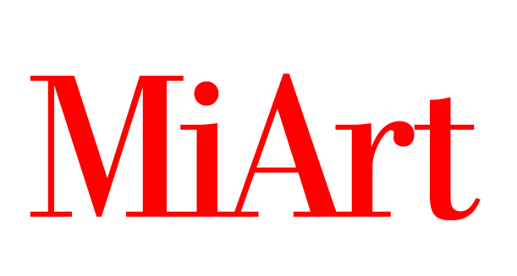
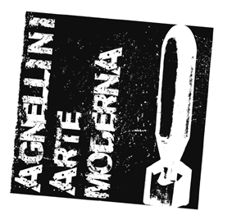
AGNELLINI ARTE MODERNA

Press Release 28.03.2011

AGNELLINI ARTE MODERNA at MIART 2011
pad. 3 stand E11

April 8th – 11th
Opening Thursday 7th April, h 18.00.

Agnellini Arte Moderna is delighted to announce its presence to Miart 2011 where will be presented an extraordinary collective of Internationally acknowledged artists.
Therefore, there will be shown works of art of the most important modern and contemporary artists, such as Josef Albers, Karel Appel, Giacomo Balla, Miquel Barcelò, Sam Francis, Andy Warhol, Georges Mathieu.

In particular, great attention will be given to this latter, universally recognized as one of the most significant European figure of the Abstract Expressionism, and will be presented an exclusive preview of the Mathieu’s exhibition that will be hosted by the gallery next October.

Roberto Agnellini has dedicated the past Miart editions to the celebrations of the big master artists such as Andy Warhol, Robert Rauschenberg and Jacques Villeglé with monographic exhibitions.
Instead, this edition will be characterized by a collective show that witnesses a new and significant step forward on the successful artistic path undertaken by the gallery.

Agnellini Arte Moderna, guided by the artistic direction of Dominique Stella is keeping on offering high quality exhibitions with an eye turned towards the new trends of the emergent art market such as the Chinese and Indian panorama amongst the others: Gupta, Thukral&Tagra, Reddy, Zhang Xiaogang e Feng Zhengjie.

Besides them, Agnellini Arte Moderna keeps representing the key artists of the modern history of art: Fontana, De Chirico, Prampolini, Balla, Severini, Burri, Boetti, Christo, Haring, Spoerri, Scarpitta, Vasarely and many others.

MiArt details
Location MiArt, pad. 3 stand E11
Fieramilanocity, entrance Porta Teodorico, Viale Scarampo - Milan
Press conference Thrusday 7 april, at 11.30am
Vernissage Thursday 7 april, at 6pm
Dates 8 – 11 April 2011, h11am - 8pm; Saturday 9 April, h11am-9pm and on Monday 11 April, h11am – 5pm
Entrance fee €15; €10 students

Information Agnellini Arte Moderna
Via Soldini 6/A – 25124 Brescia
Tel. +39 030.2944181 – info@agnelliniartemoderna.it
www.agnelliniartemoderna.it

Press Office Irma Bianchi Comunicazione
tel. +39 02.89404694 r.a. - fax +39 02.835646 info@irmabianchi.it
texts and jpegs: http://www.irmabianchi.it/MiArtbis.htm

