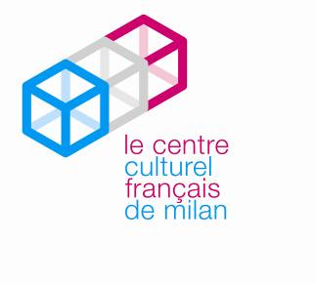
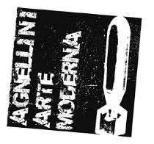

Council of Brescia
Culture and Tourism Dept.
of the City of Brescia

AGNELLINI ARTE MODERNA

Press Release 11.10.2011

GEORGES MATHIEU
1948-1969
curated by Dominique Stella

Venue Brescia, Agnellini Modern Art Gallery
Dates 18 October 2011 – 14 April 2012
Grand opening Saturday, 15 October 2011 at 6.30pm

On Saturday, 15 October the Agnellini Modern Art Gallery of Brescia launches the solo exhibition of Georges Mathieu, which will be open to the public from 18 October 2011 to 14 April 2012. The exhibition Georges Mathieu. 1948-1969, curated by Dominique Stella, consists of an excellent selection of 24 works, extremely meaningful in the career of the artist, some of which are presented at the Centre Cultural Français de Milan for the first time.

The important works on display thoroughly illustrate the artistic career of Georges Mathieu between 1948 and 1969, twenty years which very well represent the fundamental steps of his creative language. After he founded the Lyric Abstraction movement in 1947 the artist turned his research towards a more explosive gestural art to arrive at a more geometric style in the ‘60s. According to Mathieu painting is meant as an art of pure passion, free from any formal constraints, which prefers improvisation and spontaneity of sign, refusing stable references and links to defined forms.
The artist has more than once said: “my painting is a painting of energy, fever, of excitement of life”. Speaking of which the curator Dominique Stella states: “no one before him had been transported by such an impetus, such spontaneity, such theatricality in the creation of paintings, the strength of which is born from the movement and also the speed of execution”.

Among the works made in extremely short times, even though they are of large sizes, one can admire on display Saint Georges terrassant le dragon of 1961 (150x300cm), which has been created in front of a big audience in Byblos, Lebanon, during one of the several performances executed by the artist during his trips around the world, in order to create a state of “positive” shock able to shake the consciousness of his contemporaries.

In his vision the artistic sign precedes the meaning and becomes a means of connection between the subconscious and the real world, as it can be perceived in Petit engorgement clandestin (1956), a work full of symbolism.
The gesture of Mathieu, apparently uncontrolled, translates the dimension of a deep and complex thought which investigates and reflects on past, present, art history, painting and his own experiences. The artist, who takes part in the contemporary cultural and political reality, is very attracted by history, especially from the Middle Ages, as it is clear in the work Potencé, Contre-Potencé (1965): it characterizes the heraldic period of the artist, when he studies and deepens his knowledge of weapons and coats of arms, interpreting them with metaphorical signs. The same is true for the painting Le Bassin de l’Ile d’Amour ou Adelbert Comte de Namur (1962), where he recalls a character from the Dark Ages. This important work is representative of a moment of transition of the artistic career of Mathieu in-between minimalism and explosive language; in fact the composition embodies at the same time harmony and a disrupting force.

The exhibition is completed by a catalogue with texts in Italian and French by Roberto Agnellini, Dominique Stella, Gérard Xuriguera, Francesca Zappia and Giampietro Guiotto, and a biography curated by Daniel Abadie.

Details
Name Georges Mathieu 1948-1969
Curated by Dominique Stella
Venue Agnellini Modern Art Gallery
Via Soldini 6/A, Brescia
Dates 18 October 2011 – 14 April 2012
Grand opening Saturday, 15 October 2011 at 6.30pm
Opening hours Tuesday-Saturday 10am-12.30pm and 3.30pm-7.30pm
Closed Sunday and Monday.
Catalogue published by Agnellini Arte Moderna with texts by Roberto Agnellini, Dominique Stella, Gérard Xuriguera, Francesca Zappia, Giampietro Guiotto and a biography by Daniel Abadie.

Info Agnellini Modern Art Gallery
Via Soldini 6/A – 25124 Brescia
Tel. +39 030.2944181 Fax 030.2478801
info@agnelliniartemoderna.it www.agnelliniartemoderna.it

Press Office Irma Bianchi Comunicazione
tel. +39 02 89404694 - fax 02 8356467 info@irmabianchi.it
Text and photo downloads from www.irmabianchi.it

