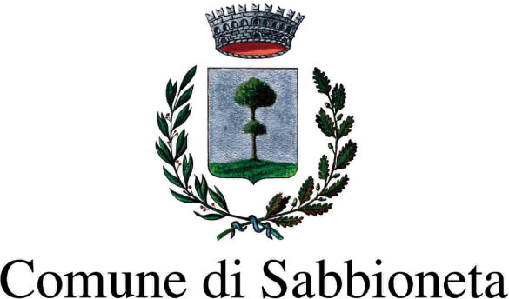

Con il Patrocinio di:
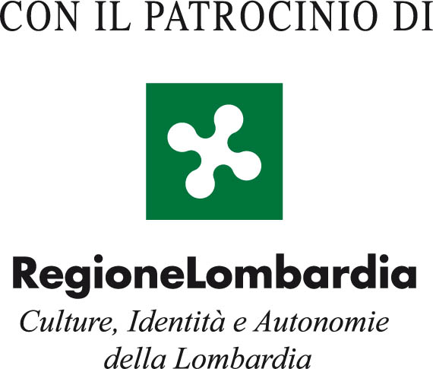

II International Biennale of Contemporary Art of Sabbioneta. Parallels

List of Works

Jake Aikmann (South Africa), Breach, 2010, oil on canvas, cm. 240x175

Marcel Alocco (France), Adam et les Demoiselles, Détissé sur châssis n°853, 2009, fabric on wood frame, cm 149x83
Marcel Alocco (France), Eve, Détissé sur châssis n°821, 2008, fabric on wood frame, cm 166x83
Marcel Alocco (France), Fragment du Patchwork n° 11 bis, 1974, glycerine on fabric, cm 227x201
Marcel Alocco (France), Les campeurs, d’après F.Léger Carte postale. Fragment du Patchwork n. 104, 1978, glycerine on fabric, cm 265x218
Marcel Alocco (France), «…et prière à la Lune», Fragment du Patchwork n° 101, 1978,
glycerine on fabric, cm 276x330

Heidi Bedenknecht (Germany), Organic symmetries, 2007, fluorescent polycarbonate tape, different sizes

Gabriella Bozzi (Italy), Untitled, oil on canvas, cm 100x100
Gabriella Bozzi (Italy), Untitled, oil on canvas, cm 100x100
Gabriella Bozzi (Italy), Untitled, oil on canvas, cm 100x100
Gabriella Bozzi (Italy), Untitled, oil on canvas, cm 120x70

Felice Cappa, (Italy), Screening of a movie on ceiling, 2010

Ferruccio D'Angelo (Italy), The town, 2010, oil on panel, oil drum cover, diam. cm 61
Ferruccio D'Angelo (Italy), Travel bag, 2009, enamelled oil drum, diam. cm 61x 57h
Ferruccio D'Angelo (Italy), Still life at east, 2010, digital shot on canvas, cm 190x120

Novello Finotti (Italy), Big cobra,1999, bronze, cm 195x170x165
Novello Finotti (Italy), Dear ancestors, 2006, Belgian black marble, cm 134x172x42
Novello Finotti (Italy), After the silence, bronze, 1972, cm 97x237x99
Novello Finotti (Italy), Nile, 1969, bronze and plexiglass, cm 200x42x30
Novello Finotti (Italy), Walking anatomy, 1969, bronze

Dario Ghibaudo (Italy), Museum of Un-natural History , 2004-2005, silicone with fluorescent dusts, cm 300x150

Zhang Hongmei (China), Memories, 2010, acrylic on canvas, cm 67x100
Zhang Hongmei (China), Memories, 2010, acrylic on canvas, cm 78x152
Zhang Hongmei (China), Memories, 2010, acrylic on canvas, cm 67,2x100,1

Long Bu Jiang (China), Absentminded black eyes, 2010, mixed media, cm 59x59
Long Bu Jiang (China), Absentminded black eyes, 2010, mixed media, cm 59x59
Long Bu Jiang (China), Absentminded black eyes, 2010, mixed media, cm 59x59
Long Bu Jiang (China), Absentminded black eyes, 2010, mixed media, cm 59x59

Nuria Rami Jurado (Spain), Indomable Locura 1, 2009, mixed media on canvas, cm 300x150
Nuria Rami Jurado (Spain), Indomable Locura 2, 2009, mixed media on canvas, cm 300x150
Nuria Rami Jurado (Spain), Ombras de Luz, 2008, mixed media on canvas, cm 150x150
Nuria Rami Jurado (Spain), Alma Araňada, 2008, mixed media on canvas, cm 150x150

Anton Karstel (South Africa), The Rapportryers Guard of Honour, 2008, oil on canvas, cm 110x150

Huang Kehua (China), Water, photograph
Huang Kehua (China), Lotus, photograph

Sarit Lichtenstein (Germany), Rainforestvv, 2005, mixed media on canvas, cm 160x120
Sarit Lichtenstein (Germany), Untitled, 2009, acrylic on canvas, cm 50x50
Sarit Lichtenstein (Germany), Untitled, 2009, acrylic on canvas, cm 50x50
Sarit Lichtenstein (Germany), New Experience, 6 pieces, 2009, mixed media on canvas, cm 120x180

Johann Louw (South Africa), Untitled II, 2010, oil on board, cm 159x122
Johann Louw (South Africa), Untitled I, 2010, oil on board, cm 159x122

Antonella Mazzoni (Italy), Nano Choices, video framings

Zhang Xian Ming (China), Phantasm No.1, 2008, cm 160x107
Zhang Xian Ming (China), Phantasm, 2008, cm 160x107
Zhang Xian Ming (China), Phantasm No.2, 2008, cm 160x107
Zhang Xian Ming (China), Phantasm No.4, 2008, cm 160x107

Francis Naranjo (Spain), Help, 2007-2008, video

Xu De Qi (China), China flower 4, 2010, oil on canvas, cm 100x130
Xu De Qi (China), China flower 6, 2010, oil on canvas, cm 100x130
Xu De Qi (China), China flower 5, 2010, oil on canvas, cm 100x130

Enrico Robusti (Italy), Meat, 2010, oil on canvas, cm 120x100
Enrico Robusti (Italy), How was it possible to get lost in this universe-bed, 2010, oil on canvas cm 200x160
Enrico Robusti (Italy), Free beach, 2010, oil on canvas, cm 200x250

Agostino Rocco (Italy), Allegory of Saint Cloud, 2008, Lambda print, cm 150x118
Agostino Rocco (Italy), Au Jardin de Gondi, 2008, Lambda print, cm 188x125
Agostino Rocco (Italy), Catherine de Medicis, 2008, Lambda print, cm 188x125
Agostino Rocco (Italy), Le Roi mourant, 2008, fotografia, Lambda print, cm 188x125
Agostino Rocco (Italy), Austria felix, Gallia felix (Madame Royale), 2008, Lambda print, cm 188x125

Marco Nereo Rotelli (Italy), Messages for the humanity 8, 2010, installation, acrylic on canvas, cm 60x60
Marco Nereo Rotelli (Italy), Don’t cut the trees, 2010, installation, acrylic on panel, cm 100x120

Medhat Shafik (Egypt), Town and parfumes, 2007, installation, iron and glass, diam cm 300, h cm 320
Medhat Shafik (Egypt), Ulysse, 2007, installation, cm 400x700

Alexander Bocchialini Shundi (USA), Eye-ia, 2008, oil on canvas, cm 91,4x91,4
Alexander Bocchialini Shundi (USA), Five Moons of Jupiter, 2009, oil on canvas,
cm 71x71
Alexander Bocchialini Shundi (USA), Never ending Sundial, 2009, oil on canvas, cm 76x111
Alexander Bocchialini Shundi (USA), Sequenza misurata - Sei x Otto - Pascoli, 2008, oil on canvas, cm 81,2x89
Alexander Bocchialini Shundi (USA), Inside truth, 2008, oil on canvas, cm 50,8x101,6

Rino Valido (Italy), The heel, 2007, mixed media on canvas, cm 200x180
Rino Valido (Italy), In Paris I met Picasso, 2007, mixed media on canvas, cm 150x200
Rino Valido (Italy), Isola, 2008, mixed media on canvas, cm 150x200

Ruchika Wason Singh (India), Contested Garden, 2008, charcoal and pencil on paper, cm 49,5x63,5
Ruchika Wason Singh (India), Contested Garden, 2008, charcoal and pencil on paper, cm 49,5x63,5
Ruchika Wason Singh (India), Blood Roots Routes, 2008, charcoal on Indian handmade paper, cm 40,6x58,4

William Xerra (Italy), I lie to my promises – da La Peste di Nicolas Poussin, 2010, print on canvas, cm 120x100
William Xerra (Italy), I use to lie at this time of the day, 2007, video

Liu Zhong (China), BP4.20, 2010, Chinese paint, cm 68x136

