LIST OF WORKS - Gianfranco Meggiato
- Monumental Sculptures - Historic Centre, Pisa
- Medium sculptures - Church of Santa Maria della Spina

14 MONUMENTAL SCULPTURES - Historic Centre, Pisa
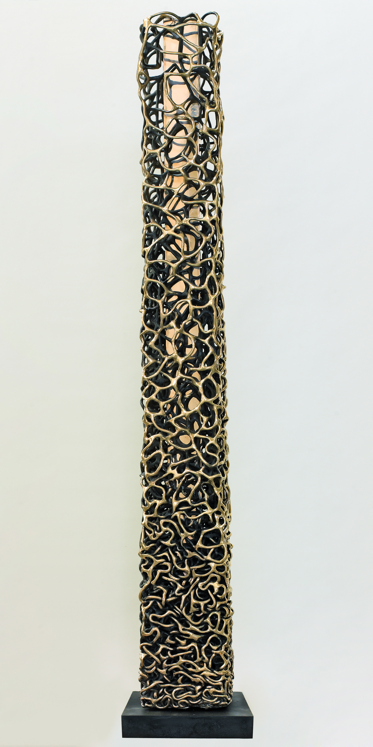 | Double Totem, 2008 - bronze 260 x 35 x 35 cm | Corso Italia  corner of Via Toselli
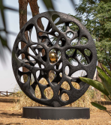 | Tension Disc, 2017 - painted aluminium, bronze  Ø 200 x 35 cm | Piazza XX Settembre
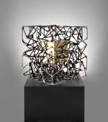 | Cube with Cube, 2015 - bronze 210 x 100 x 100 cm | Piazza San Matteo in front of the Museum
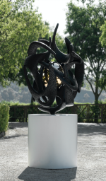 | Quantum Sphere, 2021 - painted aluminium, bronze  220 x Ø 120 cm | Church of Santa Maria della Spina, Lungarno Gambacorti
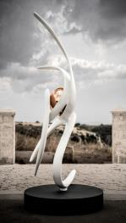 | Beyond, 2017 - painted aluminium, stainless steel  300 x 110 x 70 cm | Church of San Paolo –  Ripa d'Arno
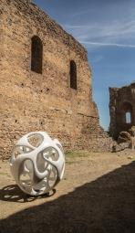 | Sirius Sphere, 2017 - painted fibre glass - Ø 200 cm | Piazza Terzanaia
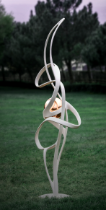 | My Free Thought - 2017, painted aluminium, stainless steel - 400 x 100 x 150 cm | Piazza Terzanaia
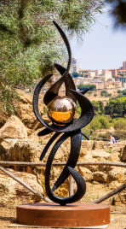 | Taurus, 2017 - painted aluminium, bronze  300 x 60 x 90 cm | Lungarno Simonelli, pedestrian area around the Museum of Ships
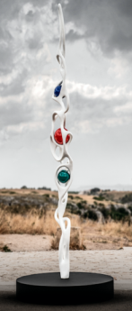 | Triad, 2019 - painted aluminium, painted brass  400 x 40 x 55 cm | Via Santa Maria  Piazza Cavallotti
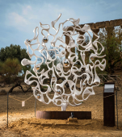 | The Mirror of the Absolute, 2021 - painted aluminium, stainless steel - Ø 330 x 40 cm | Piazza dei Miracoli
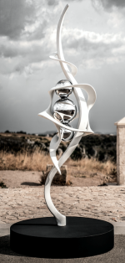 | The Breath of Life, 2019 -painted aluminium, chrome-finished brass - 300 x 90 x 80 cm | Cloisters of the Jesuits, Scuola Superiore di Sant’Anna, Piazza Martiri della Libertà
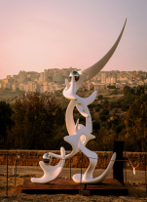 | Quantum Man, 2021 - painted aluminium, stainless steel - 500 x 280 x 210 cm | Piazza dei Cavalieri
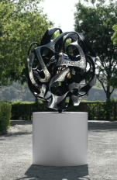 | Antares Sphere, 2021 - painted aluminium, bronze  220 x Ø 120 cm | Church of San Michele in Borgo, Borgo Stretto
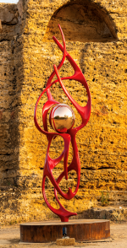 | Latin Soul, 2017 - painted aluminium, gilt-finished bronze - 300 x 100 x 70 cm | Corso Italia

cont.
11 MEDIUM SCULPTURES - Church of Santa Maria della Spina
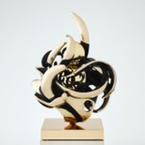 | Aquarius sphere, 2019 - bronze - 81 x Ø 60 cm
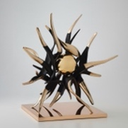 | Dancing in The Dark, 2021, bronze - Ø 75 cm
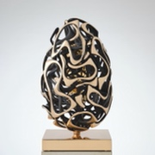 | God is Mother, 2020 - bronze - 56 x Ø 40 cm
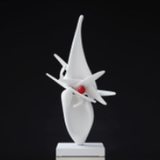 | The Violated Venus, 2019 - painted bronze - 90 x 50 x 27 cm
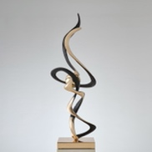 | The Magic Touch, 2020 - bronze - 110 x 45 x 37 cm
 | Concept of Spatial Synchronicity, 2019 - painted bronze - 119 x 50 x 30 cm
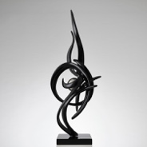 | Mistral, 2019 - painted bronze - 115 x 48 x 42 cm
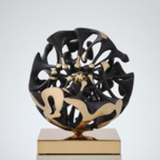 | Inner World, 2020 - bronze - Ø 40 cm
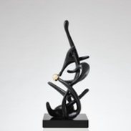 | Music is a Perfume, 2018 - coated bronze, 72 x 27 x 30 cm
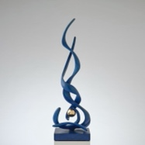 | Beyond the Finite, 2019 - coated bronze - 85 x 32 x 23 cm
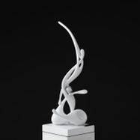 | Germination, 2019 - painted bronze - 75 x 28 x 25 cm

