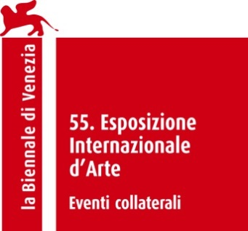

GLASSTRESS
WHITE LIGHT / WHITE HEAT

Curated by Adriano Berengo e James Putnam

Collateral event 55. Esposizione Internazionale d’Arte – la Biennale di Venezia

Biography of ‘White Light/White Heat’ curator James Putnam

James Putnam is an independent curator and writer. He founded and was curator of the British Museum’s Contemporary Arts and Cultures Programme from 1999 to 2003. His book ‘Art and Artifact – The Museum as Medium’ (Thames & Hudson in 2000/10) surveys the interaction between contemporary artists and the museum. He has curated an ongoing series of critically acclaimed projects with contemporary artists at the Freud Museum, London that have included Sophie Calle, Sarah Lucas, Tim Noble and Sue Webster and Mat Collishaw. He was appointed curator of Arte ‘all Arte 9, in Tuscany in 2005 and was on the curatorial committee for the 2006 Echigo Tsumari Triennial, Japan. In 2009 he curated ‘Distortion’ and ‘Library’ as Collateral exhibitions of the 53rd Venice Biennale. He was a curator for the Busan Biennale, S.Korea (2010). Most recently he curated ‘The Knowledge’ exhibition for the 54th Venice Biennale (2011) that included a site-specific installation by Chiharu Shiota. From 2003-2004 He was Visiting Scholar in Museum Studies at New York University and is currently Senior Research Fellow, Exhibitions, The London College of Fashion, University of the Arts, London.

