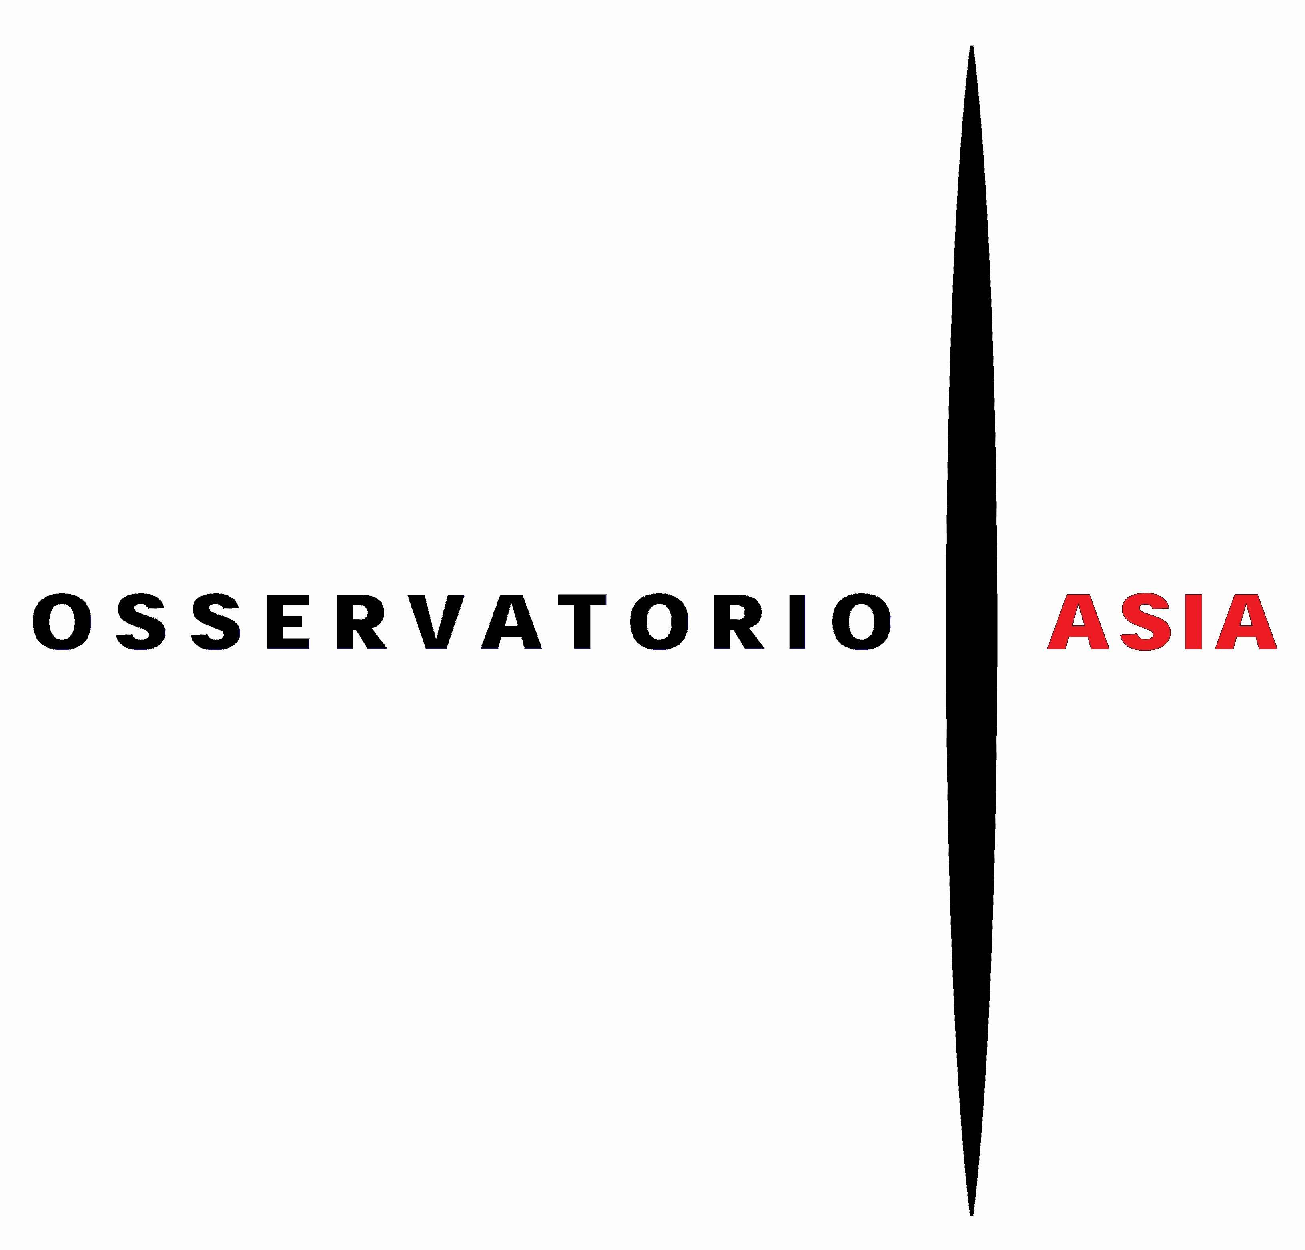 |  |  | In collaboration with | 

INVITATION

CULTURE AS AN INSTRUMENT FOR PEACE

Anticipating My East is your West
Rashid Rana, Pakistan and Shilpa Gupta, India
at the 56th Venice International Art Biennale

Pre-opening Conference
Milan, Monday, 9 February 2015 at 18:30
Palazzo Giureconsulti, Piazza dei Mercanti 2, Sala Colonne

The recent award of the Nobel Prize for Peace to Pakistan’s Malala Yousafzai
and India’s Kailash Satyarthi is confirmation that historical conflict
can be overcome, and that dialogue can prevail between the two countries.

Speakers
Federico Maria Bega, Manager of Strategic Areas, Promos - Chamber of Commerce
Romeo Orlandi, Chairman of the Scientific Committee of Osservatorio Asia
Feroze Gujral, President of the Gujral Foundation
Martina Mazzotta, Curator, Fondazione Antonio Mazzotta

On the occasion of the 56th Venice International Art Biennale, which will open in May in conjunction with the Milan International Expo, India and Pakistan will be present in a unique shared participation.
The event is supported and curated by Feroze Gujral of the Gujral Foundation, India.

The prestigious Palazzo Benzon on the Grand Canal will be home to this exhibition, which will bring together an artist from India and an artist from Pakistan. As an official collateral event of the 56° Venice International Art Biennale, the project is closely integrated with the vision of Okwui Enwezor, the Biennale’s curator for 2015. His statement to “offer the world a global sounding board”, and the Biennale’s title of All the World's Futures, invite us to reflect on the role the visual arts play in tracing meaningful elements from the upheavals of our time.

The Milan preview, to be held at the Chamber of Commerce, is promoted by four institutions operating in diverse areas: Promos, Osservatorio Asia, The Gujral Foundation and Fondazione Antonio Mazzotta.

The chosen theme takes its cue from two shared reflections: globalisation can be an instrument of peace, and that culture, the arts and education represent complementary rather than antagonist factors to the economy. New perspectives therefore can and should be opened in bilateral relations. A more open and constructive social foundation is the best way forward for the circulation of products, resources and capital. The benefits of this would soon spread to Italian businesses as well.

The project promoted by The Gujral Foundation, which brings together Shilpa Gupta from India and Rashid Rana from Pakistan at Palazzo Benzon, represents an unprecedented initiative, far-sighted and full of implications that go way beyond a mere ‘event’ in a contemporary art programme.
Martina Mazzotta of the Fondazione Antonio Mazzotta, Italian partner foundation in the initiative, shares with Romeo Orlandi of Osservatorio Asia the curatorship of the project’s collateral events.
Press office

IBC Irma Bianchi Communication
Via Arena, 16/1 - 20123 Milano
tel. + 39 02 8940 4694 mob. + 39 328 5910857
skype: irmabianchicomunicazione1
text and photo downloads from www.irmabianchi.it- info@irmabianchi.it

Sutton PR
South Wing Somerset House, Strand, London WC2R 1LA
+44 (0) 20 7183 3577 +44 (0) 78080 39663
www.suttonpr.com
Twitter: @sutton_pr Instagram: suttonpr

