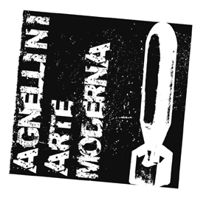
AGNELLINI ARTE MODERNA

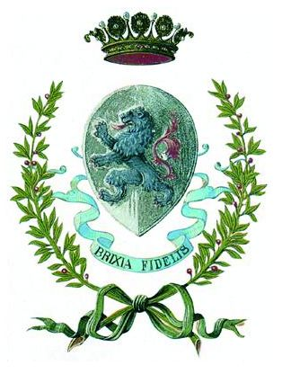

Comune di Brescia
Assessorato alla Cultura
e al turismo della città di Brescia

JIM DINE

Works on exhibition

- Jim Dine, Night in the Room, 1994, wood, cm 182,9x45,7x53,3
- Jim Dine, Other Heart on the Rock, 2007, bronze, cm 121x53x50
- Jim Dine, The Red Twins, 2004, bronze, cm 162,6x160x83,8
- Jim Dine, Pinocchio, The Grey Shirt (Böras), 2007, wood, cm 127x88,9x68,6
- Jim Dine, Plascassier, 2008, acrylic on panel, cm 80x69
- Jim Dine, Opio, 2008, acrylic on panel, cm 80x69
- Jim Dine, Gourdon, 2008, acrylic on panel, cm 80x69
- Jim Dine, Cagnes sur Mer, 2008, acrylic on panel, cm 80x69
- Jim Dine, Le Rouret, 2008, acrylic on panel, cm 80x69
- Jim Dine, Grasse, 2008, acrylic on panel, cm 80x69
- Jim Dine, The Dream in the Mini Bar, 2007, dyptich, mixed media, cm 150x202
- Jim Dine, Chez Big René, 2007, acrylic on canvas, cm 200x150
- Jim Dine, John Cage, 1961, mixed media, cm 187x32
- Jim Dine, Double Hearts, 1972, tempera on paper, cm 57,2x72,4
- Jim Dine, Jessie with Shell, 1982, mixed media, cm 108x76,8
- Jim Dine, Herman, 2008, acrylic on panel, cm 61x44,5
- Jim Dine, Dear, 2008, acrylic on canvas, cm 70x50
- Jim Dine, Blue Sun, 2008, acrylic on canvas, cm 150x202
- Jim Dine, A Sea of Blood, 2008, acrylic on canvas, cm 200x150
- Jim Dine, The Crack at Dawn, 2008, acrylic on canvas, cm 200x150
- Jim Dine, Jolly Arm, 2008, acrylic on canvas, cm 200x150
- Jim Dine, Moss in the Glen of Paint, 2007, acrylic on canvas, cm 243,8x304,8
- Jim Dine, Colorful Parrot at Home, 2007, bronze, cm 167,6x96,5x66

