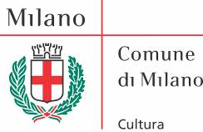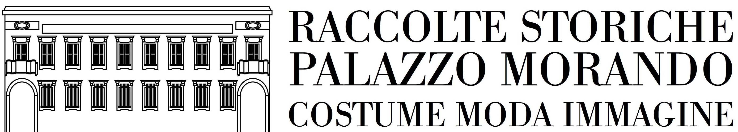

Palazzo Morando Costume Moda Immagine
Milan

Barbara Molteni Zanessis.
Milos isole interiori/ Milos Inner Islands
curated by Philippe Daverio

April 24th – May 29th 2013
Opening: Tuesday, April 23rd, at 6:30 pm

Press Release, March 21th 2013

Palazzo Morando – Costume Moda Immagine presents from April 24th to May 25th the photo exhibition entitled “Barbara Molteni Zanessis. Milos isole interiori” / “Barbara Molteni Zanessis. Milos Inner Islands”, curated by Philippe Daverio.

On display there will be shots made in Milos by the artist, Italian by birth and Greek by adoption, from 2010 to 2013. The images tell us the natural beauties on the Greek island located in the heart of the Cyclades, where she has been living for over twenty years now.

Barbara Molteni Zanessis is attentive to every visual and emotional aspect that she conveys through a direct photographic language, describing her own feelings in front of an unpolluted nature and of local landscape aspects.

In the exhibition path, you encounter different themes dear to the artist, namely: Giganti rossi (Red Giants), I colori del vulcano (The Colours of the Volcano), I Luoghi (The Places), La forma della lava (The Shape of Lava), La pelle sensibile delle scogliere (The Sensitive Skin of the Cliffs), Le tracce dell’uomo (The Traces of Man) and Sentinelle silenziose (Silent Sentinels). These summarized the issues on which the artist investigates most, i.e. the plays of light, perspective cuts, polychromatic earth of the volcano, varied textures of rocks, unusual shapes of the cliffs and relationship between man and environment.
Particular attention is paid to forms - which are combined in compositions of balances and symmetries - and colour, enhanced in bright tones and contrasts of reds, ochres and greys.
Besides the remarkable naturalistic vein, an extensive research of the detail emerges which leads to the realization of shots with an abstract taste resulting in a strong emotional impact. The landscapes and the elements of nature sometimes evoke animal, anthropomorphic, dreamlike features which link reality to fantastic dimensions.

This exhibition, of a high artistic and cultural profile, establishes a dialogue between Greece and Italy, and is the result of a project supported by the patronage of the Greek Consulate, the Greek Tourist Board, the Hellenic Community and the City of Milos.

The exhibition is accompanied by the monographic book “Barbara Molteni Zanessis. Cicladi” (“Barbara Molteni Zanessis. Cyclades”), published by Arti Grafiche Lucini in Italian, English and Greek, with an introduction by Philippe Daverio.

Biographical notes
Barbara Molteni Zanessis was born in Como, Italy, in 1959.
Having always been a lover of photography, she began her artistic career in parallel with her studies in architecture.
After graduating in Venice, in 1984 she moved first to Athens and then to Milos, the island in the Cyclades, where she actually lives.
In Greece, besides her passion for photography, she devotes herself to private practice: together with her husband, an architect, she designs residential and public buildings, hotel facilities and museums.
During several journeys throughout Europe, Asia, Africa and America in the 1980s and 1990s she refined her technical knowledge and deepened her artistic research.
In the first years of activity, she devoted herself mainly to architectural elements, having recourse particularly to black and white. Then she gradually turned her interest to portraiture and natural themes. Her artistic path is characterized by an increasing attention to detail, which lead Barbara Molteni Zanessis to abstract interpretation.
Her passion for photography and the architectural profession continue to be part of her evolution; she focuses mainly on the study of the effects of light on volumes and on the research on colours, which play a crucial role in both disciplines.
Barbara Molteni Zanessis’ photographic research reached over time increasingly original artistic investigation, which lead her to hold several solo exhibitions.
Since 2009, she has created some works with the Greek-German artist Leda Luss Luyken as part of “ModulArt”.
In her works of the last two years she emphasizes the search for suggestions through the use of advanced digital processing techniques.
She participates in group exhibitions held in Greece, the Netherlands and Germany.
Her works are included in private and public collections.

Exhibition details
Title: Barbara Molteni Zanessis. Milos isole interiori (Milos Inner Islands)
Curator: Philippe Daverio
Venue: Palazzo Morando - Costume Moda Immagine, Via Sant’Andrea, 6 - Milan
Opening ceremony: Tuesday, April 23rd, at 6:30 pm
Period: April 24th – May 29th 2013
Opening hours: Tuesday to Sunday from 9:00 am – 1:00 pm / 2:00 pm – 5:30 pm
Admittance: free

How to get there: MM1 San Babila – MM3 Montenapoleone – Tram lines 1- 2 / Bus line 94

Visitor information: Phone: +39 02 884 65735 - 46056
c.palazzomorando@comune.milano.it - www.civicheraccoltestoriche.mi.it

Press Office
Irma Bianchi Comunicazione
Phone: +39 02 8940 4694 (PBX system) – Fax: 02 8356467 info@irmabianchi.it
Text and photos available for download at: www.irmabianchi.it

