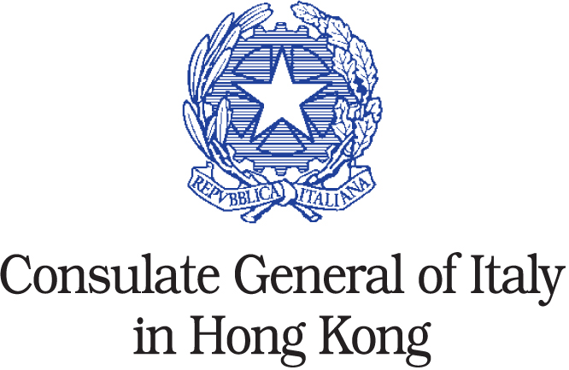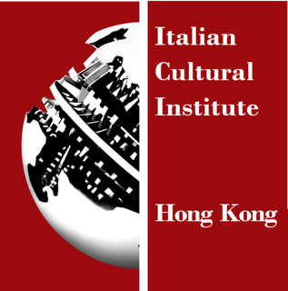

Consulate General of Italy in Hong Kong

Maria Cristina Carlini in China

23 may – 30 june 2013

Press release 10.06.2013

The sculptress Maria Cristina Carlini is back in China with an exhibition held at the headquarters of the Consulate General of Italy in Hong Kong, from May 23rd to June 30th.
The exhibition opens in conjunction with LINK - ArtFair - Hong Kong, the local international exhibition of contemporary art, where the artist is present, as well as with the first edition of Art Basel - Hong Kong, which hosts numerous galleries from all over the world.

On this occasion the public will thus be given the opportunity to admire two big size works made of corten steel and resin: these are two of the materials that Maria Cristina Carlini prefers for the creation of her works, which – at a preliminary stage – she makes using mainly stoneware, before giving birth to medium and large size sculptures of corten steel, resin, stoneware, iron and wood.

Over the years, Maria Cristina Carlini approached constantly new aesthetic experiences, dealing each time with different materials in order to meet her artistic needs.

There are three continents that have received over the years the works of Maria Cristina Carlini, namely: Europe, Asia and America. Following her exhibitions in China, we can now find some of her works permanently installed in: Beijing, Shanghai, Jinan, Tianjin and Rongcheng – Shandong.

The exhibition, organized by “arte Ipse dixit”, is under held the patronage of the Italian Cultural Institute in Hong Kong.

Bio
Maria Cristina Carlini is on exhibition with her works in three continents: Europe, America and Asia.
The sculptor started working ceramics in the early Seventies in Palo Alto, California, to later achieve to different materials as stoneware, iron, corten steel, wood and resin to create sketches and also monumental sculptures.
During the artistic activity of Maria Cristina Carlini, exhibitions in numerous international public and private venues followed one another, including these solo exhibitions: in Turin, in the rooms of the Monumental Complex of the Royal Palace (2005) and at the National Museum of Villa Pisani in Strà-Venice (2005), the State Archives in Rome (2006), the National Library in Cosenza (2008), the State Archives in Milan (2008), the International Sculpture Biennale at the Castle of Racconigi (2010), the Roman School Archive (2011-2012).
Several the events abroad to be reported. In 2009 Paris and later Madrid house her monumental sculptures in the streets of their historic centre. The following year, one of her monumental works is installed permanently in front of the Italian Embassy in Beijing. In the Forbidden City, a solo exhibition is inaugurated and she takes part to the IV Beijing International Art Biennale, in NAMOC National Art Museum of China. In Shanghai, in conjunction with the World Expo 2010, two of her monumental sculptures are placed in People’s Square.
She exhibits in the Jinan’s Shandong University of Art and Design and in Tianjin inaugurates a monumental sculpture.
In the same period her works are exhibited in Denver, USA, in the college of Auraria and the Rocky Mountain College of Art + Design and in Cap D’Agde in Southern France.
In 2011 in Miami, USA, one of her greatest monumental works, Icaro, inaugurates the Corpus Christi Catholic Church Sculpture Park and in the same year they put the Vittoria di Samotracia (Victory of Samothrace) just outside the Dade College.
In 2012 Carlini takes part to Artcurial during the “2012 AD Interiors” fair in Paris.
In 2012 in Italy she exhibits her monumental sculptures inside the park and the halls of Villa Recalcati, seat of the Province of Varese and later in Milan at Mudima Foundation and Stelline Foundation, with an important solo show, and at Bocconi University.
She received several awards and wrote of her leading critics such as: Luciano Caramel, Claudio Cerritelli, Gillo Dorfles, Carlo Franza, Flaminio Gualdoni, Yakouba Konaté, Elena Pontiggia.

Permanent Monumental Sculptures
Europe - Italy: 2005, Pesaro, civic Museums; 2006, Rome, State Archives; 2007, Milan, Court of Auditors; 2008, Milano Rho International Fair; 2008, Cosenza; 2009, Loreto; 2010, Reggio Calabria
China: 2010, Beijing, Italian Embassy; 2010, Beijing, NAMOC - National Art Museum of China; 2010, Shanghai, Sculpture Park; 2010, Jinan, Shandong University of Art and Design; 2010, Tianjin, Italian Institute of Culture; 2011, Rongcheng - Shandong
USA: 2010, Denver, Auraria Campus; 2010, Denver, Rocky Mountain College of Art+Design; 2011, Miami, Dade College; 2011, Miami, Corpus Christi Catholic Church - Sculpture Park

Exhibition details
Title: Maria Cristina Carlini in China
Venue: Consulate General of Italy in Hong Kong
3201, 32/F Central Plaza, 18 Harbour Road, Wanchai
Period: 23 May – 30 June 2013
Admittance: free

Press Office for Maria Cristina Carlini
Irma Bianchi Comunicazione
tel. +39 02 8940 4694 r.a. | fax 02 8356467 | info@irmabianchi.it
Download text and images from www.irmabianchi.it

