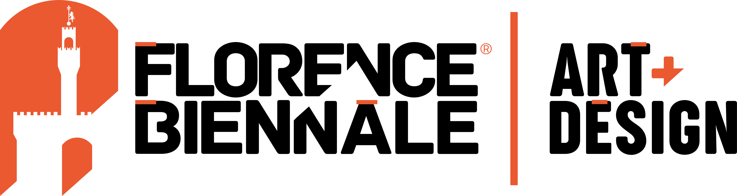

Fortezza da Basso
Viale Filippo Strozzi, 1 - Firenze

Maria Cristina Carlini is participating in the

XIII FLORENCE BIENNALE

ETERNAL FEMININE | ETERNAL CHANGE
Concepts of Femininity in Contemporary Art and Design

23 – 31 October 2021

Press preview Saturday 23 October, 10:00
Opening Saturday 23 October, 11:00

Press release, 12.10.2021

Maria Cristina Carlini is taking part in the XIII edition of the Florence Biennale ETERNAL FEMININE | ETERNAL CHANGE. Concepts of Femininity in Contemporary Art and Design, where she has been warmly invited to present a new work. The sculpture, titled Foresta [Forest], is on show in the Cavaniglia Pavilion, which is hosting a new project developed by the curator Fortunato D’Amico.

The Florence Biennale, an international exhibition of contemporary art and design, is being held in Florence’s Fortezza da Basso from 23 to 31 October 2021 under the patronage of the European Parliament, the MIC (Ministry of Culture), the Tuscany Region, the Municipality of Florence, and ADI (Tuscany Delegation of the Association for Industrial Design).

Approximately 400 artists, architects and designers from over 70 countries around the world are involved in this important event, which centres on the theme of femininity in its most varied and multiple facets. Commencing from Mother Earth, the essence and origin, the exhibition extends to include a wide range of current issues linked to the contemporary world from a cultural and social point of view, such as feminism and the LGBTQ+ community.

Following tradition, a number of prizes will be awarded, including lifetime achievement awards. In 2021 these go to the celebrated British designer and activist Vivienne Westwood; the world-famous Milanese photographer Oliviero Toscani; and to Piedmont artist Michelangelo Pistoletto, one of the leading exponents of Arte Povera.

Conceived and curated by Fortunato D'Amico, a new, special project is presented in the Cavaniglia Pavilion. Entirely focused on installations, it includes a wealth of interdisciplinary and multicultural dimensions, including art, design, poetry, architecture, music and sociology, linked to meetings, workshops, conferences and lectures on philosophical, social, scientific, cinematographic, spiritual and environmental topics.

The artworks aim to provide the public with original elements for further reflection, not only on the “feminine” in all its aspects and various levels of interpretation, but also on arguments relating to the nature, ecology and well-being of the planet.

These issues have been a constant concern of sculptor Maria Cristina Carlini, who to mark the occasion is presenting a new work Foresta [Forest], a monumental sculpture in recycled wood and iron. With its close link to the natural environment and the earth, the work is a metaphor for Mother Nature, who, through the image of branches, embraces, envelops and regenerates. Reclaimed wood helps to reinforce the image of stability and rootedness. This vision of femininity is traced back to its origins, to a natural context filled with life, with its own ecosystem that also projects into another dimension, far from everyday reality. An immersion in this “forest” offers the chance to identify the elements and tools that can be used to implement a transition geared towards change. Whereas from a macroscopic point of view we seek the means to protect the environment and biodiversity, from a microscopic point of view the goal is to repopulate urban spaces with greenery and nature.

Biographical notes. Maria Cristina Carlini began her artistic career working in the field of ceramics in Palo Alto, California, in the early 1970s. She subsequently continued her practice in Brussels and then in Milan, where she focused exclusively on sculpture. From that time on, in addition to her work in terracotta and stoneware, she began to use materials such as iron, Corten steel and recycled wood, creating sculpture of small, medium, but predominantly monumental dimensions. She has held solo exhibitions and taken part in group shows in numerous national and international public and private venues, such as Rome, Paris, Madrid, Miami, Denver, Beijing, Hong Kong and Shanghai. Her work is on permanent display in three continents: Europe, America and Asia, and she has been the recipient various awards and honours.
She currently lives and works in Milan.

www.mariacristinacarlini.com

Information
Title: Maria Cristina Carlini is participating in the XIII edition of the Florence Biennale ETERNAL FEMININE | ETERNAL CHANGE. Concepts of Femininity in Contemporary Art and Design
Location: Fortezza da Basso, Viale Filippo Strozzi 1, Florence
Dates: 23 – 31 October 2021
Press Preview: Saturday 23 October, 10:00
Opening: Saturday 23 October, 11:00
Opening to the public: Saturday 23 October, 11:30
Opening hours: every day 10:00 – 20:00 I Sunday 31 October 10:00 – 7:00 I Closed Mondays

Entrance fee
Full price: €10
Reduced price: €7 (over 65, under 30)
Youth price: €5 (6 – 18)
Free entrance: (0 – 6)
Ticket purchase: www.florencebiennale.org
Further information: Florence Biennale Tel. +39 055 324 9173 - info@florencebiennale.org
www.florencebiennale.org

Press Office
for Maria Cristina Carlini

IBC Irma Bianchi Communication
Tel. +39 02 8940 4694 - mob. +39 334 3015713 - info@irmabianchi.it
www.irmabianchi.it

