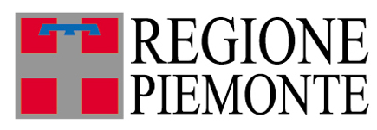
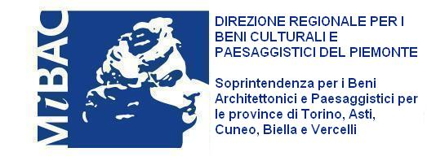
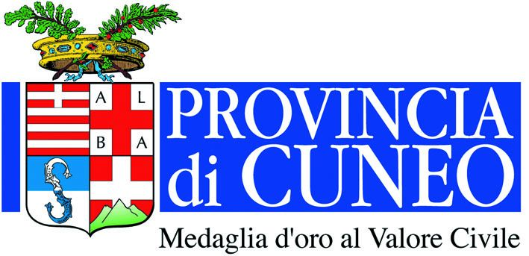
Con il Patrocino della:

Con il contributo della:

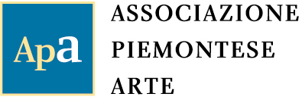
Organizzazione

Sculpture in the Contemporary World
Now in its sixth edition, this International Sculpture Biennale – promoted by the Region of Piedmont and organised by the Piedmontese Art Association, in partnership with the Piedmont Superintendency for Architectural Heritage and Landscape, in some of the region’s historical buildings and parks – has always been designed and conducted not as a static display of sculpture as objects set in the natural and architectural scene of the area, but on a dynamic, dialectic register of interaction between the sculpture and its context. So this is never a sequence of works of art to be contemplated, such as you might fight in a museum, but a real living world to experience with your mind, your feelings, all five senses and your whole body, as you make your way along the long routes that all visitors will no doubt invent for themselves: more demanding than before this year, they stretch over the two kilometres that separate the exhibition’s two foci, one centred on the seventeenth-century stately home and other at the Margaria, the farm run by the Royal House of Savoy, for centuries the owner of the entire complex.
The first two exhibitions, which Victor De Circasia installed in the Park of La Mandria in 2000 and 2002, aimed at the almost exclusive relationship between the sculpture and the very striking and rich natural environment. The next three, which I curated in 2004, 2006 and 2008 in the Castle, the garden and the park of Agliè, also in the environs of Turin, differed somewhat, in that they sought a more complex inter-relationship between contemporary sculpture and the nature and the architecture of the royal palace and of its garden and park, while also involving tradition and history. The unquestionable feature of the 2004 exhibition was the dominant presence of the splendid Castle itself, built in the mid-seventeenth century and extended in the eighteenth, with which the sculptures were induced to dialogue by being located in such a way as to interfere with the stately home and with the complex and varied architecture of the park and garden. The attempt was made, then, to avoid the tired model of open-air sculpture exhibitions with their superficial evasive and aestheticising connotations. In the following edition, in 2006, the dialectic between sculpture, nature and architecture flourished further on the relationship and confrontation between sculpture with a contemporary purpose and function and the eighteenth-century sculptural works of Ignazio and Filippo Collino, the directors of the Royal Sculptural Studio established by the Savoy family. The approach changed again for my third curatorship, two years ago, which focused on the burning issue of nature itself, as approached in both the Oriental and Western traditions, once again through the contemporary sculpture produced by the two different cultures, inspired by two maestros of the calibre of Naum June Paik, for the Far East, and Joseph Beuys for the West, to whom two tributes were dedicated.
This year, the focus is back on the dialogue between sculpture and the nature and architecture of the park, the garden and the monuments, in a context of unusual quality, beauty and historical and artistic significance. One of the largest of the palaces built by the Savoy family, the royal residence of Racconigi has an especially important and complex architectural and functional articulation that offers unprecedented opportunities to place contemporary sculptures. This is because the actual stately home itself, which was built in 1757 with the perspectives of a monument and a majestic façade with classical inclinations in the setting of a park and garden with tidily arranged areas of woodland, is accompanied on the very outskirts of the estate by the smaller complex known as the Margaria, designed in the neo-Gothic style in 1835-1843 by Pelagio Pelagi and at one time famous – among other things – as the home of a collection of exotic plants, and by the Royal Glasshouses, unblemished, slim, elegant structures, once again in the neo-Gothic style, designed a few years later by Carlo Sada, whose evocative subterranean rooms on this occasion house the works that require closed spaces, while all the others – the majority – are scattered around the park and garden, benefitting from the greater or lesser proximity of the architectural features as their backgrounds.
Reiterating the approach used in the previous editions, this year’s invited artists were once again from different nationalities, generations and so cultures and creative preferences. In 2004, the works on show were by Italian, Spanish and British sculptors, plus a group of sculptors who lives and work in Italy but originally came from France, Japan, Iran and the United States. In 2006, a selection of Italian artists once again partnered with their peers from Switzerland and Japan, while the theme chosen in 2008 induced the choice to fall on a group of western artists, from Denmark, Italy, Germany the UK, and a second group of eastern artists, from China, Korea and Japan. This year, the choice has once again fallen on artists from Italy and the UK, a land fertile for its plastic and sculptural output, together with several others from Taiwan who are not so well known in this part of the world. In the exhibition’s constituent international flavour and so variety, these artists all share the ambition to overcome the far from unmotivated sluggishness that besets sculpture today, by using Racconigi to stage a documentary record of living experiences (We are here and we are alive, as we entitled the 2006 edition), in a multidimensional, multiply shaped and multicoloured array of forty-five pieces by the same number of artists, made in the widest imaginable variety of materials and all sorts of sizes, that spreads over the whole park, reaching into its most secluded corners and into the glasshouses. Underlying these works is a desire and a commitment related to the quest for a new legitimacy for sculpture, also on the large scale, that goes beyond mannerisms and revivals, in an environmental and public dimension. Without betraying the creation’s status as a 3D object, the artist here sets out to demonstrate – to quote Arturo Martini in his Sculpture – a Dead Language, dating back to the distant year of 1945 – that sculpture is not just “an object, but an extension, that does not stay confined to the three dimensions, where death lurks”. This is aperture, the intention to relate, as opposed to drawing back into closure, isolation and statuary; it is extension, as Martini said, as opposed to the object: a concept that was later to be enriched – obviously with different connotations from the ones related to the different context postulated by Martini – by an increasingly decisive profile that penetrated beyond uniquely environmental terms to establish broader, versatile topological co-ordinates, introducing the totality of a space, perceived and frequented as a terrain, among other things experiencing a direct friction with a past charged with historical and artistic memorials, as in the case of Racconigi, involving those who visit this venerable stately home in a stimulating cultural experience, rich in creativity and imagination, in a context where the environment has shaken off its past role as an uninfluential, external factor, to become a constantly unfolding process that transforms the work of art to the same extent as the work of art transforms it. A process that, more generally speaking, can contribute to overcoming the crisis that has been afflicting the canons of sculpture for more than half a century by reviving its role and destination in relation to its urban and rural setting, the reconquest of a function in town and country planning and landscaping, adding quality to places that have none, such as suburbs and rundown areas, or, as in this case, adding further quality to existing quality in places that already have a positive character of their own. This is a process that can benefit from the fresh, youthful intervention of today’s art to get a rather useful revitalisation that does not clash with the memory and vestiges of the past, but makes them cohabit and dialogue with the life of the present day. And in the present day, where in practice we always experience the past, including art, which is no timeless absolute, but a reality that is dated to other years, centuries and millennia, but that it is impossible to escape experiencing in our present day, with all the tastes, preferences and values that belong to today. So much so that, in the introduction to his treatise on art, that great aesthetologist Dino Formaggio could state with apparent tautological provocation that the definition “Art is everything that people call art” is “maybe the only acceptable and verifiable one […] for trying to encompass the infinite, shimmering life of the meaning of art, of what people have called art in the past and call art today”. Adding that “it is possible to talk about a general idea of artistry, as long as we are aware that it is simply and solely” the result of the “connection of all the meanings with which people have defined the term ‘art’ from time to time in the course of history, restricting it, expanding it and modifying it all the time”. Or “it is an indeterminate and variable active form that embraces and connects all the possible ways of providing meaning that the experience of history produces with regard to what people have called art, every time starting all over again from scratch. It does not exist (in fact it is inconceivable) except as something that is done together with the making of art”. So art as art history, also because, as Giulio Carlo Argan pointed out, “the concept of art does not define categories of things, but a type of value” and “a work is only a work of art because that is what our consciousness judges it to be. So art history is not so much a history of things as a history of value judgements”. And history is always contemporary, as Benedetto Croce never ceased to remind us.
This much refers to the involvement of the many who will visit the venerable stately home in the months to come for an even more stimulating cultural experience, rich with inventiveness and imagination, which will no doubt contribute to the totality, again as described above, of the “terrain” that will be generated, precisely because of the very fact of being actively attended by visitors to the exhibition at Racconigi. Where we find the different tensions that have been shaking this ancient art of sculpture increasingly radically, by removing it and by placing it, ever since the sixties. On the one hand are the defenders at all costs of the continuity of sculpture’s status, while on the other are those who deny it all legitimacy, opposing above all its monumental connotations, its use of “noble” materials, especially marble and bronze, and even its choice of certain iconic forms, which are always accused of being anachronistic, because they fall into the trap of rhetoric, of those self-same monumental connotations, or of narrative descriptiveness. While many others – the majority, also in this exhibition – try to make sculpture contemporary, without throwing the baby away together with the bathwater. They are often the artists whose experimentation is the most lively, also in terms of their conceptualism. Among other things, they feature some interesting and sometimes definitive passages from the practice of painting that they originally professed – or still do – to sculpture, a procedure that has some illustrious precedents in both the recent and the distant past. Among the Italians showing in Racconigi, this is the case of Batacchi, Celiberti, Licata, Gastini, Paladino, Rotta Loria and Walter Valentini, while their British peers include Allen Jones, Christopher Le Brun and Rod Ward. Another unusual and apparently anachronistic aspect of great figural impact is the choice of topics and formal solutions that go beyond currency and contingency to refer to mythology, or at least to an archaeological and symbolic dimension that can be detected not only in the British sculptor Le Brun, but also in Mitoraj and in Paladino, as well as the unclassifiable figures that yet take part in a shared yet detached synopsis with an archaic flavour, charged with evocative suggestion.
The variety of positions that feature in this exhibition is macroscopically evident in the Arnaldo Pomodoro – Alex Guzzetti “couple”. The former, with Phillip King unquestionably one of the greatest sculptors of the second half of the last century, is showing four gigantic bronze Stelae, which are certainly monumental and “venerable” for their dimensions (700 x 70 x 40 cm), yet are also “light” for their upward thrust and the elaborate, cultivated processing of their surfaces. The latter, the author of Symbiotic micro-robot, solar battery-powered mobiles and sounds that “get lost”, because they are symbiotic, between the boughs and leaves of the trees, on the other hand has thrust radically into the contemporary, also by using technological mechanisms that enable him to place his micro-robots in the environment with unique, effective solutions, so that his mechanical “creatures” can be heard without being seen, for example, or seen without being heard.
Referring visitors to the illustrations and the biographies in this catalogue for information about the sculptors I have not mentioned here, I would nevertheless like to mention the five sculptors from Taiwan specifically: with the possible exception of Masayuki Koorida, they are all showing in Europe for the first time, bringing evidence of a lively artistic cultural climate that is open to European and US trends, yet has its own home-grown accents, as is demonstrated consciously and exclusively by Hung Yi with orientally-inspired figurings of tigers and other animals made of steel lacquered with bright, lively colours.

Luciano Caramel
Curator of the exhibition

