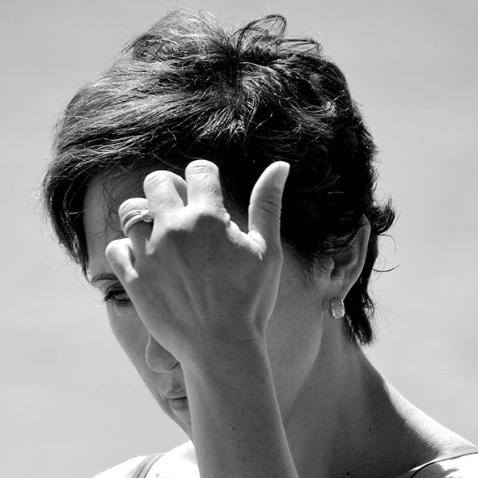
Biography

Luisa Menazzi Moretti was born in Udine in 1964. She moved with her family to the United States when she was thirteen; she was educated in Texas, first in College Station where she attended the high school and then in Houston for part of her academic education. During those years, she began cultivating her passion for photography; she attended courses, favouring printing and black and white development. She then got back to Europe, got her MA in Modern Foreign Languages and Literatures, worked in London and, after three years, she moved to Italy, where she began teaching English. She lived in Udine, Bologna, Rome, Neaples and Venice.
Arte’m published two books of Luisa Menazzi Moretti : Words (2013) and Nature’s Matters (2014). Her exhibitions have been curated and presented by Denis Curti, Achille Bonito Oliva, Francesco Bonami, Fortunato D’Amico and Maria Flora Giubilei.
Exhibitions

AMACI – Giornata del contemporaneo, Cose di Natura, Galleria La Salizada - Venezia (2015)
Visual Action Ayotzinapa, Ayotzinapa Rural Teachers College - Guerrero, Messico (2015)
Premio L’Isola 2015 - Tropea (2015)
Festival dei due mondi di Spoleto, Sconfinamenti #3, Rocca Albornoziana - Spoleto (2015)
The Billboard Creative: finalista per lo Show Q1, Hollywood – Los Angeles, USA (2015)
MIA Fair, Ingredients for a Thought, Galleria STILL – Milano (2015)
Affordable Art Fair, Galleria Spazio Farini – Milano (2015)
Tre Oci Tre Mostre: Cose di Natura, Fondazione Tre Oci - Venezia (2015)
Words, Galleria Dafna – Napoli (2015)
Oci su Luisa Menazzi Moretti ed Elio Ciol, Galleria La Salizada - Venezia (2015)
Christie’s Auction: a noi ci frega lo sguardo, Galleria di Arte Moderna - Milano (2014)
Forum Universale delle Culture, Words, San Domenico Maggiore – Napoli (2014)
Fotofest International, The Collector’s Eye: the Maloney Collection, Silver Studios – Houston, USA (2014)
Words, Galleria la Salizada – Venezia (2014)
Cose di Natura, Galleria d’ Arte Moderna – Genova (2014)
Words, Galleria Civica Tina Modotti – Udine (2014)
Words, Galleria Civica d’Arte Moderna e Contemporanea - Pordenone (2014)
Winter Sensations, Galleria Spazio Farini – Milano (2014)
Magic Mirror, Galleria La Salizada – Venezia (2014)
Magic Mirror, Galleria Tedofra – Bologna (2014)
Holiday Dreams, Galleria Spazio Farini – Milano (2013)
Finalista Premio Combat, Museo G. Fattori - Livorno (2013)
Finalista Premio Venezia (2013)
Words, Galleria Spazio Paraggi – Milano (2013)
MIA Fair, Words, Paola Sosio Contemporary Art Gallery – Milano (2013)
Magic Mirror, Galleria Le Stanze Bianche – Palermo (2013)
Affordable Art Fair - Milano (2013)
Bambini in missione di pace, Fondazione Sambuca - Palermo (2013)
Obiettivo la Ricerca, Centro Convegni AIL – Roma (2013)
Italo Zannier: la sfida della fotografia, Galleria d’Arte Moderna e Contemporanea – Pordenone (2013)
Magic Mirror, Fabbrica delle Arti – Napoli (2013)

