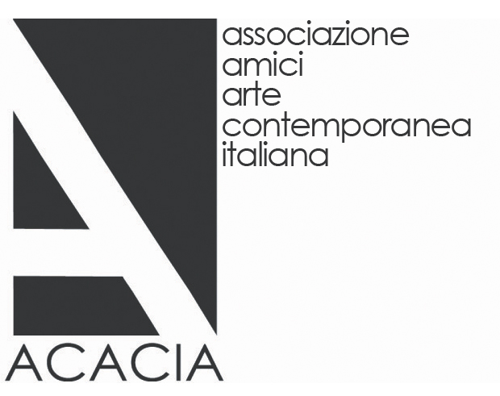
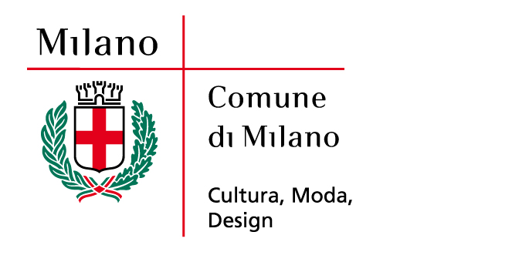


The Italian Artists of the ACACIA Collection
Friends of Contemporary Art Association

A collection for Milan
Giorgio Verzotti

The Italian artists featured in this show have been selected by the collectors of the ACACIA association with a view to their inclusion in a museum of contemporary art envisaged for Milan, a city where no such institution exists as yet. The choice has fallen on some of the leading figures in absolute terms of the cutting-edge explorations initiated in the late 1980s. This period marks a turning point with respect not so much to the type of work, a subject discussed below, as to the international renown soon attained by some of these artists. With the exception of the major figures of the post-war period and trends like Arte Povera and then Transavanguardia, presented in the form of movements even though no authentic group was involved, this has very seldom occurred in Italian art. There is nothing odd about this consideration and the priority it is accorded here in the context of a discussion regarding museums and the works to be housed there, because the success that has smiled more or less from the very outset on the work of Maurizio Cattelan, Vanessa Beecroft, Francesco Vezzoli and Paola Pivi, and is still smiling on the work of the younger artists today, means something particular and very important. It means that what is known as the art system began to function in Italy during that period. A system is an organism with a complex internal structure where all of the necessary functions are performed smoothly by a whole range of different operators. This came about in Italy with the growing responsiveness of museums, the institutional part of the system and the one previously conspicuous by its absence. Together with the public museums, the birth of private foundations finally made it possible to take over the role of promoting art otherwise delegated to galleries rightly operating for commercial ends. The existence of this field of public and private synergies then fostered other related phenomena, such as the birth of a very precise branch of specialized journalism and above all, as regards our present concerns, of associations of collectors determined to play an active part in stimulating the awareness of works of art among the general public. This show is one of the many results of this renewed vitality of the Italian system. Defended at home, artists have less difficulty in obtaining recognition on the international scene.

As we have clearly seen, the Italian art developed all through the 1990s and up to the present is fully comparable in terms of quality with the major international trends. Proof is provided not only by the fact that nearly all the artists present here, and some who are not, are normally invited to take part in the most important events held all over the world, starting with the now notorious biennials, but also and above all by the depth, intensity and meaningfulness of the work itself. The generations presented share the common characteristic of refusing to regard art as an occasion for purely formal exercises that may appear technically appealing but are vacuous and purely self-referential.
The spirit pervading them all is still and always that of the avant-garde, understood as the striving to break new ground and to probe the real world – the social context or the panorama of the cultural industry – with an openly critical stance. This intention often has a tinge of irony and sometimes becomes authentic provocation that is not, however, an end in itself because it always pinpoints a real contradiction, an unresolved conflict in the collective social or cultural sphere. If we were asked to indicate the “content” of these explorations, we could say that it is identified with existence. The artists develop their view of the world starting from themselves, from their existential experience and personal history, which they seek to connect with the history of everyone. The most customary (and hence disquieting) aspects of everyday life and cultural stimuli, from the most basic to the most sophisticated and exclusive, are all an integral part of existence and hence of the soil that feeds the artwork, which is often an attempt to combine the top and the bottom, day-to-day life and its cultured sublimation, culture and an ironic view of the same.

