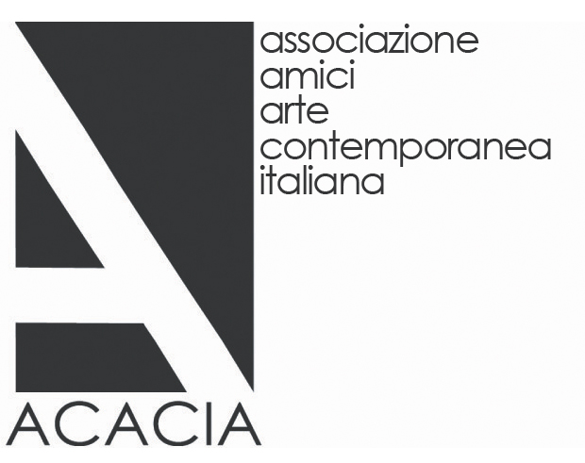
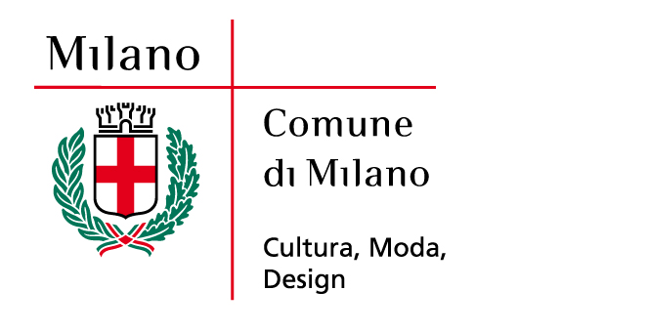


The Italian Artists of the ACACIA Collection
- Friends of Contemporary Art Association –

Collective patronage
Gemma De Angelis Testa

ACACIA is a young association. Though founded as recently as 2003, it commenced activity in its first month of existence and can take pride today in an intense programme consolidated over years of dedicated endeavour in fields ranging from the organization of exhibitions and lectures to cooperation with universities in the education and dialectical sphere and guided tours both in Italy and in other countries to cover the major events in contemporary art at the international level.

The acacia is solid and tenacious tree capable of overcoming every form of environmental hardship, including drought, and flourishing. As such, it constitutes a point of reference and an image encapsulating the spirit that animates the Associazione Amici Arte Contemporanea Italiana (Friends of Contemporary Art Association), better known as ACACIA, which has organized some twenty shows in the space of just nine years. The association’s aim is to obtain a museum, an adequate “institution-container” capable of promoting contemporary art at a level in keeping with the demands of a cosmopolitan city like Milan. Its first step with a view to this ultimate goal was to concentrate on “content” by building up a collection, also through loans and donations, so that these works will one day be available to the community.
‘The Italian Artists of the ACACIA Collection’ features the embryo of a nucleus of works in progress. As collectors and members, we believe it important for a museum to have its own collection, we believe in art and in the artists represented, and we believe that the responsibility of supporting our artists does not rest solely on the public institutions but also on us, as in other countries. The aim of all this is to ensure their appreciation at the international level and above all the creation of an authentic national system where collectors too have an active role to play in stimulating public awareness, working concretely to ensure that contemporary art is correctly promoted, preserved and protected, that it ceases to be the exclusive preserve of the happy few. It is of course undeniable that it is more difficult to obtain results individually and to establish dialogue with the various major figures in the world of art in the absence of adequate resources, competence and experience. I believe, however, that working through an association like ours makes it possible to give birth to a new form of collective patronage in the awareness that no impact can be made on the intellectual, social and economic life of our city without the pooling of resources. And it is precisely by fuelling this drive to build up relations between private and public bodies day after day that we have jointly become a dynamic point of reference for the various artistic circuits. It is true that in most cases a collection of artworks reflects the choices, interests and background of one particular collector. Just consider how many institutions – like the MoMA and Guggenheim in New York, the MOCA in Los Angeles and the Museum Tinguely in Basel – reflect the precise tastes of their donators. It can be stated that many museums depend on the generosity of private individuals. Nor should it be forgotten that “conscious” collecting originated in Italy in the 15th century as the outward expression of reputation, refinement and power.
This now lost form of patronage has given way in a certain sense to other private bodies of a reciprocally homogeneous nature like banks, foundations and the holdings of fashion designers, perhaps with the same motivations as in the past. ACACIA instead and quite unusually reflects the polyphonic views of individuals while comprehensibly retaining a directorate capable of providing guidance in its programmatic actions and cultural choices, including the conception and reiteration of the ACACIA Prize, its key tool. The purpose of this annual award is to support the work of the young Italian artists featured in the collection today, who have frequently obtained success in other countries before their own.
The ACACIA Collection has been built up through channels ranging from purchase to donations from the individual award winners in the shape of site-specific works and others specially created for the association. Like every set of works, ours also captures the memory of cultural events and stimuli, of fascinating encounters with artists who reflect the ideas and the poetics of our era. Offering the concrete testimony of Italian artists to the museum of the future means preserving the
traces of all this experience.
The exhibition at the Palazzo Reale in Milan bears witness to our activities and provides a particularly stimulating opportunity for reflection on the varied panorama of Italian art with works on long-term loan to ACACIA not only by the latest generation but also by authors like Ettore Spalletti, Vanessa Beecroft and Gianni Caravaggio. The artists presented –Mario Airò, winner of the first ACACIA Prize in 2003, Rosa Barba winner of the 2012 ACACIA Prize, Maurizio Cattelan, Roberto Cuoghi, Lara Favaretto, Francesco Gennari, Sabrina Mezzaqui, Marzia Migliora, Adrian Paci, Paola Pivi, Grazia Toderi, Luca Trevisani, Marcella Vanzo, Francesco Vezzoli and Nico Vascellari and the aforementioned Ettore Spalletti, Vanessa Beecroft and Gianni Caravaggio – draw upon the entire range of tools of expression, from painting and sculpture to the most recent techniques of representation, in describing life and the world.
Each one enjoys recognition at the national and international level, and the fact that many of them were either born in Milan or have chosen to live and work there demonstrates the association’s close attention to its region. In line with this perspective, we see the future museum both as a suitable container for preserving the works and as a showcase for the art of the new generations, a centre of dissemination capable of reflecting the contemporary scene and its dynamics, of conveying a knowledge of art to a public with differing levels of culture through various channels and without lapsing into banality, of providing a real opportunity for individual enrichment and collective involvement. A museum perceived as a sort of lighthouse, a “home” for artists and visitors, a structure that greets its visitors with a welcoming embrace while implementing a policy of exhibitions, purchases and partnerships with Italian collectors willing to loan or donate their works. A museum to be created before many collectors faced with the absence of a suitable space decide to explore other avenues, as has already happened. As mentioned above, the primary aim of the operation of patronage undertaken in building up the collection has never been personal gain but rather to promote Italian excellence in synergy with the resources that the local territory has to offer.
For nearly a decade now, ACACIA has always pursued dynamic involvement of the public in an effort to foster familiarity with works of art, seeking to spread and promote contemporary culture through carefully calibrated actions of a capillary character. Among the numerous initiatives launched over this period, I attach particular importance in this connection to the Cerchia delle fontane (Circle of Fountains). Conceived in 2006 and still awaiting implementation, this project envisages the old systemof canals, nowall filled in, as the basis for an ideal artistic itinerary with a series of spectacular fountain-sculptures produced by international artists to highlight the relationship between Milan, creativity and water. Conceived as the “outreach section” of the future public museum of contemporary art, urban initiatives of this type are conducive to a form of nomadism of art, which thus emerges from the walls of its traditional container and comes into contact with the city’s inhabitants. The underlying aim of the individual works could be to foster a multidisciplinary approach in the artistic field and harness Milan’s equally fundamental relationship with music by securing the involvement of artists who work with sound installations.
Among the various activities carried out, I would also attach emblematic importance to the Invito (Invitation) series of exhibitions, which involves opening the private homes of individual members and creating interaction between their already existing collections and the works of a young artist selected by ACACIA. Invito has not only strengthened the idea of a relationship between art, architecture and design, stimulating fruitful relationships of exchange between artists, collectors, dealers and the public, but also and above all opened the doors of an intimate and private place like the home. This is why the private rooms of the Prince of Savoy in the Palazzo Reale strikeme as the natural setting for this collection, which lives in symbiosis with the simultaneously sophisticated and domestic atmosphere of a place that was one inhabited, just like the homes of the collectors and ACACIA members, which undergo constant variation, enrichment and transformation in relation to the works they house, thus taking on acquiring new meanings.
Art is not always immediate. In order to transmit their message and vision of life, artists sometimes use objects picked up in the street, pieces of life imbued with new energy and symbolism, in an attempt to perceive something and establish a relationship of intimacy with the work, to go beyond the visceral or aesthetic approach that makes you say you either like or dislike something. In particular, it is of fundamental importance for collectors to use their knowledge in making choices. The mass of information surrounding us requires selection, and it is necessary to invest a great deal of time through readings and visits to art fairs, biennials and shows in museums and galleries.
Importance also attaches to dialogue with all the leading figures in the world of the art. If we are to continue along the path of the future, it is important never to lose our desire to explore the present so as to understand the complexity of the contemporary world, and artists are often the only ones capable of offering a personal and never banal reading of this.

