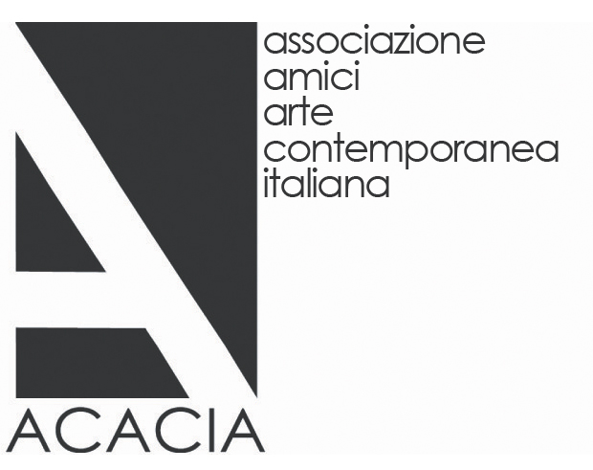
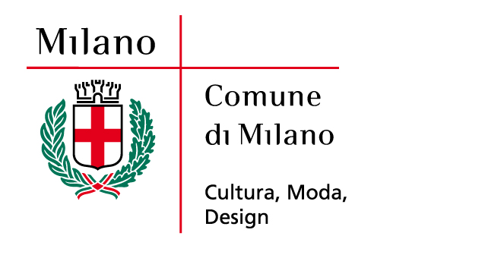


The Italian artists in the ACACIA Collection
Associazione Amici Arte Contemporanea
(Friends of Contemporary Art Association)

Curators: Gemma De Angelis Testa and Giorgio Verzotti

PALAZZO REALE
12 april_24 june 2012 | Milan

Press Conference > wednesday 11 april at 12.00
Sala Otto Colonne | Palazzo Reale
Vernissage > wednesday 11 april at 18.00

Promoted by the Municipality of Milan - Culture, Fashion, Design, the Royal Palace and the ACACIA Association, the exhibition entitled “Gli artisti italiani della Collezione ACACIA-Associazione Amici Arte Contemporanea”/“The Italian artists in the ACACIA Collection-Contemporary Art Friends’ Association” will be held from April 12th to June 24th 2012 In this venue located in the very heart of Milan.

This cultural event, curated by Gemma De Angelis Testa – President of ACACIA – and Giorgio Verzotti, proposes to the public about thirty works by artists in the contemporary art collection of the association.
All expressive forms of visual arts are represented here, from painting to sculpture, photography, video and installation. On display we can admire works by Mario Airò (winner of the first edition of the ACACIA Award), Rosa Barba, Vanessa Beecroft, Gianni Caravaggio, Maurizio Cattelan, Roberto Cuoghi, Lara Favaretto, Francesco Gennari, Sabrina Mezzaqui, Marzia Migliora, Adrian Paci, Paola Pivi, Ettore Spalletti, Grazia Toderi, Luca Trevisani, Marcella Vanzo, Nico Vascellari and Francesco Vezzoli. Each of these artists can boast the awarding of both national and international prizes.

ACACIA is a private non-profit association that embodies the role of an active collector, attentive to the cultural problems of its city and, in general, of its country. The promotion of and support to art and to the work of young Italian artists is one of the main aims of the association. In this perspective, ACACIA has worked since its establishment to create a collection of contemporary Italian artworks. Its commitment goes hand in hand with the willingness of the association members to encourage - through various forms of collaboration with public institutions - the creation of a museum of contemporary art to be entrusted with the collection, which is steadily growing.

“The collections are a unique legacy for contemporary art in Milan - said the Councillor for Culture, Mr. Stefano Boeri - and their exhibition to the public, when guided by scientific criteria as is the case for ACACIA, may be a very important contribution to give strength to the idea of ​​ Territorially Extended Museum that we are building in Milan”.

Moreover, the association established since its birth the ACACIA Prize for contemporary art, which is awarded every year to an Italian artist ‘under 40’ in recognition of his/her work on the national and foreign scene, who is then included in the collection.
“The collection - Gemma De Angelis Testa argues in this respect - builds a memory of fascinating cultural events, meetings and incentives that reflect the ideas and poetics of our time. By opening our collection to the public we certainly intend to propose a cultural event closely related to the time we are living but, at the same time, begin an active and proactive dialogue so that contemporary art does not remain a prerogative of a few, but is promoted, preserved and protected.”

The exhibition at the Royal Palace on one side bear witness to the work of ACACIA and the other proposes a reflection on the current Italian art scene of the latest generation, which has given the impetus to the creation of the collection in the perspective of a new form of ‘collective patronage’.
The underlying theme, the common denominator that binds all the artists on display is the refusal to consider art as a formal exercise, empty and purely self-referential. Giorgio Verzotti - the co-curator of the exhibition - also emphasizes that the spirit that pervades the protagonists of the contemporary Italian scene is the aspiration to an authentic relationship with the reality that is often tinged with irony until becoming, at times, extreme critic and real provocation. He continues, “these are the years when in Italy there was a restart of what we call 'the art system': that is, a well-articulated body, a field of public and private synergies that all together have at last played the role of art promoters. This exhibition is one of the many consequences of the renewed vitality of the Italian system”.

The exhibition presents for the first time to the public the work of Rosa Barba, the ACACIA 2012 Prize winner: “Theory in order to Shed Light”. Her works are defined as “filmic sculptures”, since the artist likes to express herself through the use of the video, which she splits up into its structural elements: words, music, images and light. The word is the part that most matters to Rosa Barba: whole sentences and texts are projected on the walls, accompanied by commentary voice-overs or music. Rosa Barba uses old film projectors connected to instruments of modern technology.

The exhibition is accompanied by a catalogue published by Silvana Editore with critic texts by De Angelis Testa and Giorgio Verzotti.

The event is supported by sponsors sensitive to the art world: TestaperTesta, Deutsche Bank, Vhernier and Open Care.
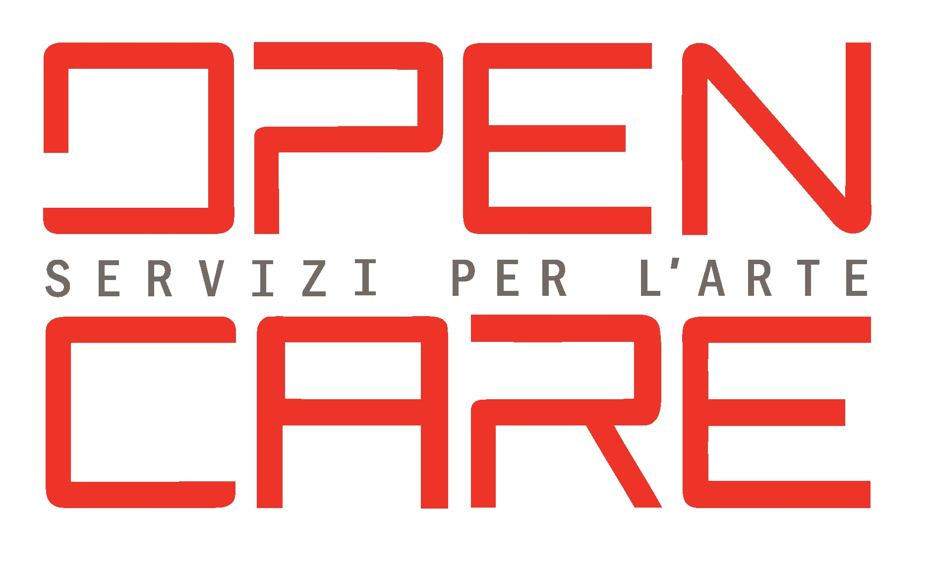




Exhibition details

Title The Italian Artists in ACACIA Collection - Associazione Amici Arte Contemporanea
Curators Gemma De Angelis Testa and Giorgio Verzotti
Place PALAZZO REALE | Piazza Duomo 12, Milan
Opening dates 12 april_24 june 2012
Opening hours Monday: 14.30_19.30
Tuesday, Wednesday, Friday and Sunday: 9.30_19.30
Thursday and Saturday: 9.30_22.30
Last entrance one hour before the closing time
Entrance Free
Catalogue Silvana Editoriale
Italian and English texts by Gemma De Angelis Testa and
Giorgio Verzotti

Infos www.acaciaweb.it
www.comune.milano.it/palazzoreale

Press Offices Exhibition press office
Irma Bianchi Comunicazione
tel +39 02 89404694 r.a. fax +39 02 8356467 info@irmabianchi.it |
Text and images: www.irmabianchi.it

City of Milan press office
Elena Conenna
tel +39 02 88453314 elenamaria.conenna@comune.milano.it

